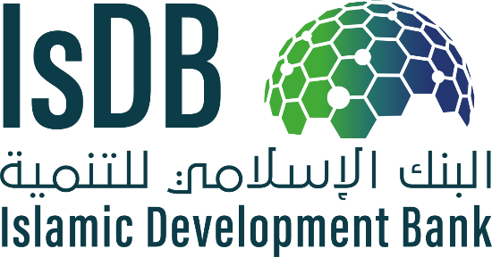
REQUEST FOR EXPRESSION OF INTEREST
(CONSULTANT SERVICES)
Consultancy Services for the “Enhancing Women’s Financial Inclusion through Islamic Finance” Program – Project Code ZZZ-2625
The Islamic Development Bank (IsDB) has established a program to introduce gender-sensitive perspective and practices within the Islamic finance industry to enhance women’s financial inclusion.
The objective of this assignment is to strengthen the Islamic Finance Industry’s ability to better support women’s financial inclusion by: i) creating awareness and disseminating knowledge on how Islamic finance can be used as a driver for women’s financial inclusion; ii) developing the capacity of financial institutions in designing Islamic products for women; and iii) supporting the development and launching of a new Islamic financial product for women. The Program will focus on providing support to government agencies, regulatory and supervisory authorities and also the market players (Islamic banks, financial institutions, etc.), which have a vested interest in enhancing women’s access to finance. The detailed Terms of Reference (TOR) for the assignment are attached to this request for expressions of interest.
IsDB now invites eligible consulting firms (“Consultants”) to indicate their interest in providing the services. Interested consultants must provide specific information which demonstrates that they are fully qualified to perform the aforementioned services (with details in ToR). The shortlisting criteria are:

- Adequacy of the Consulting firm’s expertise and experience for the assignment (based on identified project team members who will undertake the assignment)
- Strong understanding and experience working on women’s financial inclusion
- Experience in developing knowledge products, publications and practical guidelines.
- Solid technical knowledge and expereince in the Islamic Finance Industry
- Experience in developing financial products for women
- Demonstrated experience with design and facilitation of training workshops.
- Professional English language-editing / copy-editing competency (either in-house or outsourced) by consulting firm.
Note: Key Experts will not be evaluated at the shortlisting stage. Please DO NOT submit any technical or financial proposal at this stage.
The Consulting Firm will be procured through the Quality- and Cost-based Selection (QCBS) method set out in the Procurement Guidelines. The attention of interested Consultant firms is drawn to Paragraphs, 1.23, and 1.24 of the Guidelines for Procurement of Consultant Services under Islamic Development Bank Project Financing (the “Procurement Guidelines”), setting forth IsDB’s policy on conflict of interest.
Consulting firms may associate with other firms to enhance their qualifications but should indicate clearly whether the association is in the form of a joint venture and/or a sub-consultancy. In the case of a joint venture, all the partners in the joint venture shall be jointly and severally liable for the entire contract, if selected.
Interested consultants may obtain further information at the emails below until the due date.
Expressions of interest must be delivered electronically to the email addresses below by: 15:00 hours Jeddah Standard Time on December 6, 2020.

Name |  | Designation
Mr. Syed Faiq Najeeb | snajeeb@isdb.org | Senior Islamic Finance Specialist
Mrs. Kristonia Lockhart | klockhart@isdb.org | Lead Gender Specialist

Islamic Development Bank Group
Head Quarter, 8111 King Khalid St. AI Nuzlah AI Yamania Dist. Unit No. 1
Jeddah, 22332-2444, Kingdom of Saudi Arabia
Website: https://www.isdb.org

