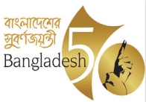 | Government Of The Peoples Republic Of Bangladesh  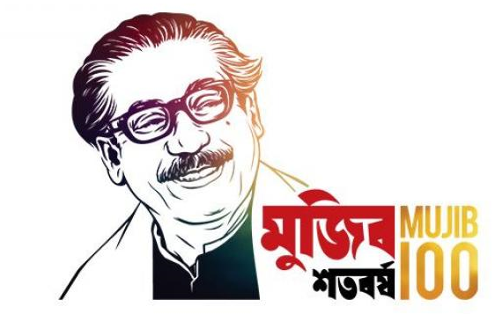  Office Of The Executive Engineer,  Department of Public Health Engineering (DPHE)  e-mail:ee.sylhet@dphe.gov.bd | †kL nvwmbvi g~jbxwZ MÖvg kn‡ii DbœwZ
Memo no: 46.03.9100.061.07.141.17- Date: /04 /2022
Urban Water Supply and Sanitation in 23 Pourashavas Project (GOB-IDB).

Notice Type: Specific Procurement Notice for Civil Works
Tender Number: KANA-P28
Procurement Type: National Competitive Bidding (NCB)
Sector: Water, Sanitation, and Waste Management
Country: Bangladesh
Issuing Date: 27April 2022
Last Date of Submission: 30May 2022
Invitation for Bids

Date: 27April 2022
Financing No: BD-181, BD-182 & BD-183
Contract Title: Installation of 19.39 kms pipelines, 1740 House Connections with meter &8 Street Hydrantsin Kanaighat Pourashava of Sylhet.
IFB No (NCB): KANA-P28
- The People’s Republic of Bangladesh has received financing from the Islamic Development Bank (IsDB) towards the cost of Urban Water Supply and Sanitation in 23 Pourashavas Project (GOB-IDB) and it intends to apply part of the proceeds toward payments under the contract for KANA-P28.
- The Executive Engineer, DPHE, Sylhet Division, Sylhet, Bangladesh now invites sealed bids from eligible bidders for “Installation of 19.39 kms pipelines, 1740 House Connections with meter &8 Street Hydrants in Kanaighat Pourashava of Sylhet”under “Urban Water Supply and Sanitation in 23 Pourashavas Project (GOB-IDB)” (“the Works”). The works will be implemented in Kanaighat Pourashava of Sylhet District, Bangladesh.
- Bidding will be conducted through the National Competitive Bidding (NCB) procedures as specified in IsDB’s Guidelines: Procurement of Goods, Works and related services under Islamic Development Bank Project Financing, April 2019 (“Procurement Guidelines”), and is open to all eligible bidders as defined in the Procurement Guidelines. In addition, please refer to paragraphs 1.18 -1.21 setting forth IsDB’s policy on conflict of interest.
- Interested eligible bidders may obtain further information from and inspect the bidding documents at the Office of the Project Director, Urban Water Supply and Sanitation in 23 Pourashavas Project (GOB-IDB), 7th Floor, DPHE Bhaban, 14 Shaheed Captain Mansur Ali Sarani, Kakrail, Dhaka, Telephone: +880-255130739, Email: pdgobidb23@gmail.com, at the Office of the Executive Engineer, Sylhet Division, Sylhet, Telephone: +8802996633011 Email: ee.sylhet.dphe@gmail.com and at the Office of the Executive Engineer, Dhaka Division, Dhaka, Telephone: +8802996633011, Email: ee.dhaka.dphe@gmail.com.
- A complete set of bidding documents in English Language may be purchased by interested eligible bidders from the Office of the Executive Engineer, Sylhet Division, Sylhet, Telephone: +8802996633011, Email: ee.sylhet.dphe@gmail.com and at the Office of the Executive Engineer, Dhaka Division, Dhaka, Telephone: +8802996633011, Email: ee.dhaka.dphe@gmail.com on the submission of a written application and upon payment of a non-refundable fee of BDT 2,000 (Two thousand) only. The method of payment will be cash. The Documents may be sent by air mail of courier or may be collected through authorized representatives of the bidder.
- The last date of selling bidding documents is 29 May 2022 till 17.00 hr. Bids must be delivered to the Office of the Executive Engineer, Department of Public Health Engineering, Sylhet Division, Sylhet on or before 12:00 hr on 30May 2022 and must be accompanied by a security of BDT 1,200,000.00 (One Million &Two Hundred Thousand) Only. Late Bids will be rejected.
- Bids will be opened in the presence of bidders’ representatives who choose to attend at 12:05 hr on 30May 2022 at the office of the Executive Engineer, Department of Public Health Engineering, Sylhet Division, Sylhet, Telephone: +8802996633011, Email: ee.sylhet.dphe@gmail.com.
Notice: Potential bidder desiring additional information on the procurement in question or the project in general should, unless indicated otherwise, contact the project agency and not the IsDB.

(Alamgir Hossain)
Executive Engineer, DPHE
+8802996633011

