Invitation for Expression of Interest (IEOI) – Individual Consultant

Invitation for Expression of Interest (IEOI)

Date: 08/Aug/2022

Preparation of Project Completion Report (PCR) of Support to the National Water Supply and Sanitation Program in Six Regions Project- AZE (0040), Azerbaijan

- The Islamic Development Bank (IsDB) has approved an administrative budget for financing consulting services (the Services) for the above project.

- The Terms of Reference (TOR) of the Services are in Appendix A. The Services will be provided by an individual international consultant (the Consultant) who may be a self-employed professional or an employee of a consulting firm.

- IsDB will select and engage the Consultant in accordance with the IsDB Corporate Procurement Policy (Policy). The consultant for the assignment will be engaged based on a Fixed Budget Selection method.

- IsDB now invites Expressions of Interest (EOI) from potential applicants for consideration by IsDB in selecting qualified candidates.

- The Consultant should complete the EOI Form in Appendix B and submit it along with his/her CV.

- The full set of documents should be submitted through email to the following authorized IsDB representative, not later than 31/08/2022 (03:00 PM GMT+3):
To designated email address for the assignment as follows
Email: EOI Submission - BCC2022-048 Preparation of Project Completion Report _PCR_ of Support to the National Water Supply and Sanitation Program in Six Regions Project- AZE _0040__ Azerbaijan 3570012d.isdb.org@emea.teams.ms
- All interested consultants shall start registration within SAP ARIBA for the self-registration,
Please find the link below: http://isdb.supplier.mn2.ariba.com/ad/selfRegistration/

Appendix A: Terms of Reference of the Assignment
Appendix B: EOI Form
Appendix C: IsDB Table of Contents of Project Completion Report (PCR)

Appendix A: TERMS OF REFERENCE
Short Term Evaluation Consultancy Services for the Preparation of a Project Completion Report (PCR) of the Islamic Development Bank (IsDB) funded project

Project Background:

- The Government of Azerbaijan (GOA) requested the Bank in 2011 to finance the second phase of the National Water Supply and Sanitation Project (NWSSP II). The project is part of the GOA’s vision for the water sector which focuses on the rehabilitation of water supply and sanitation facilities in all centers outside Baku, the capital city, and to provide reliable water supply and wastewater services.
- As appraised, the project was to cover six (6) rayons secondary cities including their surrounding villages), namely Astara, Dashkasen, Gadabay, Gazakh, Samux and Tartar.
- The project scope comprises of the following components:
  - Civil Works
  - Detailed Design
  - Additional Surveys & Studies
  - Consultancy services for works supervision
  - Project Implementation Unit
  - Support for Operations & Maintenance
  - Capacity Building for Non-Technical Staff in 6 regions
  - Project Financial Audit
  - Land Acquisition
  - Familiarization visit and Start-up workshop
- IsDB financing was earmarked to finance all the components except of land acquisition, detailed design and additional surveys and studies.
- The project executing agency (EA) was the National Water Utility AzerSu Open Joint Stock Company (AOJSC). The project was implemented by the PIU established under AzerSu.
- As the project was completed, the IsDB is required to conduct an ex-post evaluation of the project to capture overall achievements as compared to its intended outputs and outcomes. In addition, the PCR should identify the lessons learned from the project implementation.

- Description of the Assignment
- Objectives
- The Economic and Social Infrastructure Department (ESID) within IsDB, is seeking a consultant to assist in preparing a PCR for Support to the National Water Supply and Sanitation Program in Six Regions Project- AZE0040. The services shall be performed within a period of 1.5 months starting from first week of October 2022, or any other period as may be subsequently agreed by both parties in writing.
- Expected Outputs of the Consultant
- The Consultant will prepare the PCR according to IsDB standards, guidelines, and procedures. The Consultant's report of the assignment should be based on the IsDB standard template of PCR, which is attached in Appendix C.
- A knowledge product will be prepared (around 10 pages) based on specific lessons learned.

- Scope of the assignment
The scope of the assignment is as follows:
- Evaluate the processing and design of the project, both by IDB and the Beneficiary Country (and, as applicable, co-financiers and other project partners);

- Assess the performance of the relevant executing agency (EA) (and Beneficiary Country) in managing and implementing the project, in complying with IsDB’s guidelines, policies, practices, procedures, and loan covenants, and evaluate project costs, disbursements, and institutional improvements;

- Assess the performance of consultants, contractors, and suppliers with respect to services, construction, supply, delivery, and installation;

- Review problems encountered during implementation and the effectiveness of measures to resolve them, by the EA, the Beneficiary Country (as applicable) and IsDB;

- Assess whether the EA, the Beneficiary Country and IsDB monitored progress effectively in comparison with quantifiable and monitoring targets;

- Re-evaluate the financial and economic performance of the project at its initial stage of operation and compare with the qualified indicators in the project log-frame and in project progress reports and, as applicable, the PIASR;

- Assess the project’s transition to operations, and identify any remedial measures needed;

- Assess future operation and maintenance schedules to ensure sustainability of the project;
- Recommend any other steps that the Beneficiary Country and EA need to take to ensure the project’s sustainable operation;

- Assess the performance of the monitoring and evaluation system established for the project and reexamine the indicators selected for monitoring operations and assessing development impact;

- Assess whether the procurement and disbursement plans have been carried out as originally framed and the reasons for any difference between planned and actual project achievements;
- Assess, if applicable, the extent and effectiveness of implementation of project safeguard measures (e.g. environmental, social); and
- Assess whether the immediate development objective has been met and the likelihood of attaining long-term development impacts in terms of the planned and final project log-frame targets.

- The project assessment should take into account the following four dimensions of Relevance, Efficiency, Effectiveness and Sustainability, by answering the following questions:

i). Relevance – Assess the relevance of each project to the GOE and IsDB
- Was the project relevant to the identified needs and country’s strategy?
- Was the project relevant to the IsDB strategic priorities?
- Were the inputs and strategies identified, and were they realistic, appropriate and adequate to achieve the results?
ii). Effectiveness- Describe the management processes and their appropriateness in supporting delivery
- Was the project effective in delivering expected results (time and budget)?
- Was the project implemented according the schedule?
- How does the actual project implementation schedule compare with the initial schedule?
- What are the reasons for any deviations from the original schedule?
- What are the financial results of the project: the total cost, financing plan, and disbursements against the estimates made during the appraisal?
- How effective were the strategies and tools used in the implementation of the project?
- How effectively did the project respond to the need of the beneficiaries?
iii). Efficiency – of Project Implementation
- Do the deliveries of the project justify the costs incurred?
- Were the resources made available efficiently utilized?
- Did project activities overlap with and duplicate other similar interventions?
- Are there more efficient ways and means of delivering more and better results (outputs and outcomes) with the available resources?
- Could a different approach have produced better results?
iv). Sustainability- assess economic, environmental and social sustainability
- Does the project cause natural resources depletion in the long run?
- Were the local communities and stakeholders consulted during the project implementation?
- To what extent will the project revenues cover its O&M costs?
- Does the EA possess the technical capacity for the project operation?
- Did the project address the training needs for operation and maintenance?
- What is the likelihood of continuation and sustainability of the project outcomes and benefits after their completion?
- What are the key factors that will require attention in order to improve prospects of sustainability of project outcomes and the potential for replication of the approach?
v). Lessons learned- what are the lessons learned: The recommendations should provide comprehensive proposals for future interventions by answering inter alia the following questions:
- What are the main lessons that have emerged?
- What are the recommendations for similar future interventions?
- What are the problems and obstacles encountered during the implementation of the project?
- How did the project financial management processes and procedures affect implementation?
- What are the strengths, weaknesses, opportunities and threats of the project implementation process?
- What are the future intervention strategies and issues?

- Detailed tasks of the assignment
- The tasks of the Consultant are as follows:
  - Coordinate the communication to and interface with EA, the EPADP and other key stakeholders.
  - Prepare a questionnaire for the stakeholders’ interviews of the project.
  - Initiate the required meetings, interviews, and visits to the project area for close communication with key stakeholders.
  - Undertake a field visit: following the clearance of EA and IsDB, the Consultant proceeds with the field visit: (i) visit the site as per the scope of the project and expected outputs; (ii) hold thorough on-the-ground discussions with the stakeholders including the EA, Project Management Consultant, and end-beneficiaries; (iii) collect all necessary information concerning project implementation, outputs and outcomes; and (iv) collect photographs & videos of the project outputs and beneficiaries upon consent of the concerned parties.
  - If necessary, the IsDB team may join the field visits and the consultant should provide/contribute all the required support to facilitate the discussions with all the stakeholders.
  - The draft PCR is prepared after the field visit of the Consultant and should point out and explain the eventual variations in terms of cost, implementation schedule, financing plan and stakeholders’ performance. It should include among other things: (i) evaluation of the performance of the executing agency, the Bank, the contractors, and the consultants based on available information; and (ii) lessons learnt along with the Consultant’s recommendation to the Bank and the Country concerning project implementation and sector interventions.
  - The draft PCR should draw attention to the variations from the position envisaged at the time of the appraisal and assess the results delivered by the project against the project outputs and outcomes detailed in the Results-Based Logical Framework (Annex 1).
  - The final draft PCR should be submitted to IsDB, and revised based on the field visits, feedback from IsDB.
  - Prepare a knowledge product of 10 pages on specific lessons learned and relevant annexes, such as graphs, photos, videos and maps.
  - Prepare a short presentation highlighting key issues and lessons learned from the site visit (i.e. slide highlighting key issues and lessons learnt from the project summarizing the main findings of the exercise).

- Deliverables:
- The Consultant will produce the following major outputs:
- An Inception Report detailing methodology and work plan.
- Supporting documents including:
- Semi-structured interviews questionnaires
- List of interviewees
- Brief note summarizing the interviews
- The first draft PCR as per the IsDB PCR standard format.
- The Final PCR based on the feedback of the IsDB.
- A knowledge product of 10 pages on specific lessons learned.

- Time Frame of the Assignments:
- The assignment shall be over 1.5 months (October to November 2022), with a total duration of 22 working days, including 7 days for field visits.
- The Water Sector Team from ESID will supervise the Consultant. The Team will provide overarching supervision to the process and will provide feedback and guidance to achieve the goal and specific objectives of the consultancy.
- All deliverables are expected to be finalized through rigorous consultative meetings and in-depth discussions with the EA, the PIU and other key stakeholders, at the national and provincial levels.

- Qualification and Requirements:
- The Consultant should have the following minimum qualifications and skills:
- MSc degree in Civil Engineering, or relevant field in the water and irrigation sector or another related field in Economics, Environmental Engineering, etc.;
- Work experience in handling similar consultancy assignments in preparing at least 2 PCRs, in the context of developmental projects financed by Multilateral Development Banks;
- Language skills: fluency in written and spoken English;
- Knowledge of analytical and statistical tools.

- Evaluation Criteria:
- The consultant will be selected according to the Fixed Budget Method of selection. As such, the contract will be awarded to the highest-ranked technical proposal within the available budget. Financial proposals exceeding the budgetary limit shall not be considered. The following criteria will be used for evaluation of technical proposals (detailed criteria in Annex-2):
- General Qualifications 20 points
- Adequacy for the Assignment 60 points
- Experience in the Sector 20 points
- Total 100 points

- Budget and Payment Schedule
- The total estimated budget for this assignment is US$ 14,800, and the financial proposal shall not exceed this amount. Payments are linked to deliverables as defined below:
- First payment in the amount of 20% of the Contract Price upon receipt by the Bank, of the Inception Report detailing methodology and work plan;
- Second progress payment in the amount of 30% of the Contract Price upon receipt and written acceptance of the first draft PCR by the Bank;
- Third progress payment in the amount of 30% of the Contract Price upon receipt and written acceptance of the final PCR by the Bank, and
- Final payment in the amount of 20% of the Contract Price upon receipt and written acceptance of the Final Report and the knowledge product by the Bank.
- The remuneration perceived by the Consultant includes all his/her costs and profits as well as any tax obligations that may be imposed on the Consultants.
- Contract Administration:
- Client's Input: the ESID team will provide access to all required documents (i.e. Bank's standard template for Project Completion Report (PCR), Project Appraisal Document, PAD-RRP, Detailed Technical Documents, Project Progress Reports, Relevant Official Communications on the project, etc.). IsDB will also facilitate the assignment remotely by introducing the consultant to the EA, and providing any official support, which may be required.
- Logistics: The Consultant will coordinate with the EA to make necessary arrangements for the logistics of the field visit. The visit’s related expenses shall be borne by the Consultant.
- Confidentiality: The Consultant shall not, during the term of this Contract and within 3 years after its expiration, disclose any proprietary or confidential information relating to the Services, this Contract or the IsDB's business or operations without the prior written consent of the IsDB;
- Ownership of Material: Any studies, reports or other material, graphic, software or otherwise, prepared by the Consultant for the IsDB under this Contract shall belong to and remain the property of the IsDB.

Annex 1. Results-Based Logical Framework
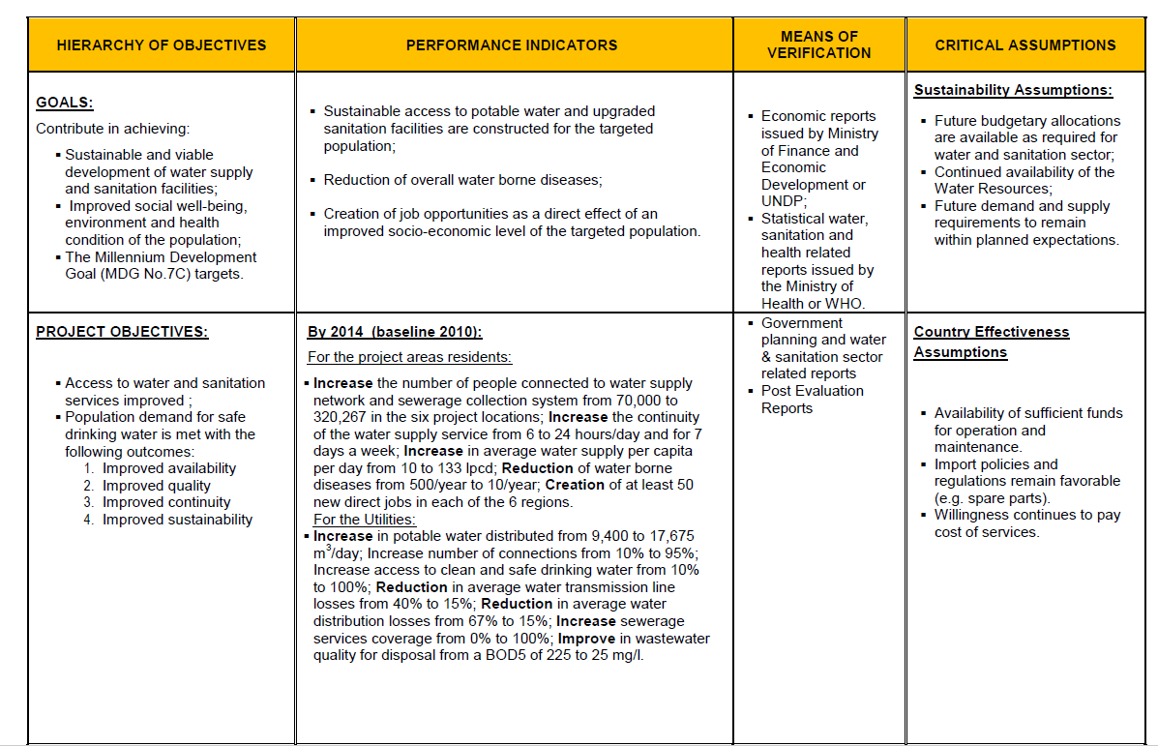
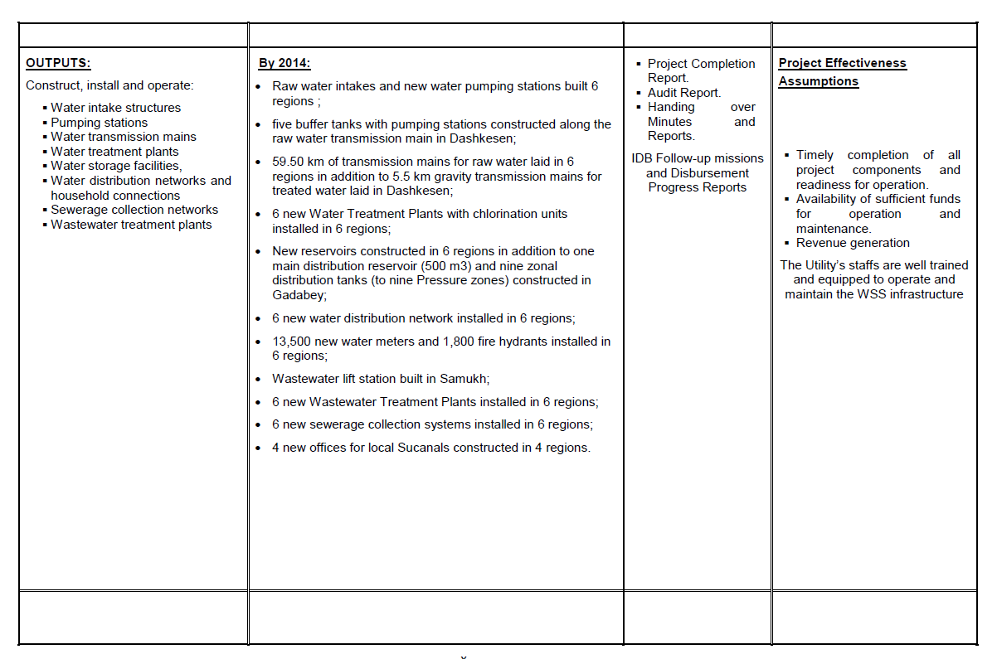

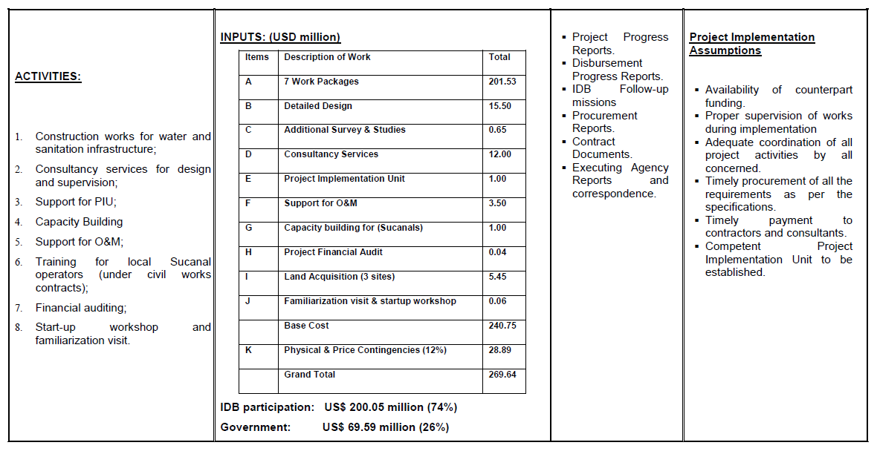

Annex 2. Detailed Evaluation Criteria
# | Criteria | Maximum score
1.0 | General Qualifications | 20
1.1 | Academic Background | 10
1.2 | Language skills | 10
2.0 | Adequacy for the Assignment | 60
2.1 | General Experience | 20
2.2 | Experience with similar assignments | 40
3.0 | Experience in the Sector | 20
3.1 | Sector and relevant sub-sectors | 10
3.2 | Multilateral /International Organizations | 10
 | Total Score: | 100

Appendix B
Expression of Interest (EOI) by Applicant

Preparation of Project Completion Report (PCR) for Support to the National Water Supply and Sanitation Program in Six Regions Project- AZE0040 - Azerbaijan

Date: ________________

Dear Mr.
I have read your Invitation carefully for Expression of Interest (IEOI) for the captioned assignment/project and find the Terms of References (TOR) and Scope of Work match my skill mix and experiences for providing the services required in the TOR. I would like to express my interest in being considered for the assignment. I understand that IsDB does not have an obligation that I must be selected.

I have attached to this EOI my Curriculum Vitae (CV) for your consideration. Some of the key information is highlighted below:

I. Personal Profile

Nationality:

Date of Birth:

Permanent Address:

Phone No.:

Email:

II. Past Consultancy Assignment References
[Notes to consultant: Please select most relevant consultancy assignments you have recently completed to demonstrate your technical qualifications and experience.]
Period | Client | Project | Country | Your role (As lead consultant or as member of a team?) | Value of the  Contract

III. Availability
I shall be available for the services from ____________ to____________.

IV. Eligibility Declaration
I, the undersigned, certify to the best of my knowledge and belief:

☐ I have read terms of reference (TOR) and Scope of Work (Appendix A), for this assignment.

☐ I confirm that the project references submitted as part of this EOI accurately reflect the experience of myself.

☐ I confirm that I have ever been convicted of an integrity-related offense or crime related to theft, corruption and fraud.

☐ I understand that any misrepresentations that knowingly or recklessly mislead, or attempt to mislead may lead to the automatic rejection of the proposal or cancellation of the contract, if awarded, and may result in further remedial action, in accordance with IsDB’s Integrity and Anti-corruption Policy.

{day/month/year}

Name of the Applicant Signature Date

Financial Proposal Format

No. | Item | Unit | Qty | Unit Cost  (US$) | Total  (US$)
1 | Professional fees including report preparation (unit rate) per day | Man. days
2 | Field visit expenses including travels (for all activities and inputs stipulated in the TOR including miscellaneous travel expenses, report preparation, production, and transmission, local transportation, communications, etc.) | Man. days
3 | Expenses for International Travel (If required) | Lump-sum
 | Contingencies
 | Total:

{day/month/year}

Name of the Applicant Signature Date

Curriculum Vitae (CV)

Position Title and No.: {Individual Consultant for Preparation PCR}

Name of Expert: {Insert full name}

Date of Birth: {day/month/year}

Country of Citizenship/Residence:

Contact information:
___
Education:
{List college/university or other specialized education, giving names of educational institutions, dates attended, degree(s)/diploma(s) obtained}

Employment record:
{Starting with present position, list in reverse order. Please provide dates, name of employing organization, titles of positions held, types of activities performed and location of the assignment, and contact information of previous clients and employing organization(s) who can be contacted for references. Please mark if the assignment is considered relevant to the assignment.}

Period | Employing organization and title/position. Contact information for references | Country | Summary of activities  (Comment if relevant to the Assignment)

Membership in Professional Associations and Publications: ___

Skills (language, technical, computer, others): ___

Certification:
I, the undersigned, certify that to the best of my knowledge and belief, this CV correctly describes myself, my qualifications, and my experience, and I am available to undertake the assignment in case of an award. I understand that any misstatement or misrepresentation described herein may lead to my disqualification and/or sanctions by the Bank.

{day/month/year}

Name of Expert Signature Date

 | Yes / No
- I am employed by the concerned Agency / (ies) related to this consultancy assignment | ☐
- I was involved with the preparation of the terms of reference for this consultancy assignment | ☐
- I am not currently debarred by a multilateral development bank or other similar institutions (If yes, identify who) | ☐

Appendix C

IsDB Table of Contents of Project Completion Report (PCR)

Table of Contents

S. No. | Item | Page
 | Abbreviations
 | Project Map
 | Executive summary
A | Project information
B | Project performance assessment
 | 1. Relevance
 | - Effectiveness
 | - Efficiency
 | - Sustainability
C | Project Stakeholders’ Performance
 | 1. Bank’s Performance
 | 2. Beneficiary’s Performance
 | 3. Other Stakeholders’ Performance
D | Overall Score and Rating
E | Lessons Learnt
F | Risks to Development Outcome(s)
G | Follow-up Actions and Recommendations
Appendix 1: Results-Based Logical Framework – Targets Vs. Achievements
Appendix 2: Organization Structure for Project Implementation
Appendix 3: Financing Plan – Planned Versus Actual
Appendix 4: Project Cost Breakdown – Planned Versus Actual
Appendix 5: Implementation Schedule – Planned Versus Actual
Appendix 6: Procurement Plan – Planned Versus Actual
Appendix 7: EIRR/FIRR Scores and Assumptions – Planned Versus Actual
Appendix 8: List of Documents Reviewed in Preparing PCR
Appendix 9: PCR Mission Dates and Persons Met
Appendix 10: Project Events, Missions and Milestones
Appendix 11: Project Photographs and Beneficiary Testimonials
Appendix 12: Performance Rating Scale and Methodology

(Note: Full version of IsDB Standard Template of Project Completion Report (PCR) will be provided to the Consultant upon the signing of the Contract)

Includes any overhead costs while working at place of residence.

