**Invitation for Expression of Interest**

**Hiring a Project Preparation Consultancy Firm**

**for the Project “Construction of Phosphorus Fertilizers Production Plant (TKM1013)”**

1. The Islamic Development Bank (IsDB) is hiring a consultancy firm for preparation of project preparation report of the project titled “Construction of Phosphorous Fertilizer Production Plant” in Turkmenistan. The Services will be provided by consultancy firm (Consultant). IsDB will select and engage the Consultant in accordance with the IsDB Corporate Procurement Policy (Policy).
2. The scope of the consultant services: (i) include preparing a project preparation/ design report by conducting thorough project design and assessment as per the standard template to be provided by IsDB (included in Terms of Reference as Annex); and (ii) support IsDB in its due diligence during project appraisal exercise. The estimated duration of the assignment is 5 months requiring nearly 100 man days of consultant firm inputs. The assignment is expected to commence from 15th September, 2022. The detailed Terms of Reference (TOR) of the Services is in Appendix A or can be obtained by writing to [wwijayanto@isdb.org](mailto:wwijayanto@isdb.org) and/ or [amkhan@isdb.org](mailto:amkhan@isdb.org).
3. IsDB now invites Expression of Interest (EOI) from eligible consultancy firms for consideration by IsDB in determining a shortlist to be invited to submit proposals. Depending on the number of the EOIs received and the qualifications of the applicants, IsDB may or may not short list all potentials who have submitted EOIs.
4. Interested Consultants must provide specific information which demonstrates that they are fully qualified to perform the services (brochures, description of similar assignments, experience in similar conditions, availability of appropriate skills among staff, etc.). Consultants from both the Member and Non-MCs are eligible in line with IsDB guidelines.
5. The shortlisting criteria are: (i) Experience in working with MDBs; (ii) experience in conducting assessment/ feasibility of fertilizer production projects and similar projects; (iii) experience in Central Asia region will be an advantage; (iv) overall experience and reputation of the firm.
6. Consultants may associate with other firms to enhance their qualifications but should indicate clearly whether the association is in the form of a joint venture and/or a sub-consultancy. In the case of a joint venture, all the partners in the joint venture shall be jointly and severally liable for the entire contract, if selected.
7. A consultant will be selected in accordance with the Quality and Cost Based Selection criteria as per IsDB Corporate Procurement Guidelines. Decision of IsDB shall be final.
8. Interested consultants may obtain further information at the contact below.
9. Firms who wish to submit an EOI should complete the EOI Form in Appendix B or obtain the template by writing to [WWijayanto@isdb.org](mailto:WWijayanto@isdb.org) (cc: amkhan@isdb.org) and submit it through email to the below mentioned authorized representatives within 21 days from the date of advertisement. The proposals shall remain valid for three (3) months after the above deadline, and it may be required by the Bank to be extended if need be.

Wahyu Sunaryo

Operations Team Leader

Regional Hub of Almaty

Islamic Development Bank

Email: [WWijayanto@isdb.org](mailto:WWijayanto@isdb.org);

amkhan@isdb.org

**Appendix A:** Terms of Reference

**Appendix B:** EOI Form

**Appendix C:** Design Report Template

**Appendix A**

**Terms of Reference**

**for Consulting Services for Supporting the Project Team in**

**Preparation of the Project of Construction of Phosphorus Fertilizers Production Plant**

**Background**

The Islamic Development Bank (IsDB) received an official request from the Government of Turkmenistan (GOT) to consider financing “Construction of Phosphorus Fertilizers Production Plant at S.A.Niyazov Chemical Plant in Turkmenabat city of Turkmenistan”. The objective of the project is to: improve the food security and income of farmers in food security in line with the country’s development strategy through: (i) enhancement of the productivity of agriculture sector and (ii) increasing the share of local fertilizer input in crops production. This proposed project will contribute to the improvement of reliability of the country's agricultural supply of phosphorus fertilizers, eliminate the import of these fertilizers, and provide a wide range of combined fertilizers, which are widely used in agriculture and will continue maintaining in high demand in the future. Phosphorus fertilizers to be produced at the Chemical Plant in Turkmenabat will be intended for the agricultural sector of the country, for the supply of agricultural producers, including wheat and other food crops grown for food security and to improve soil reclamation conditions.

The project will comprise of the following key tentative components: (i) Construction of the Industrial Plant, (ii) Procurement and Installation of Goods and Equipment, (iii) Project Management Consultancy Services, (iv) Project Implementation Unit, (v) Financial Audit and (v) Capacity Development.

The Executing Agency of the project is intended to be a State Concern “Turkmenhimiya” (TurkmenChemicals) which has submitted a generic project annotation, an internally-produced technical and economic appraisal document and Terms of Reference for EPC contractor. A project concept note has been developed.

The Bank is considering the financing of the project with intended timeline of processing it to its Board of Executive Directors meeting in January 2023. In order to meet the Bank Quality at Entry requirements, a comprehensive project design document is required.

Within this context, the IsDB considers engaging a reputable consultancy firm to support the IsDB throughout preparation activities.

**Objective of the Assignment**

The overall objective of this assignment is to prepare a comprehensive project design document as per IsDB needs and requirements (template as reference attached) to enable the bank to process and appraise the project as per its corporate requirements. This will include undertaking all necessary due-diligence and analysis not covered by the Government prepared project report, verification/ validation of report and preparation of additional sections.

A local consultancy firm has been hired by the Government of Turkmenistan, which shall prepare Sections A, B, F and G of the attached project document. The IsDB consultant would be required to validate the quality of these sections provided by the local consultant. The consultant is also expected to work with the IsDB project team in preparation of Project Preparation Report and Project Appraisal Report.

**Scope of the Assignment**

The scope of the assignment includes:

* Preparation of a comprehensive project design document. In doing so validate, enhance and finalize as necessary the sections A,B, F and G, being prepared by the local consultant for their quality and overall incorporation in project design document
* Collection of relevant data (as needed) during project preparation and appraisal exercise to be conducted by IsDB after the project design report is ready;
* Join the IsDB Team, virtually or physically, as the case may be during project preparation and appraisal mission exercise.

**Detailed Task and Activities**

The purpose of this assignment is to support the IsDB’s Project Team in preparation of the project documents on the basis of IsDB guidelines as per the attached template. The scope of assignment will include the following:

* Provide a detailed description of the project components and sub-components including cost breakdown, and implementation plan. Review TORs for the EPC contractor and draft EPC contract.
* Undertake assessment of risks and sustainability of the project.
* Undertake technical, financial, economic, social and environmental feasibility assessment of the project.
* Develop detailed project costing and financing
* Assessment of lessons learnt from other similar projects in the country and region
* Prepare Environment and Social Mitigation Plan Framework (ESMPF) to describe the institutional arrangements for environmental and social standards (ESS) governance during the project implementation as per IsDB requirements.
* Undertake assessment of projects orientation towards thematic areas, climate, environment, social and gender assessment of the proposed project interventions, identify project potential contribution to climate adaptation, mitigation, resilience; determine project linkage to climate relevant SDG goals, analyze fragility and employment generation and how that is integrated in the project design.
* Undertake institutional capacity assessment for Executing Agency including assessment of existing plant sites and propose necessary measures for enhancing the capacity to ensure successful implementation of the Project.
* Define project implementation structure, including roles and responsibilities and propose suitable project management, implementation and reporting arrangements based on country’s institutional structure and IsDBs norms.
* Prepare TORs for the Project Management Consultant to be procured during the project implementation.
* Prepare procurement strategy and procurement plan for the project
* Review and update performance parameters of the new plant. To explore on alternate project design options and, if applicable, to recommend possible adjustments in the project objective and scope with a view to streamline it with the objectives of the Turkmenistan’s national strategies and priorities, IsDB’s new strategy as well as sectorial and thematic policies of the Bank.
* Providing an overall knowledge of the chemical industry and agricultural sector of Turkmenistan and identifying bottlenecks/challenges and proposing solutions for reaching SDGs and realization of the state policies/programs in these sectors.
* Conduct a systematic assessment of the chemical industry in the context of its impact to the agriculture and rural development sectors of Turkmenistan. This will include review of the related state policies and programs; analysis institutional aspects, key issues and challenges, relevance of the project to the sector development plans/ sector strategy, general and socio-economic related data of the project areas and project location, and Executing Agency of the project, covering assessment in terms of equipment, human resources and technical/scientific capacity.
* Stock taking of the projects/programs, particularly focused on increasing the output and productivity of the agro-industrial sector, implemented by the Government of Turkmenistan, UN Agencies, development partners, NGOs, etc. and to derive lessons and synergies with proposed project.
* Design project results framework and collect baseline information and data (without the need for surveys) for the Project Targets and KPIs at the national level, at the level of target cities/regions/provinces. This will be the basis for proposing of the draft results framework (including outcomes, outputs, activities, indicators and risks/assumptions) for the Project.
* Support the IsDB Project Team during preparation and appraisal by providing technical backstopping as needed.

**In undertaking his work, the consultant will:**

* Review the upstream policy documents, strategies, development plans and other related governmental decrees and regulations aiming to develop the industrial and agricultural sectors’ performance.
* Review the relevant and other preparatory works carried out by the Government and the sector/sub-sectoral reports/analysis by the international organizations and development partners.
* Design questionnaire and collect information/data for need assessment of the Executing Agency for designing capacity building activities.
* Undertake consultations with government, development partners and project stakeholders as necessary to develop various aspects of the document
* Attend virtual or physical consultative meetings to be held under the project with participation of the IsDB Project team and the other project stakeholders.
* Provide any other information required by IsDB for preparation of the Project.

**Expected Outputs and Deliverables with Milestones**

All deliverables shall be prepared in English and submitted in an electronic copy (in Word format). The key deliverables under this assignment include:

* Project Design Report as per the attached template- Draft-1 - to be produced within 50 days from the notification of selection of the consultant
* Project Design Report as per the attached template- Draft-2 Version - to be produced within 20 days from the date of IsDB review of the first draft and provision of written comments to the consultant.
* Project Design Report as per the attached template- Final Draft - to be produced within 14 days from the date of IsDB review of the second draft and provision of written comments to the consultant.
* A brief project summary will be attached to the main report (format attached);

The following assessments will be provided in Annex of the main report:

* Institutional Capacity Assessment Report of Turkmenabat Chemical Plant with a proposed program of activities
* Terms of Reference for Project Management Consultant (PMC) readily to be used by the EA for the selection process
* Environment and Social Mitigation Plan Framework (ESMPF)
* The deliverable during the preparation and appraisal mission shall be any necessary write-ups or written material the project team may request to complete the project preparation and appraisal exercise, building on the scope of the initial report.

**Methodology:**

1. Consultant will prepare deliverables by undertaking consultations with key government agencies, meeting other MDBs, and conducting stakeholder analysis. He will also undertake field visits as necessary to validate his findings.
2. The consultant will physically or virtually, as be requested by IsDB team, participate in IsDB preparation and appraisal missions (1 week each).

**Assignment Supervision Arrangement and Reporting Requirements**

1. IsDB will assign a project/ Task team leader who will oversee the work of the consultant during the duration of the assignment. The Task Team leader may engage other IsDB and GoT expertise to provide inputs/ review of consultant work and guide the consultant as necessary
2. The consultant will coordinate and report to the IsDB project team leader throughout his assignment. Coordination and progress update will be conducted through a virtual meeting at least once during the week or as determined by the IsDB Team Leader
3. The consultant will provide written update on progress of work on weekly basis through email
4. The IsDB will provide its review on consultants inputs within a maximum period of 30 days. However, for efficiency purposes, the Bank will seek to provide its input within a 15 days period.
5. The consultant will provide physical mission reports within 1 week from his return from physical mission notifying the IsDB team leader of key outcomes or issues.

**IsDB and Government of Turkmenistan Support to the Consultant:**

* Provision of project concept document already available (attached with the TORs)
* Support through a local consultancy firm hired by the GoT responsible for preparing sections A, B, F and G of the report. Consultant will validate the outputs of the local consultancy or guide him as necessary for finalization.
* Support in setting up virtual meetings with the various government agencies and stakeholders (noting that consultant must provide advance notice of 2 weeks for this purpose, especially at the beginning of the assignment)
* Support in arranging logistics for the Physical missions and setting up field visits in the country
* Logistical support in setting up physical meetings and consultations
* Providing necessary templates and guidance on IsDB policies and procedures, internal documents, including evaluation reports, to facilitate consultant’s work, upon request

**Key Expertise and Qualifications Required:**

The key expertise required for the core consultancy team must include the following:

* Economist with experience in design of development projects (Team Leader)
* Industrial engineer with experience in Chemical/ Fertilizer industry
* Environmental and Social Safeguards expert

The selection criteria to assess the technical capacity of the consultants’ experts includes the following:

* Advanced level degree in related field
* At least 7 years of professional experience in the area of project preparation/management/evaluation/ assessment
* Experience of work with MDBs/IFIs and Multilateral institutions is an advantage.
* Strong interpersonal skills and ability to dialogue with diverse stakeholders to create consensus around issues and capable of working in multi-cultural environments.
* Effective time management and organizational skills to ensure qualitative outputs under strict deadlines.

Strong (written and oral) command of English and Russian languages. *Proficiency in English and Russian or local language is essential. In case the consultant team is not proficient in Russian or a local language the proposal should include a support staff or other arrangement to be managed by the consultant for translation. The expenses will be covered by the consultant for such staff within the total budget of the assignment.

**Total Inputs:**

The total inputs of the consultancy assignment are estimated at around 100 man-days.

**Location of the Assignment:**

The assignment will be done through a mix of desk review, virtual meetings and field visit to Turkmenistan where the new plant will be built.

**Duration of the Assignment:**

The total duration of the assignment is expected to be 5 months, with intermittent engagement of consultant. This includes the 2 months for production of report by the consultant and 3 months for IsDB processing of the project. It may be noted that this does not reflect the man-days for the assignment, which are estimated at 100 man-days. However, the consultant is expected to manage his own time and resources for successful delivery of the outputs within the deadlines.

* Expected start of services (notification of award) is 30th August 2022.

**Nature of the contract and Payment Schedule:**

The contract will be lump sum basis and the consultant will be entitled for payments for the assignment outputs (deliverables). The contractual details of the assignment will be reflected in the contract to be signed between the consultant and the IsDB. The payment schedule will be as follows:

* Project Design Report as per the attached template- Draft-1: 20% upon clearance of Draft-1 by IsDB
* Project Design Report as per the attached template- Draft-2: 20% upon clearance of Draft-2 by IsDB
* Project Design Report as per the attached template- Final Draft: 40% upon clearance of Final Draft by IsDB
* Completion of appraisal mission and inputs to appraisal reports and preparation reports of IsDB: 20%

**Appendix-B**

**Expression of Interest (EOI) by the Firm**

**Hiring a Project Preparation Consultant for the Project**

**of Construction of Phosphorus Fertilizers Production Plant, Turkmenistan (TKM1013)**

Date: ________________

Dear,

*Wahyu Sunaryo*

*Operations Team Leader*

*Regional Hub of Almaty*

*Islamic Development Bank*

*Email:* [*WWijayanto@isdb.org*](mailto:WWijayanto@isdb.org) */ amkhan@isdb.org*

We have read carefully your Invitation for Expression of Interest for the captioned assignment/project and find the Terms of References (TOR) and Scope of Work match our firm skill mix and experiences for providing the services required in the TOR. We would like to express our interest being considered for the Shortlist. We understand that IsDB does not have an obligation that we must be shortlisted.

We have attached to this EOI supporting documents highlighting the relevant expertise and Experience for your consideration. Some of the key information is highlighted below:

**Profile of the Firm**

|  |
| --- |
| Country of Registration:  Year of Establishment:  Address of the Firm:  Phone No.:  Email:  Highlight Experience of the Firm and its expertise in detail: |

**Past Consultancy Assignment References**

*[Notes to consultant: Please select most relevant consultancy assignments the firm has recently completed to demonstrate your technical qualifications and experience. Additional space can be used to cover the information request, which can be presented in non-Tabluar format.]*

|  |  |  |  |  |  |  |  |  |
| --- | --- | --- | --- | --- | --- | --- | --- | --- |
| Period (Year and Duration) | Client | Project Name and Description- Clearly indicate Key Tasks performed by the consultancy firm | Country | Was assignment financed by MDB or international financial institution? Is yes, name of the MDB/ IFI. | Did this assignment relate to preparation of Feasibility? If yes, highlight how. | Did this assignment relate to assessment of phosphorous/ fertilizer production plant or similar plants. Explain how. | Your role (As lead consultant firm or as member of the JV?) | Value of the  Contract |
|  |  |  |  |  |  |  |  |  |
|  |  |  |  |  |  |  |  |  |
|  |  |  |  |  |  |  |  |  |
|  |  |  |  |  |  |  |  |  |
|  |  |  |  |  |  |  |  |  |
|  |  |  |  |  |  |  |  |  |

**III. Availability**

Our Firm shall be available for the services from *____________* to*____________.*

**IV. Eligibility Declaration**

I, the undersigned, certify to the best of my knowledge and belief:

I have read terms of reference (TOR) and Scope of Work (Appendix A), for this assignment.

I confirm that the project references submitted as part of this EOI accurately reflect the experience of the firm

I confirm that our firm has never been convicted of an integrity-related offense or crime related to theft, corruption and fraud.

I understand that any misrepresentations that knowingly or recklessly mislead, or attempt to mislead may lead to the automatic rejection of the proposal or cancellation of the contract, if awarded, and may result in further remedial action, in accordance with IsDB’s Integrity and Anti-corruption Policy.

I am the authorized representative of the firm

*Signature: Name of the Authorized Representatives*

**Appendix C: Project Design Report Template**



# Project Design Report Template

**“PROJECT TITLE”**

**Country:** “Insert the Name of the Country”

**Acronyms and Abbreviations**

**Glossary**

**Currency and Measurement Conversions**

**Key Stakeholders and Focal Points**

|  |  |  |  |
| --- | --- | --- | --- |
| **Name** | **Designation** | **Contact No** | **Email** |
|  |  |  |  |
|  |  |  |  |
|  |  |  |  |
|  |  |  |  |
|  |  |  |  |
|  |  |  |  |
|  |  |  |  |
|  |  |  |  |
|  |  |  |  |
|  |  |  |  |

**[1]**

Date of Design Study Draft:

Dates of Field Visits and Stakeholder Consultations:

1. **Table of Contents**

**A.**

**Strategic Context**

**B.**

**Project Development Objective and Rationale**

**C. Project Description**

**D. Project Thematic Orientation**

**E. Project Cost and Financing Plan**

**F. Implementation Arrangements**

**G. Fiduciary Due Diligence**

**H. Project Results and Monitoring**

**I. Project Risks and Sustainability**

**J. Project Feasibility Analysis**

**Name of the Project, Country**

1. **Strategic Context**

The annotation for this document is for guidance only, please remove it in the final document.

This section will include a narrative in the following sub-sections that will describe in summary the context and rationale for developing the project and seeking financing from IsDB:

**Brief Project History:**

1. Provide information relevant to the origins of the project, including the following:
   * Timeline towards conceptualization, development, preparation and appraisal of the project
   * Approval and endorsement of the project by different government authorities
   * Internal processes undertaken to clear/ endorse the project concept and feasibility study
   * Additional steps to be undertaken for clearance of the feasibility study by relevant country authorities and its inclusion in countries investment program for the year
   * Participatory approach used in preparing the project (consultations/ interactions with stakeholders and its outcomes)
   * Documents, studies, consultations and information on the basis of which the feasibility is prepared.

**Other Similar Projects Planned or Already Undertaken in the Country and their Performance:**

1. Provide a brief description of other similar projects undertaken in the country with specific reference to their current status, financing, and performance.

Suggested table as follows:

Country Sector

|  |  |  |  |  |
| --- | --- | --- | --- | --- |
| **Source of Funds** | **Project Name** | **Key Dates**   1. **Approval** 2. **Completion** | **Amount (US$ m eq.)** | **Status**  **Ongoing or Completed and other details** |
|  |  | a.  b. | a.  b. |  |
|  | a.  b. | a.  b. |  |
|  | a.  b. | a.  b. |  |
|  | a.  b. | a.  b. |  |
|  | a.  b. | a.  b. |  |
|  | a.  b. | a.  b. |  |

*Provide additional information in* ***Annex if needed.***

**Project Context:**

***Country Context:***

1. Provide a brief description of the country’s context (limited to last five years), including the following:
   * Principal features of the beneficiary country: Geographical location and its strategic importance, land area, population demography
   * Summary of country’s main socio-economic indicators
   * Country’s growth rate, output / productivity trends supported by recent statistics, drivers of growth or deceleration, global ranking (Global competitiveness index), sovereign credit risk rating
   * Country’s poverty reduction strategy, policies, instruments, etc.
   * Country Economic Situation and Recent Economic Performance: include information related to GNP/GDP, growth rate trends, drivers of growth or deceleration, highlights of fiscal and monetary policy
   * Poverty Profile of the Country: include information about poverty rate and changes over time reflected by indicators such as Human Development Index etc.
   * Country Development Strategy and Challenges: include relevant information on the development plan adopted by government, pillars, objectives, and commitment towards achieving SDG targets. Specifically indicate how the current project objectives align with the country development strategy

*Provide additional information in* ***Annex if needed***.

***Thematic Context:***

1. Provide a brief description of the thematic context, including the following thematic considerations: include relevant information on women and youth empowerment strategies in the country in general, and the sector of the project in specific.

***Sector Context:***

1. Provide a brief description of sector context relevant to the project, including the following:
   * Description of the salient features of the sector in the country, and its potential/opportunities
   * Details of the sector situation and performance in the country, supported by recent statistics
   * Relevant sector policies of the country
   * Explanation of key sector issues/challenges/major constraints hindering the growth of the sector in the country that will be addressed as part of the proposed project
   * Possible solutions for addressing these constraints
   * Government strategy for development of the sector
   * Interventions by other Development Partners (DPs) helping to improve this sector in the country / address sector challenges.

*Provide additional information in* ***Annex if needed***.

**Alignment with Government Strategy:**

1. Provide a brief description of the alignment of the project with the Government country and sector Strategy, covering the and how it will help achieve the SDGs. Provide specific linkages with SDG indicators and government policy pillars which the project will directly address.
2. **Project Development Objective and Rationale**

This section states the development objectives of the proposed project, including the key project results indicators and information related to target beneficiaries. The project objective should be outlined as:

1. Impact: Higher level contribution to government national strategy or sector strategy
2. Outcome: Specific objective the project will achieve directly after its completion and key indicators to measure that. The indicators should be “SMART” (see log-frame on relevant information required for each indicator)
3. Outputs: Key direct deliverables that will result through completion of project activities with SMART KPIs

Outline the direct beneficiaries in specific location and their socio-economic characteristics as well as indirect beneficiaries.

**Project Objectives:**

1. Include the project development objective (PDO) directly relevant to the issues being identified. While defining the PDO, the following are considered:
   * Problem Statement and problem tree: “What is the problem(s) the project is going to address?” This should be a critical constraint or a priority earlier mentioned in sector context. Presenting a problem tree is essential to show how the project (see project description) will address the sector constraint through project activities.
   * Linkage of Project Development Objective to Problem Statement and Country’s Development Goals / MCPS

NOTE: Project Development Objective is a clear, succinct and measurable objective statement.

Provide the project log-frame as below:

SMART and CREAM indicators are the following:

* *Specific* – stated clearly and relate to the results the project seeks to achieve.
* *Measurable* – can be monitored and provide verifiable data (quantitative)
* *Achievable* – are neither too ambitious nor too modest. The latter will call into question the planned investment.
* *Relevant* – useful for management information purposes.
* *Time-Bound*– stated with target dates.
* *Clear* – precise and unambiguous.
* *Relevant* – appropriate and timely.
* *Economic* – the data is available at reasonable cost.
* *Adequate* – sufficient to assess performance (in order to reduce the number of indicators for a given result).
* *Monitorable* – can be independently verified.

|  |  |  |  |  |  |
| --- | --- | --- | --- | --- | --- |
| Country and Project Title:  Project Purpose: | | | | | |
| Narrative Summary | Performance Indicators | | | Means of Verification | Assumptions |
| Indicator | Baseline | Target |
| Impact(s) |  |  |  |  | Sustainability assumptions |
| Outcome(s) |  |  |  |  | Country effectiveness assumptions |
| Outputs |  |  |  |  | Project effectiveness assumptions |
| **Key Activities**  Component 1:  Component 2:  Etc. | Inputs  Component 1:  Component 2: (etc.) | | |  | Project implementation assumptions |

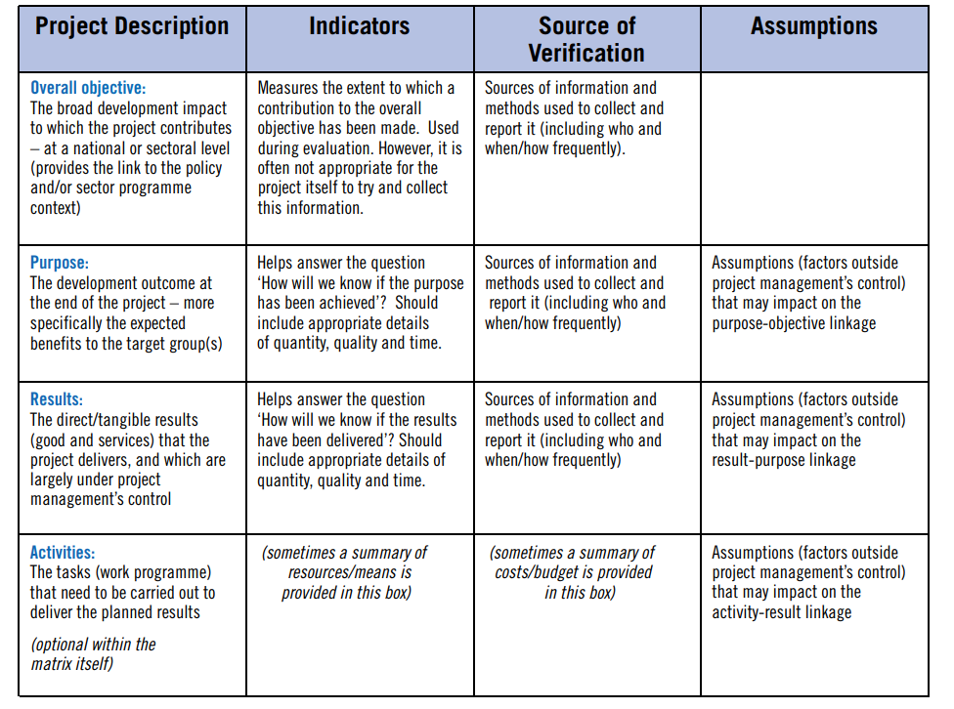

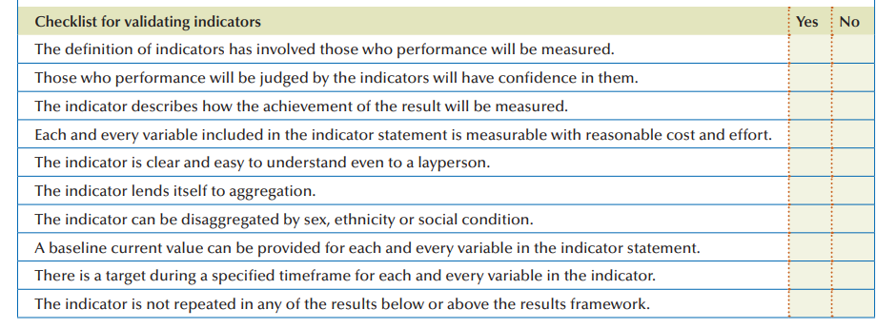

**Project Location:**

1. State the location of the project site (s), region/ provinces, highlighting the access to the project site, the overall commination mechanisms, i.e., access to road, rail, etc. and distances from the main cities/ airports. Any other socio-economic and logistical indicators relevant to project implementation. Also indicate if the land is available or steps to be undertaken to ensure project location is available to start the project with timelines.
2. Provide the **Project Location Map(s)**

*Provide additional information in* ***Annex if needed****.*

**Project Beneficiaries and Stakeholder Consultations:**

1. State the target beneficiaries (age and gender disaggregated), direct and indirect, of the project. Moreover, provide information about ownership by national stakeholders (govt ministries and other stakeholders) and beneficiary groups evidenced through consultations with key project stakeholders and participatory processes that were held during the design and preparation stages of the project. The consultation modalities should be briefly outlined for the various types of stakeholders involved. Key findings of the consultations, and concerns raised by beneficiary groups, especially women, youth and vulnerable groups of the population, should be presented. Further concerns of any stakeholders which may not support the project should also be noted. Lastly, the priorities or consultations with direct beneficiaries of the project, including private sector that will utilize project facilities should be outlined clearly.
2. Civil Society:

|  |  |  |  |  |
| --- | --- | --- | --- | --- |
| **Thematic** | **Actions** | **Yes** | **No** | **Information available or**  **Comment** |
| ***Civil Society Engagement:***  Purpose: to identify key stakeholders and a strategy for consultation and participation of civil society in the project design, implementation and monitoring | 1. Identify the Ministry (focal point) in charge of the cooperation with developmental CSO (to retrieve CSO database, preparatory studies) 2. Mapping of/identify CSOs (i.e INGO, local NGOs, CBOs) active in the targeted sectors i.e (i) providing value addition, (ii) helping hard-to-reach communities, vulnerable groups, rural communities 3. Preliminary consultations with key CSOs to include all relevant stakeholders and potential beneficiaries 4. Initiate discussions on their roles and technical & financial contribution in the project: service provider (technical)/executing agencies or co-financing partner (INGO) |  |  | IsDB Civil Society Engagement Policy |

**Civil Society Engagement**

Provide stakeholder analysis table summary below:

Stakeholders Chart

|  |  |  |  |  |  |  |
| --- | --- | --- | --- | --- | --- | --- |
| Diagnostic Phase | | | | | Design Phase | |
| (1)  Stakeholder  Group | (2)  Interests | (3)  Problems Perceived | (4)  Resources/ | (5)  Mandates | (6)  Interest in the Project (proposed or underway) | (7)  Force-field Analysis |
|  |  |  |  |  |  |  |
|  |  |  |  |  |  |  |
|  |  |  |  |  |  |  |
|  |  |  |  |  |  |  |
|  |  |  |  |  |  |  |

**Rationale for Seeking IsDB Financing for Investing in the Project:**

1. State the rationale for proposed IsDB financing, including the following:
   * Rationale for Country and Sector Support: Key development country / sector issues addressed by the project. This should be linked to sector/ country context.
   * Alignment with country’s development strategy / priorities and sector-specific strategy and the basis for the project being a high priority for the country,
   * Alignment with policies/activities of the government and other DPs who are also working in the sector.
   * Alignment with SDGs
2. **Project Description**

This section includes a description of the core of the project, including the project’s scope, components, financing plan and reflects lessons learned within project design. This is the MOST important section of the feasibility study,

**Project Design and Scope/Components:**

1. Provide a brief description of what the project entails, including the proposed project design, different project components covering all categories of expenditures, i.e., Works, Goods and Services. It should include:
   * civil works
   * equipment
   * consultancies
   * training and capacity building
   * project management arrangements
   * audit arrangements
   * any other activities which are part of the project scope

It should cover detailed information on technical aspects of the project clearly indicating all activities which will be undertaken within the project scope to achieve the project results.

1. Provide the results tree linking project components with project objective. It will be directly linked with project problem tree presented earlier, to show how the project components will address some of the problems to achieve the project objective. A sample of project problem and results tree are presented below.

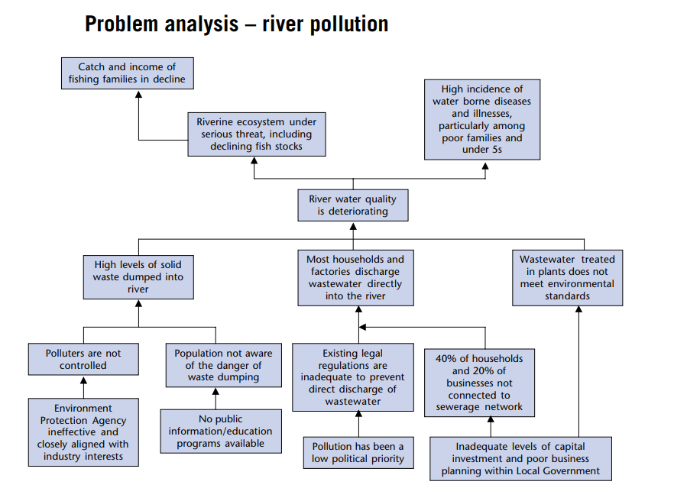

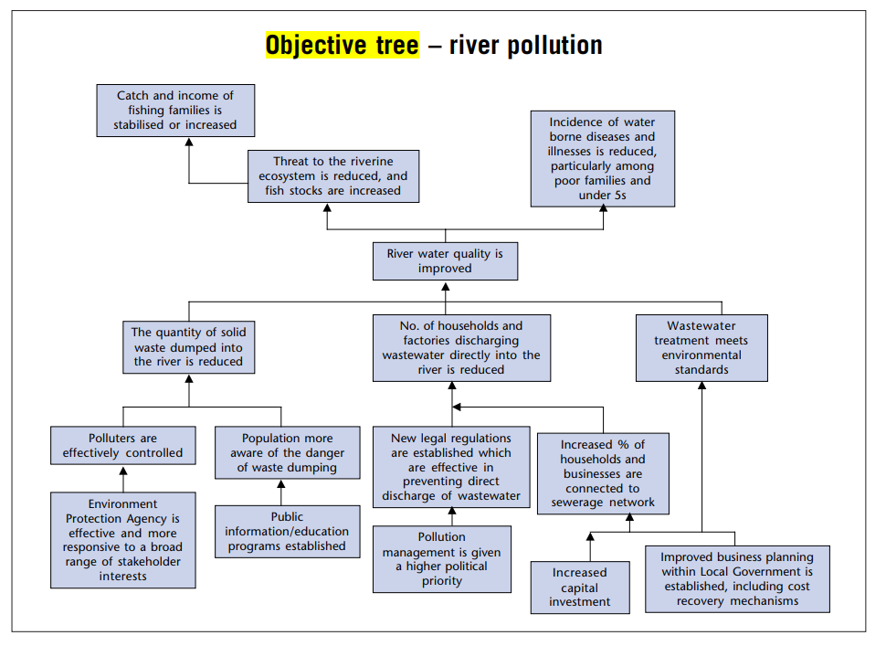

*Provide additional information in* ***Annex if needed***

**Past Lessons Learned and Reflected in Project Design:**

1. Provide a brief description of how the project design reflect on the lessons learned from on-going/completed projects by the country, and known best practices, including the following:

* Lessons learned from executing agency past projects, especially with other MDBs.
* implementation issues and current experience of Executing Agency in implementing such projects.
* Experience of implementing similar projects in other countries and lessons from those.
* Various remedial/mitigation measures proposed in the project to overcome issues faced during design and implementation of previous projects.
* Indicate in tabular form how each of the project lessons have been addressed in the project design.

1. **Project Thematic Orientation**

This section will include a discussion of the project’s orientation towards the Bank’s thematic areas.

**Climate Change:**

1. Provide a brief on integration of climate considerations in the project, including the following:

* Project Potential Contribution to Climate Adaptation, Mitigation, and Resilience
* Project Climate co-benefits
* Project Climate Finance share
* Project linkage to NDCs, NAPs, NAMAs or other climate relevant SDG goals
* Indicate clearly how the project design takes adverse climate implications into account and how the project contributes to climate adaptation, mitigation or building resilience as well as to countries climate and environment strategy. Also indicate how the negative climate impacts will be addressed during implementation.

**Women and Youth Empowerment:**

1. Provide a brief on the analysis on women and youth empowerment, fragility and employment generation (where applicable) and how that is integrated in the project design. Demonstrate how concerns raised by beneficiary groups, especially women and youth, are reflected in the design of the proposed project. This section should specifically indicate how the women and youth will be engaged in project implementation and benefit from its results. What is the project doing to ensure that these outcomes are achieved.

**Fragility and Conflict Sensitivity Analysis:**

1. Indicate how the project will or will not lead to increasing or decreasing fragility during implementation and through its results (after implementation), as relevant. Provide context and situation analysis to drivers and causes of the risks and pressures conducted to address underlying causes of fragility and conflict and prevent future conflict by working on complex deep-rooted issues that drive fragility, such as patterns of exclusion, uneven distribution of project resources, results and impacts. Means to capitalize opportunities to prevent conflict and promote resilience are identified.

**Disaster Risks Management Analysis:**

1. Indicate the vulnerability of project implementation and sustainability to any disaster and climate related risks and how they have been addressed in project design. Provide project’s potential impact on mitigating disaster risks and response in member countries that are prone to natural disasters needs to be carried out, to ensure that “development gains” from the Bank’s projects are sustainable to tackle potential disasters. This step needs to be included in relevant components of projects considering that vulnerability to natural hazards is complex one that have unique challenges, which require specific solutions.
2. **Project Cost and Financing Plan**

This section includes the project cost and financing plan information.

**Project Costs:**

1. Provide an item-wise project cost estimate in detail in the table in local and foreign currency (US$ equivalent). Local currency items are those which are expenses that will be made in local currency, while foreign currency items are those which are imported to implement the project. This should not include any operational expenses and only expenses to be incurred to complete the project investment. Provide breakdown where necessary through additional tables for specific activities. BOQ and TOR based tables where applicable for specific activities should be separately provided in addition to overall project table.
2. Outline all key assumptions and sources used in calculation of costs

|  |  |  |  |  |  |
| --- | --- | --- | --- | --- | --- |
| **Sr. No.** | **Project Component** | **Category of Expenditure** | **Local Cost** | **Foreign Cost** | **Total Cost** |
|  |  |  |  |  |  |
|  |  |  |  |  |  |
|  |  |  |  |  |  |
|  |  |  |  |  |  |
|  | Base Cost |  |  |  |  |
|  | Contingency (Physical) |  |  |  |  |
|  | Contingency (Financial) |  |  |  |  |
|  | Total Cost |  |  |  |  |

Provide detailed cost and resource schedule. Template is below:

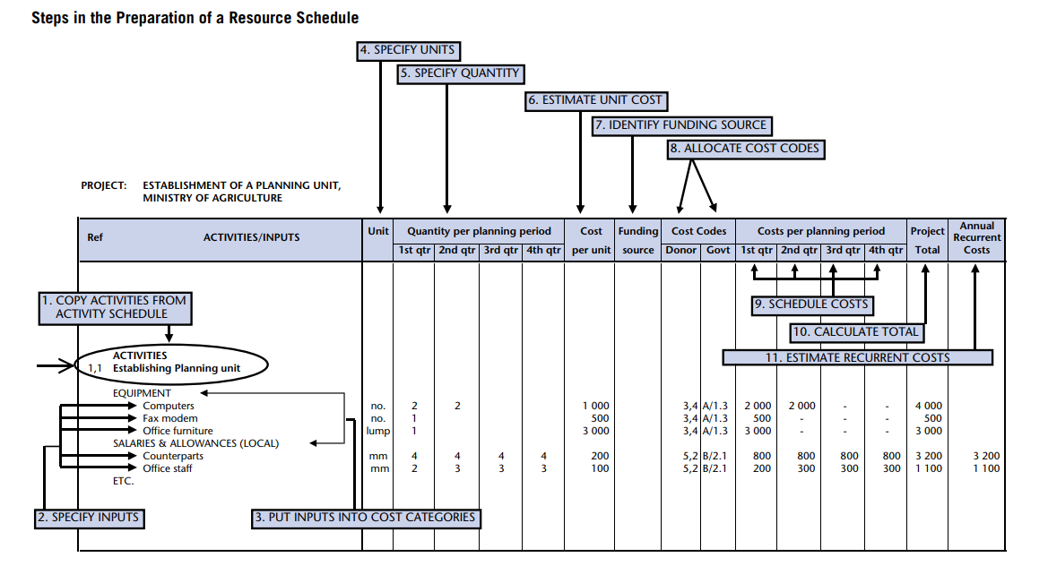

**Proposed Financing Plan:**

1. Provide the proposed project financing plan which shows the suitable mode of financing and the various sources of funds for each project component in project currency

*Provide additional information in* ***Annex if necessary****.*

|  |  |  |  |  |  |
| --- | --- | --- | --- | --- | --- |
| **Sr. No.** | **Project Component** | **IsDB** | **Co-Financiers** | **Government** | **Total Cost** |
|  |  |  |  |  |  |
|  |  |  |  |  |  |
|  |  |  |  |  |  |
|  |  |  |  |  |  |
|  | Base Cost |  |  |  |  |
|  | Contingency (Physical) |  |  |  |  |
|  | Contingency (Financial) |  |  |  |  |
|  | Total Cost |  |  |  |  |

1. **Implementation Arrangements**

This section includes a description of the project’s implementation arrangements. It should be clearly developed with sufficient detail.

**Executing Agency / Agencies (EAs):**

1. Provide a brief description of the suitability of the Executing Agency (main agency that will oversee the project implementation) / Agencies, including the following:

* Identification of the suitable EA and Implementing agency (if different from executing agency or if more agencies are involved or specific departments within the implementation agency)
* Listing the main Responsibilities / Functions of EA and IA, including the effect/ collaboration of other institutions/ ministries on these roles
* Project implementation capacity of EAs: Staffing of EA, prior experience of EA(s) of working on similar projects, same location/area, IsDB in particular and other MDBs and DFIs in general, and the brief on the status of those projects / programs;
* Assessment of agencies capacity, experience and skills to manage project implementation from a technical, financial and procurement standpoint, and adequate capacity-building measures (if needed) that are built in the design of the operation. The specific capacity building needed should be included in project components.
* Assessment of adequacy of operational rules, regulations, procedures and staff incentives that will enable the agency/ies to successfully implement and later operationalize the project.
* Assessment of financial management systems and capacity of the EA/ IA and their systems in the area of planning and budgeting, management and financial accounting, reporting, auditing, and internal controls for efficient project implementation and sustainability.

*Provide additional information in* ***Annex if needed****.*

**Institutional Arrangements:**

1. Provide a brief on the institutional arrangements (exact description of who will manage the project implementation and decision making roles on day to day basis) for project implementation and the required reporting structure, including the following:

* Overall governance and project management structure/ organizational chart for Project Implementation with all relevant stakeholders / institutions clearly identified and their roles/ responsibilities listed clearly. Organogram for project implementation setup
* Project Management Unit (PMU): Mention where the PMU is housed, including its main responsibilities, experience, reasons for selecting particular type of PMU structure, financing of PMU and Budget / capacity building needs of the PMU
* Structure of PMU: Staff composition of PMU and their roles, reporting structure, and coordination requirements
* Project Implementation Unit (if required): Mention location (s), staffing budget, and the TOR, etc.
* Project Implementation Consultant(s) if needed: provide the reasons and corresponding ToR
* Staffing of the Project Management / Implementation Unit and Implementation Consultants (if any) along with their intended TORs

*Provide additional information in* ***Annex if needed****.*

**Implementation Plan and Project Readiness:**

1. Provide a brief on the status of project readiness, including the following:

* Project implementation plan / chart by key project components: This indicates the estimated time / schedule / timeline for project implementation, kind of works that have already been completed or commenced, and key implementation milestones (key implementation dates). This should accompany a Gantt chant with clear activities in detail. Example of part of the gantt chart is below:

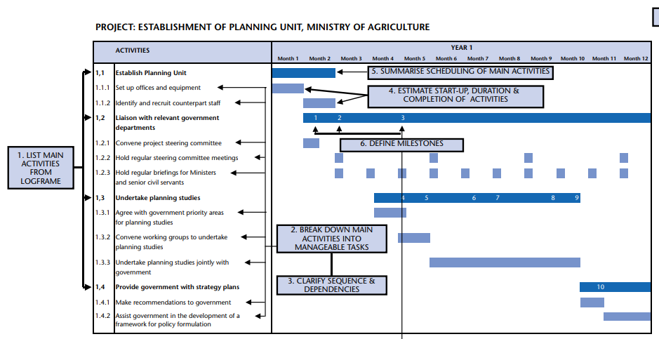

* Presentation of modalities for the participation of national stakeholders and beneficiary groups during implementation, including CSOs and beneficiary groups, who will be involved in the implementation of the proposed intervention and analyzing its results.
* Project Readiness: This can be indicated by answering the following questions:
  + What is the status of project design/bidding documents for the first-year implementation program?
  + What is the status of readiness of specifications or the timeline to do that and who will do it
  + What is the status of PMU, i.e. is it in-place and staffed? and timeline for that (should also be reflected in Gantt chart above
  + Are the required physical facilities – land, utilities etc. available?
  + Is Counterpart funding available?
  + is government approval obtained on FS or timeline to obtain that
* Measures, if any, to fast-track implementation (as part of implementation strategy)

*Provide additional information in* ***Annex if needed***

**Project Monitoring and Implementation Supervision Plan:**

1. Provide a brief overview of the mechanisms for project’s progress monitoring and progress reporting, including the following:

* Provide a project results monitoring plan covering key objective, KPIs, source of information, frequency of information collection, responsible party to collect the information, cost of information collection, storage and compiling of information, MIS to be used etc.
* Arrangements for coordination and exchange of information amongst the key stakeholders (government, implementing entities, consultants, contractors, IsDB and the co-financiers, if any), with responsibilities clearly assigned
* Assessment of the capacities of the execution and implementing agencies to fulfill IsDB’s information needs and reporting requirements, related to reporting on project implementation, KPIs, procurement, financial management and risks
* Information on the agreed Project achievements (including key milestone dates, PIASR frequency, trigger for the Mid Term Review)
* M&E reporting requirements.
* Type of activities, tools and mechanisms used for supervising, monitoring and reporting progress:
  + Reports submitted by EA / PMU to IsDB: Frequency / schedule of submission, contents of the report outlining project progress achievements, financial progress, procurement plan progress, problems encountered, and mitigation actions
  + Project Start-Up Workshop: Purpose and scope, location
  + Project Supervision Missions by Senior EA staff
  + Mid-term review: agreement on the milestone to launch the review to assess the overall performance of the Project and gap analysis to identify if any improvements are needed

*Provide additional information in* ***Annex if needed****.*

1. **Fiduciary Due Diligence**

This section will include a brief on the project’s fiduciary requirements.

**Procurement Arrangements:**

1. This provides a brief analysis of the project’s procurement arrangements, including the following (Annex-2):

* Procurement Strategy: Highlight the strategy to ensure that capable key staff is in place to satisfactorily implement project procurement tasks. This entails taking into consideration the assessment of Procurement Capacity of Country and Executing Agency, while reflecting on EAs previous experience on similar projects. Also assess procurement risks and mitigation measures, corresponding responsibility, and timeframes. See attached document for further information on template for development of procurement strategy.
* Assessment of Agency’s Capacity to implement procurement – remedial measures
* Procurement Plan: Show the contracts required to be procured to implement the Project throughout its duration as a list of Indicative Procurement Packages for all IsDB financed items. This will also provide information about the procurement method, timelines, type (s) of contract(s) to be used, how vendors will be managed, and who will be involved at each stage of the process.
* Detailed justification for choice of Mode of Procurement & Method of Selection for all IsDB financed items.
* General description as to how the procurement would be cared out – using IsDB procurement manual dated _______. Similar reference to governing documents are to be given for procurement of civil works, goods, equipment, services, etc.
* Procurement status of the project including the need for advance procurement (where applicable).

*Provide additional information in* ***Annex -2***

**Project Financial Management and Audit Arrangements:**

1. This provides a brief description of the project’s financial management arrangements, including the following. Also fill assessment checklist as in Annex:

* Assessment of financial management capacity in the country and the project entity.
* Measures to bring this capacity to acceptable level (if needed)
* Assessment of EA’s Financial Management System: Verify the integrity of the financial management (FM) system of the EA, considering the areas of: (i) planning and budgeting, (ii) accounting; (iii) internal control; (iv) financial reporting; and, (v) external audit provisions.
  + Accounting: key accounting policies and procedures, financial information system, and staffing arrangements funds flow, accounting and auditing arrangements.
  + Internal control: the internal control system, including internal audit function.
  + Financial reporting: responsibility, reporting period / frequency, the type and format / contents of the audit reports to be submitted.
  + External oversight: external auditing arrangements, including the type of auditor, frequency of submission of reports. The arrangements should also present a financial management action plan that specifies the actions to be taken by the borrower to complete the arrangements based on the level of risk and weaknesses identified.
* Relevance of country public financial management system: if applicable, provide rationale for not using the country FM systems should also be provided.
* Describe Financial/Accounting Management Arrangements based on applicable accounting policies, procedures, and standards, for the project. Consider the following aspects:
  + Staffing arrangements
  + including the type of auditor (private firm, national audit institution or both)
  + IT Financial information system
  + Responsibility for financial reporting

*Provide additional information in* ***Annex if needed.***

**Project Disbursement Arrangements:**

1. This provides a brief description of the project’s disbursement arrangements, including the following:

* Assessment of EAs capacity to manage funds flow and disbursements
* Assessment of capacity of the project entity/ the project management unit to process and keep record of the project proceeds.
* Measures to bring this capacity to acceptable level (if needed)
* Disbursement process highlighting flow and processing of funds, including the responsibilities regarding initiating, review, clearance and approval of disbursement requests
* Tentative Project Disbursement Schedule
* Detailed Projected disbursement Plan i.e. disbursement by year for each project component (linked with the project procurement plan)
* Disbursement Methods: Modes of payments to various stakeholders for all activities; justification for the need for any Special Account (SA)

*Provide additional information in* ***Annex if needed****.*

1. **Project Results and Monitoring**

This section includes a description of the project results and monitoring and evaluation (M&E) framework.

**Key Development Results Indicators:**

1. Include a summary of development results that the project will deliver in line with its objectives, with clearly defined cause-and-effect relationship all along the result chain, i.e., inputs, activities, outputs, outcomes and impact. The development results will include outputs, outcome(s) and impact with the associated SMART results indicators.

Provide *additional information in* ***Annex if needed****.*

**Monitoring and Evaluation of Outcomes/Results:**

1. Provide a brief description of project’s M&E framework, including the following:

* Monitoring and evaluation framework to track inputs, outputs and outcomes and evaluate the project results. The framework must be accompanied by SMART results indicators, with appropriate baseline and target values, and the corresponding sources of information for verifying them.
* Roles and responsibilities for monitoring results indicators during implementation
* Mechanisms used for Project Monitoring and Evaluation: it will include a summary of the mechanism agreed with the PMU/PIU to submit to IsDB the status of implementation, achievement on outputs and outcomes indicators and actions taken to ensure satisfactory project implementation.

1. **Project Risks and Sustainability**

This section includes description of the project risks and project sustainability.

**Project Risks:**

1. Provide a brief description of the potential risks associated with the project, the impact of the risk proportional to its severity, likelihood of the identified potential risks, and the proposed / existing mitigation measures including responsible party to manage it during implementation and upon completion, including the following:

* The Project Risk Matrix: Identify all the potential risks associated with the project (with specific emphasis on project sustainability), assess and assign a risk rating to each risk, and provide an explanation for the risk rating considering the severity/ impact of risk, likelihood of the risk. This will identify the overall risk rating of the project. **The risks should be assessed both from the lens of these factors impact on project as well as how the project itself increases these risks.**  The risks can either be things that can “go wrong” in the project compared to plan during implementation and operations or “any outcome worse then what was targeted in the results matrix”. Ideally, the impact of most severe risks should be quantified, while others can be qualitatively assessed. The risks are identified related to the following categories
  + Stakeholder Risks: This includes risks related to Counterpart, Co-financiers, Beneficiary, Contractors/Suppliers
  + Country Risks: This includes risks related to Political/Security, Economy and Legal Risks.
    - *Economic risks: how will macroeconomic situation impact the project during implementation and operations. What macroeconomic assumptions are made and why? How can the impact of economic growth, inflation, tax or subsidies, government policies be made favorable to increase project success? Can the impact of these risks be reduced?*
    - *Economic Resilience: Vulnerability of project to world events; impact of project on increasing economic vulnerability.*
    - *Site availability and permits from various agencies*
    - *Political Risks: This includes continued support from beneficiary/ government for project; change in government or key ministries or its structure; change in operating laws or regulations; war/ unrest; nationalization risk for potential beneficiaries which may invest after project completion; FOREX and capital flows laws; currency controls and exchange rate controls.*
    - *Legal and Policy Risks: Change in statute- taxes, environmental laws, employment laws, investment laws, H&S standards, change in strategy or sector policy etc that impact project during implementation and operations.*
    - *Pandemics that could impact pace of work.*
  + Economic and Financial Risks: This includes assessment of the following:
    - *Demand risk: how much demand is present for project goods/ services. Is the market growing or shrinking; what are local, regional and global trends? What are the alternative markets available. What alternate products can be produced if market for one product shrinks? What is the possibility or available off-taker agreements? What marketing strategies and consumer segmentation strategies can be used (different regional markets or different product categorization for example?)? What subsidies will be provided and what cost they will entail to government?*
    - *Price Risk: Are prices for products or services offered by project reasonable? How much can market price vary for inputs and outputs? How volatile are the prices? can the prices be locked or long-term agreements to secure prices available in any market? how much market power would project have in determining prices? Is there a govt set price? Are there subsidies available or required and how do they distort the market? Are prices determined locally or internationally? What is the ability to pass through inflation through high prices?*
    - *Product Differentiation/ Competition: Is the service or product different from what is available in the market. Is the market competitive. Who gets the margins and how can they be maximized for targeted beneficiaries. Is the product solely provided by the project or government or other entity. What risks or benefits that entails? How will the product market change, competitors react or impact on behaviour of other providers of same products and services? Does the project “crowd-out” private suppliers market? Are their markets for “special” products such as organic production? Is country member of such agreements which offer access to these markets?*
    - *Counter party or consumer risks: Can consumers pay for the product/ service. Do they have capacity or credit worthiness? Are their guarantees (such as govt guarantees) available that minimize the risk? What mechanisms are available if counter party defaults?*
    - *Exchange rate risk: Is exchange rate risk significant. Is foreign currency available for operations? Will the counterparty be able to secure finance from market to buy the offered product and service?*
    - *Resourcing Risks: Can the required materials, labor and other inputs to project during investment and operation be obtained at reasonable cost and time.*
    - *Financing Risk: is there a gap in project financing. What are the risks to obtaining the financing at reasonable rate and what alternates are available for cheaper financing? How will co-financiers engagement increase or change project risks and returns?*
    - *Volatility: how volatile the project cash flows are and what mitigation are available?*
  + Social Risks: This includes assessment of the following risks:
    - *Environmental risks: the risks related to environmental hazards, environmental degradation, etc*
    - *Health risks: related to possible negative health impacts to project direct and in direct stakeholders.*
    - *Social unrest: such as widening social divides or possibility of creating conflict among different stakeholders.*
  + **Project Risks:** This includes risks related to Design, Operations, Accessibility, Sustainability/Results, and Project Procurement Risk
    - Operational risks, including:
      * *Capex Risk:* *capital expenditure risk (or cost overrun)- what if it costs more then estimated and what has been done to mitigate this. What will be done if there is cost overrun?*
      * *Design risk: will the project deliver the intended results/ will it produce the required outputs? Will it work as per expected standards of operations (capacity and quality)? Will the outputs lead to desired outcomes? Will the desired design be delivered?*
      * *Processing Risk: will the technology or any production process in the project be able to process inputs/ raw materials as envisaged? Is it robust? Can raw material/ input be varied and still lead to same results? How much do we need to control the inputs quality to achieve intended production results? Are their by-product markets or can services be provided for other purposes then intended?*
      * *Construction risk, related to risks of contractors to deliver the assets on time. Availability of service providers and their capacity.*
      * *Technological risk: Will the technology used work in the project context as intended? Do we have guarantees? Are their test runs or defect liability period? Who holds this risk.*
      * *Obsolescence risk: will the technology become obsolete before the intended project life? How can we leave possibilities for upgrades? How much investment is worth putting. How would new technology impact the project?*
      * *Volume risk: will the project solution(s) be able to deliver if scale changes? What would be the costs of such scale changes? How can we improve sustainability at low volumes? Can volume be scaled up or down quickly?*
      * *Input risks: Are relevant inputs available for delivery and operations of project. What happens if their price changes. Do we have supply guarantees?*
      * *Timing Risk: Delay in achievement of various milestones and overall completion and operational timelines.*
      * *Operations and maintenance risks including: (i) available capacity locally, (ii) available markets; (iii) costs and funding source; (iv) any subsidies available? (v) management structures?*
      * *Site risks: such as suitability of site for intended project activities. Initial assumptions about site don’t hold true.*
      * *Labor risk, such as non-availability of skills or labor strikes and wage disputes during implementation or operation.*
  + Executing/ Implementing Agency Risks: This includes risks related to Capacity, and Fiduciary Risks
    - *Adherence to IsDB procedures*
    - *Capacity of EA to implement the project on time.*
    - *Financial mis management.*
* Defining Risk Mitigation Measures with clear Responsibility for each risks in the Risk Matrix: Determine appropriate response strategies and actions for each individual risk
* Risk Management Plan: Highlight the plan and mechanism to monitor the identified high impact risks during implementation of the project for overall project risk mitigation

*Provide Risk Matrix as below:*

|  |  |  |  |  |  |  |  |
| --- | --- | --- | --- | --- | --- | --- | --- |
| Risk Category | Risk | Risk Impact Level | Likelihood | Mitigation Measure | Risk Impact after Mitigation | Responbile to manage | Risk management strategy |
|  |  |  |  |  |  |  |  |
|  |  |  |  |  |  |  |  |
|  |  |  |  |  |  |  |  |
|  |  |  |  |  |  |  |  |
|  |  |  |  |  |  |  |  |
|  |  |  |  |  |  |  |  |

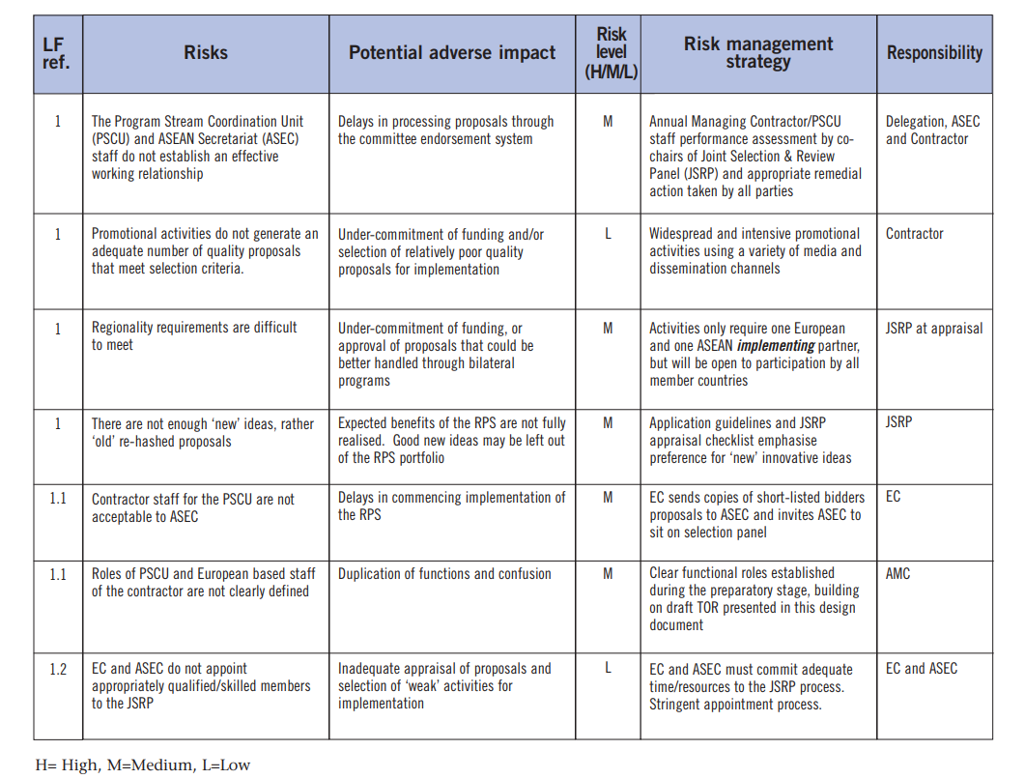*.*

**Project Sustainability:**

1. Taking into account the various risks and mitigation measures identified in the Project Risk Matrix, provide a general summary of the effectiveness of the measures to ensure sustainability of the proposed intervention with respect to the following dimensions:

* **Economic Sustainability:** It addresses the economic effectiveness and expected economic impacts of this project over its life cycle. It should assess the impact of the project on economy and sector as well as associated costs to economy. Economic sustainability also entails potential wider economic benefits that may not be captured through the EIRR and how they will lead to sustainability of project results.
  + **Social Sustainability:** It describes how the project would impact the poor, vulnerable groups and some target groups such as youth, women, and how the project would strengthen social cohesion and enhance social inclusiveness. It also entails any impacts that the project may have on the safety and security of the people in addition to any other socio-economic impacts it may have (such as new employment opportunities). It should demonstrate the positive and negative impacts of the project on social structure and whether that would lea to continuation of project benefits or risk its sustainability. Conduct distribution analysis covering: (i) Which group benefits and loses. ; (ii) Is it in line with the targeting. (iii) What kind of incentives and disincentives are created as a result of this and is it assessed in the risk and assumption analysis.
* **Environmental Sustainability:** It describes the entire life cycle of the project (construction, maintenance, and operation) and its impact in each of these stages on the surrounding environment as reflected by the Environmental and Social Impact Assessment (ESIA). It also takes implementation of the Environmental and Social Management Plan (ESMP) into account. In addition, resilience of the project to the long-term risks from climate change (climate change resilience) may also be highlighted in this section.
* **Operational Sustainability:** It is a cross-cutting criterion that addresses some of the main weaknesses usually found in projects, namely: i) Operation and Maintenance (including setup and budget availability); ii) Institutional Capacity, and Regulatory Framework and government support; iii) Resilience of the project results and Implementation to exogenous factors (i.e., resilience to risks).

1. Particular importance is to be made on the mechanisms agreed that allow local stakeholders to provide feedback and to monitor implementation of such mechanisms.
2. **Project Feasibility**

This section assesses the feasibility of the various aspects of project

**Technical and Operational Feasibility:**

1. Provide an assessment of the technical and operational feasibility of the project, outlining how the project achieves to answer the following questions. **This not a YES or NO answer but should be detailed assessment substantiated by relevant evidence and information. This needs to be very detailed to allow IsDB to assess the project feasibility independently:**

* Will the technical solution/ design of overall project proposed address the key problem being addressed and development objective being achieved?
* How does project address the sector binding constraints (regulatory, infra or policy related).
* What is the performance of the Public entity providing services, its management and government finances for the sector and entity.
* How does the project contribute to demand, affect cost, promote technology.
* What are the new investments expected in sector and how will they impact project.
* Is project the best way to address the issue.
* What are the government interventions (taxes, subisidies, price controls etc) that support or hinder the project results.
* Demand – supply analysis of the sector and other sources of supply.
* What is the Government sector development plan and how will it impact the project deliverables.
* How well proven the proposed design solution is in other projects/ countries.
* What technology is proposed and what pros and cons it has. Has it been tested elsewhere?
* What are the assumptions within which the proposed solution will operate? How well can it operate if assumptions don’t realize?
* How well can the technology operate in different circumstances.
* What is the capacity available locally or internationally to implement the proposed solution.
* What kind of operational expenses, equipment, other resources will be needed in implementation and during operations? Are they available? Who are the suppliers for these items/ resources/ technologies.
* What potential operational and managerial problems can be experienced in managing the provided assets as well as any key technology and equipment?
* How robust is the proposed solution to meet the demand of beneficiaries.
* How long and what key items would need to be replaced?
* Can the project be done within the planned cost and time and other resources?
* Is the technology adequate?
* ▪Upon completion, is the project capable of operating as planned?
* Does the country poses capacity (management, manpower etc) to implement and operate the project?
* Can the project sustain for its planned lifetime?
* Are implementation arrangements adequate to implement the project?
* Are post-project implementation mechanisms for operation adequate?
* How will the supervision consultants be engaged?
* What capacity building aspects have been included for successful implementation?
* Are operational risks, such as capital expenditure risk, design risks, processing risks, technology risks, obsolescence risks, volume risks, and input supply risks and their mitigation adequate? Assess the overall operational and technical risk.
* What other alternate design and technology alternates are available and why were they not considered?

**Economic and Financial Analysis and Feasibility:**

***Alternative Solutions:***  This section should outline key alternative solutions which have been rejected in favor of project design. The alternative solutions could entail different options in following areas:

* With or without project
* scale of project
* beneficiaries
* type of outputs/ services
* technology
* location
* starting date
* sequencing of components
* Implementation arrangement

***Financial Analysis and Feasibility:***

1. This section should provide the detailed description of the project’s financial analysis undertaken to determine its financial viability when compared to alternative project options. Provide the financial analysis of the project that answers the question, ‘Is the financial rate of return acceptable?’ Additionally, mention the key assumptions underlying the financial analysis, including the key risk factors based on the results of sensitivity analysis.
2. The financial analysis should take into account the various financial costs and benefits (at market prices), as follows:

* Revenues
* Operating Costs
* Capital Costs
* Working Capital

1. The financial analysis and feasibility should look at factors such as:
   * total production or marketable output/ services generated by the project, the amount/ volume of that output/ services
   * size and nature of the market where these outputs/ services will be sold. Who are the target consumers/ off-takers and what determines their demand; what is their socio-economic situation.
   * Demand for project services and price curve
   * Total demand and share taken by project
   * Impact of project on prices and tariffs.
   * Future growth trends of the market and what can terminate the demand. What are the competitive, social or political advantages that project produced services/ output has over alternates?
   * Impact of local and global macroeconomic situation on project finances and cash flows (both inputs and outputs), including economic growth, inflation, exchange rate, taxes and subsidies, trade regimes, labor laws etc.
   * Factors impacting the demand for the product in short term and over the project period
   * Price at which the products can be sold
   * Recent and long-term trends in pricing and what can impact that, both locally and globally depending on the projects products/ services.
   * Costs at which inputs are available and what are their cost determinants.
   * What are the prevailing price distortions and sources of distortions: Taxes/ price controls/ imperfect market.
   * Exchange rate movements and trends that could impact the project costs and prices
   * Possibility and nature of any “off-taker” agreements
   * Ability of consumers (or those paying on their behalf) to pay
   * cost for production/ investment over the project lifetime
   * Factors that impact the inputs availability and cost
   * CAPEX and OPEX costs determinants
   * Assessment of all financial and economic risks as stated in the risk section.
   * What guarantees, warranties and other securities are available that impact risks to cash flow.
   * Project reliance on FOREX and mechanism of its availability during investment and operations stages
   * If other co-financiers are involved, can the project be financed at reasonable rates. What alternate financing channels are available? Is the chosen financing best and most practical among various options available?
   * Is the FIRR of project comparable to other such projects locally or internationally?
2. Additionally, all the assumptions underlying the financial analysis must be clearly stated with appropriate reasoning.
3. The following financial indicators of the project should be used to determine the financial viability of the project:
4. Net Present Value (NPV)
5. Financial Internal Rate of Return (FIRR)
6. **Describe the results of project sensitivity analysis and identify the key risk factors that will have the maximum impact on the financial returns of the project. Key severe risks identified in the project risk matrix should be analyzed using sensitivity analysis to determine their impact on project FIRR as well as benefits.**

***Economic and Social Analysis and Feasibility (Separate Social Feasibility should be done when project is of “Social Nature”):***

1. This section should provide the detailed description of the project’s economic analysis undertaken to determine its economic viability when compared to alternative project options.
2. Provide the economic analysis of the project that answers the question, ‘Is the benefit/cost ratio for the country acceptable? and what Economic and developmental benefits are generated from the project, which may not be measurable. It covers the impact of the project on wider society and economy. It should incorporate benefits that associate to wider shareholders beyond the direct stakeholders such as project lenders, operators, and employees/ labor engaged. The economic feasibility should assess the project impact on:
   * Broad employment outcomes and multiplier effect of the project
   * Health outcomes
   * Educational and improved capacity outcomes
   * Growth of economy
   * Poverty reduction
   * Women empowerment
   * Improved governmental services.
   * environmental benefits
   * Additional tax revenue
   * Economic resilience and diversification
   * Increased forex or exports

It should also evaluate and analyze any negative impacts of the project and how they have been mitigated in project design, including:

* + Environmental degradation, hazards, habitat destruction
  + negative health outcomes such as accidents, health hazards during construction or operations for labor or community
  + impact of traditional lifestyle, culture or local population
  + Economic vulnerability such as making the economy more vulnerable to world economy downturn or global pandemics
  + Negative impact on balance of payments
  + Increased inequality
  + Increased vulnerability to any disasters or natural risks
  + Increasing social tensions among various groups

To the extent possible, the feasibility should quantitatively measure the project economic impacts quantitatively using best assumptions and expected impacts on these indicators. The details of environmental, social, gender and resilience should be thoroughly captured in relevant sections of the Feasibility Report. The summary of that assessment can be presented here.

1. This should yield cost-benefit ratio for the project by incorporating all costs and benefits of the project. **The cost-benefit analysis should be done for with and without project scenarios:**
2. Economic analysis also reflects the efficiency in which a project’s economic resources are used to deliver its outcomes, which is primarily measured by the economic internal rate of return (EIRR) of the project. This entails assessing alternate ways of resolving the problem. Additionally, mention the key assumptions and parameters used in the economic analysis.
3. The alternative analysis should be provided covering:
   * Is the project most efficient way of addressing the issue.
   * What other alternates are available and at what unit cost of output?
   * Is there a quality difference between outputs of different alternatives.
4. The economic analysis should take into account the various economic costs and benefits (valued in terms of shadow prices), as follows:

* Revenues
* Operating Costs
* Capital Costs
* Working Capital

1. Additionally, all the assumptions underlying the economic analysis must be clearly stated with appropriate reasoning.
2. The following financial indicators of the project should be used to determine the economic viability of the project in comparison to alternates (EIRR of other alternate should also be ideally calculated):
3. Economic Net Present Value (NPV)
4. Economic Internal Rate of Return (EIRR)

**Annex-1: Initial Environment and Social Analysis Form (Does not replace Environment and Social Assessment)**

INITIAL ENVIRONMENTAL AND SOCIAL ANALYSIS

|  |
| --- |
| **A. Introduction**  Projectsare assigned a category depending on the ***significance*** of potential environmental and involuntary resettlement impacts. Initial screening for environment and involuntary resettlement should be conducted as early as possible in the project cycle, at the project concept stage where feasible. |

1. **PURPOSE OF FINANCING**

|  |
| --- |
| Supporting existing businesses of related growth  Setting up additional/new facilities on existing sites  Expansion or modernization of existing facilities  Acquisition of new sites/sites or facilities/land |

1. **ENVIRONMENTAL SCREENING**

| **Screening Questions** | **Yes** | **No** | **Remarks** | |
| --- | --- | --- | --- | --- |
| **A. Project Siting**  Is the Project in vicinity of, adjacent to, or within any of the following environmentally sensitive areas? |  |  |  | |
| * Cultural Heritage Site |  |  |  | |
| * Legally Protected Area (Core Zone Or Buffer Zone) |  |  |  | |
| * Wetland |  |  |  | |
| * Mangrove |  |  |  | |
| * Estuarine |  |  |  | |
| * Special Area For Protecting Biodiversity |  |  |  | |
| 1. **Potential Environmental Impacts**   Will The Project Cause… |  |  |  | |
| * impairment of historical/cultural areas; disfiguration of landscape or potential loss/damage to physical cultural resources? |  |  |  | |
| * disturbance to precious ecology (e.g. sensitive or protected areas)? |  |  |  | |
| * any major alteration in land use patterns or result in land use conflicts? |  |  |  | |
| * major transportation and use/depletion of resources like water, electric power, fuel? |  |  |  | |
| * alteration of surface water hydrology of waterways resulting in increased sediment in streams affected by increased soil erosion at construction site? |  |  |  | |
| * deterioration of surface water quality due to silt runoff and sanitary wastes from worker-based camps and chemicals used in construction? |  |  |  | |
| * increased air pollution due to project construction and operation? |  |  |  | |
| * noise and vibration due to project construction or operation? |  |  |  | |
| * poor sanitation and solid waste disposal in construction camps and work sites |  |  |  | |
| * major release of wastewater due to project operations |  |  |  | |
| * creation of temporary breeding habitats for diseases such as those transmitted by mosquitoes and rodents? |  |  |  | |
| * large population influx during project construction and operation that causes increased burden on social infrastructure and services (such as water supply and sanitation systems)? |  |  | |  |
| * risks and vulnerabilities related to occupational health and safety due to physical, chemical, biological, and radiological hazards during project construction and operation? |  |  |  | |
| * risks to community health and safety due to the transport, storage, and use and/or disposal of materials such as explosives, fuel and other chemicals during construction and operation? |  |  |  | |
| * community safety risks due to both accidental and natural causes, especially where the structural elements or components of the project are accessible to members of the affected community or where their failure could result in injury to the community throughout project construction, operation and decommissioning? |  |  |  | |

**Assessment of Environmental Impact**

|  |  |  |  |  |  |
| --- | --- | --- | --- | --- | --- |
| **Category** | | | | | |
| **A[2]** |  | **B[3]** |  | **C[4]** |  |

1. **SOCIAL DEVELOPMENT ASPECTS**

|  |  |
| --- | --- |
| **A. Beneficiaries:** Based on existing information: | |
| * Who are the potential primary beneficiaries of the project? |  |
| * How do the poor and the socially excluded benefit from the project? |  |
| * What are the potential needs of beneficiaries in relation to the proposed project? |  |

|  |  |
| --- | --- |
| **B. Consultation, Participation and Disclosure** | |
| * Indicate potential initial stakeholders. |  |
| * What forms of consultation, participation and disclosure are required during project processing (e.g., workshops, community mobilization, involvement of nongovernmental organizations and community-based organizations, brochures, public hearings, etc.)? |  |
| * What level of participation is envisaged for project design? | Information sharing  Focus Groups  Collaborative decision making |

|  |  |
| --- | --- |
| **C. Gender and Development** | |
| * What are the key gender issues in the sector/subsector that are likely to be relevant to this project/program? |  |
| * Does the proposed project/program have the potential to promote gender equality and/or women’s empowerment by improving women’s access to and use of opportunities, services, resources, assets, and participation in decision making?   Yes  No  If yes, please mention activities proposed for due diligence to identify project components |  |
| * Could the proposed project have an adverse impact on women safety and/or girls or to widen gender inequality?   Yes  No  If yes, please mention activities proposed for due diligence to identify measures to address impacts |  |

1. **OTHER SOCIAL RISKS**

|  |  |  |
| --- | --- | --- |
| **Issue** | **Action** | **Proposed Due Diligence Activities** |
| **Labor**  Employment Opportunities  Labor Retrenchment  Core Labor Standards | Action  No Action  Uncertain |  |
| **Other Risks and/or Vulnerabilities**  HIV/AIDS  Human Trafficking  Others (conflict, political instability, etc.) [please specify]  Social conflicts owing to population influx (non-local labor for construction) | Action  No Action  Uncertain |  |

**Assessment of Social Impact**

|  |  |  |  |  |  |
| --- | --- | --- | --- | --- | --- |
| **Category** | | | | | |
| **A** |  | **B** |  | **C** |  |

1. **INVOLUNTARY RESETTLEMENT SCREENING**

| **Involuntary Resettlement Effects** | **Yes** | **No** | **Not Known** | **Possible** |
| --- | --- | --- | --- | --- |
| * Will the project include any physical construction work? |  |  |  |  |
| * Does the project include upgrading or rehabilitation of existing physical facilities? |  |  |  |  |
| * Are any project effects likely lead to loss of housing, other assets, resource use or incomes/livelihoods? |  |  |  |  |
| * Is land acquisition likely to be necessary? |  |  |  |  |
| * Is the site for land acquisition known? |  |  |  |  |
| * Is the ownership status and current usage of the land known? |  |  |  |  |
| * Will easements be utilized within an existing Right of Way? |  |  |  |  |
| * Are there any non-titled people who live or earn their livelihood at the site or within the Right of Way? |  |  |  |  |
| * Will there be loss of housing? |  |  |  |  |
| * Will there be loss of agricultural plots? |  |  |  |  |
| * Will there be losses of crops, trees, and fixed assets? |  |  |  |  |
| * Will there be loss of businesses or enterprises? |  |  |  |  |
| * Will there be loss of incomes and livelihoods? |  |  |  |  |
| * Will people lose access to facilities, services, or natural resources? |  |  |  |  |
| * Will any social or economic activities be affected by land use-related changes? |  |  |  |  |
| * If involuntary resettlement impacts are expected: |  |  |  |  |
| * *Are local laws and regulations compatible with IsDB’s Involuntary Resettlement policy?* |  |  |  |  |
| * *Will coordination between government agencies be required to deal with land acquisition?* |  |  |  |  |
| * *Are there sufficient skilled staff in the Executing Agency for resettlement planning and implementation?* |  |  |  |  |
| * *Are training and capacity-building interventions required prior to resettlement planning and implementation?* |  |  |  |  |

**Involuntary Resettlement Action**

|  |  |  |  |  |  |
| --- | --- | --- | --- | --- | --- |
| * Significant impacts will set category as A (*Full Resettlement Plan required)* * Moderate impact significance will set category as B (*Short Resettlement Plan required*) * Low impact significance will set category as C (*No resettlement action*) | **Significance** | **Category**  **(circle)** | | | Full Resettlement Plan  Short Resettlement Plan  Resettlement Framework  No Action  Uncertain |
| High | **A** |  |  |
| Moderate |  | **B** |  |
| Low |  |  | **C** |

*We kindly request that sufficient answers and supporting documents are provided for each question to aid due diligence process. Kindly note that a YES/NO answer will not be sufficient for the assessment needed to be done for this project.*

|  |  |  |
| --- | --- | --- |
| 1. **Executing Agency (EA) Capacity on Climate & Environment Risk Management** |  |  |
| 1. Information on EA Environment, Health and NGOSafety/Safeguards Department Structure and number of staff, their designations, and responsibilities. 2. Information on the number of past similar projects managed by the EA/PIU. 3. Information on EA’s experience managing highly climate-exposed & sensitive projects (shown in 2b) and climate risk screening result. 4. Number of Environment and Climate Change experts working in the EA (including in the project region, districts and local area) 5. Information on EA’s knowledge of country/location specific climate risk, vulnerabilities and mitigations/response measures 6. Information on EA’s experience with MDBs/IFIs |  |  |
| 1. **Historical Context of Climate Risk in Project Location** |  |  |
| 1. History/Record of known past extreme event that disrupted road infrastructure facilities, economic activities and Business-as-Usual (BAU) activities in project areas/communities. 2. Have any of the below climate variables occurred in the last 15 years in project communities? When? and How frequent?    1. Temperature increase beyond BAU    2. Increase precipitation/rainfall    3. Excessive precipitation/flooding    4. Sea level rise |  |  |
| 1. **Past & Current Adaptation Response/Measures** |  |  |
| 1. Past adaptation response/measures adopted in project beneficiary communities and sector when confronted with extreme climate events as stated above. 2. Climate risk mitigation measures and options proposed in the project design by the EA based on the results identified in the IsDB climate risk analysis to help address these risks and build robust resilient infrastructure for beneficiaries (NB. the mitigation measures and options should align with the project objectives, components and activities). |  |  |
| 1. **Project Area Characteristics** |  |  |
| 1. Existing study on project location topographic characteristics, geological terrain and details on road traffic and usage characteristics, 2. Project location hydrotechnical and geotechnical studies if available |  |  |
|  |  |  |
| 1. **Project Climate Mitigation Benefits** 2. Information on the Greenhouse Gases (GHG) emissions reduction generated and/or offset due to the project. 3. Indirect project climate mitigation benefits such as emission reduction due to bus rapid transport usage on constructed highways. |  |  |
| 1. **Environmental and Social Safeguards/Measures** 2. Information on the status of the environment safeguard preparation and development for the project. |  |  |
| 1. **Development Partners** 2. Information on sector development partners helping to address the identified climate and environmental risks. |  |  |
| 1. **Teams to meet for discussions and provide input for developing PPPR & PAD** 2. Project Design Team (within EA or external) 3. EA’s Operations and Maintenance Team 4. EA’s Monitoring and Evaluation function 5. EA’s Environment and Social Specialist |  |  |

**Annex-2: Project Procurement Strategy and Plan**

1. **Project Overview**

Completion of the template should focus on describing the details of each of the higher value / risk contracts identified. All similar contracts, having similar approaches should be consolidated and described under one heading.

|  |  |
| --- | --- |
| **Country:** |  |
| **Full Project Name:** |  |
| **Total Finance ($):** |  |
| **Project Number:** |  |
| **Summary of Project Development Objectives** |  |

For each key contract detail a short one-line summary of the requirement including the cost estimate.

1. **Overview of Country, Beneficiary and Marketplace**
2. **Operational Context**

* Governance aspects
* Economic Aspects
* Sustainability Aspects
* Technological Aspects

**Key Conclusions**

1. **Client Capability and PIU Assessment**

* Experience
* Need for hands-on support
* Contract management capability and capacity
* Complaints management and dispute resolution systems

**Key Conclusions**

1. **Market Analysis**

* Market sector dynamics
* Financial
* Procurement trends

**Key Conclusions**

1. **Procurement Risk Analysis**

|  |  |  |
| --- | --- | --- |
| **Risk Description** | **Description of Mitigation** | **Risk Owner** |
|  |  |  |
|  |  |  |
|  |  |  |

1. **Procurement Objective**

1.

2.

3.

4.

5.

1. **Recommended Procurement Approach for the Project**

* **Contract and Estimated Cost:**
* **Procurement Approach** (select from options and complete table below):

|  |  |  |
| --- | --- | --- |
| Attribute | Selected arrangement | Justification Summary/Logic |
| Specifications | Conformance/Performance |  |
| Sustainability Requirements | Yes/No |  |
| Contract Type | 1. Traditional 2. Design and Build 3. Design, Build, Operate, Maintain 4. Design and Build – Turnkey 5. EPC and EPCM 6. Design, Build and Operate |  |
| Pricing and costing mechanism | 1. Lump Sum 2. Performance based contracts 3. Schedule of Rates / Admeasurement 4. Time and Materials 5. Cost Plus |  |
| Supplier Relationship | 1. Adversarial/Collaborative |  |
| Price Adjustments | 1. None, fixed price 2. Negotiated 3. Percentage |  |
| Form of Contract (Terms and Conditions) | 1. State any special conditions of contract |  |
| Selection Method | 1. Requests for Bids (RFB) 2. Requests for Quotations (RFQ) 3. Direct Contracting |  |
| Selection Arrangement | 1. Public Private Partnerships (PPP) 2. Commercial Practices 3. Specialized Agencies 4. Imports 5. Commodities 6. Community Participation 7. Force Account |  |
| Market Approach | 1. Type of Competition 2. ICB 3. ICB/MC 4. LIB 5. NCB 6. No Competition – Direct Contracting 7. Number of Envelopes/Stages 8. Single Stage 9. Multi Stage 10. BAFO (Yes/No) 11. Negotiations (Yes/No) |  |
| Pre / Post Qualification | 1. Pre-Qualification 2. Post-Qualification 3. Short List Preparation |  |
| Evaluation Selection Method | 1. Quality Cost Based Selection (QCBS) 2. Fixed Budget Based Selection (FBS) 3. Least Cost Based Selection (LCS) 4. Quality Based Selection (QBS) 5. Consultant’s Qualifications Based Selection (CQS) 6. Direct Contracting |  |
| Evaluation of Costs | 1. Adjusted Bid Price 2. Life-Cycle Costs |  |
| MC/Domestic Preference | Yes / No |  |
| Non-Monetary Criteria | List the type of criteria to be used (mandatory/desired) |  |

1. **Preferred arrangement for low value, low risk activities (if applicable)**

|  |  |  |  |
| --- | --- | --- | --- |
| Activity | Category | Estimated cost | Procurement arrangement |
|  |  |  |  |
|  |  |  |  |

1. **Summary of PPSD to inform the Bank’s preparation of the PAD**

|  |  |  |  |  |
| --- | --- | --- | --- | --- |
| **Contract Title, Description and Category** | **Estimated Cost US$ and Risk Rating** | **Procurement Approach/Competition**  **ICB**  **ICB/MC**  **LIB**  **NCB**  **Direct Contracting** | **Selection Method**  **Pre/Post Qualification**  **SPD (RFP/SBD)**  **Framework Agreement**  **QCBS/QBS etc.**  **BAFO** | **Evaluation Method**  **Rated Criteria (VfM)**  **Lowest Evaluated Cost** |
|  |  |  |  |  |
|  |  |  |  |  |

1. **Project Procurement Plan**

# PROCUREMENT PLAN PURPOSE (VERSION# DATE: dd/mm/yy)

|  |
| --- |
| **Procurement Plan Purpose** |
| This procurement plan shows the particular contracts required to carry out the Project. It is used to provide information about the procurement of goods, works and services, how vendors will be chosen, what kind(s) of contract(s) will be used, how vendors will be managed, and who will be involved at each stage of the process. Project information for the procurement plan is in Table 1 |

Table - 1: Project Information

|  |  |
| --- | --- |
| Country  Project Name  Executing Agency  Expected date of General Procurement Notice  Project Implementation Period | |
| Period covered by this plan (12 months from approval) |  |

# PROCUREMENT PACKAGE SUMMARY

|  |  |  |  |  |  |  |  |
| --- | --- | --- | --- | --- | --- | --- | --- |
| **Table 2: Procurement Package summary Goods and Works** | | | | | | | |
| **Procurement Method** | **Number of packages** | | | | **Total amount U$S** | | |
| International Competitive Bidding limited to Member Countries (ICB-MC)  International Competitive Bidding (ICB)  Limited International Bidding (LIB)  National Competitive Bidding (NCB)  Shopping  Direct Contracting or Single Source  Force Account  Community Participation  Specialized Agencies  Commercial Practices |  | | | |  | | |
|  | | | |  | | |
|  | | | |  | | |
| **Subtotal Goods and Works** |  | | | |  | | |
| **Table 3 Procurement Package Summary - Consultancy Services/Technical Assistance** | | | | | | | |
| **Method of Short-listing\*** | | **Number of packages** | | | | **Total amount US$** | | |
| International Firms  Member Country Firms  National Firms | |  | | | |  | | |
|  | | | |  | | |
|  | | | |  | | |
|  | | | |  | | |
| **Subtotal Consultancy Services Technical Assistance** | |  | | | |  | | |
| **Consultancy** | | | |  | | |  |
| **Total Procurement Package** | | |  | | |  | | |

# PROCUREMENT DESCRIPTION

|  |
| --- |
| **Procurement Description** |
| The list of indicative Procurement Packages is presented in Table 4 below with the related procurement method, the expected date for advertisement. |

Table 4 - List of Indicative Procurement Packages IsDB financed items

|  |  |  |  |  |  |  |
| --- | --- | --- | --- | --- | --- | --- |
| Project Components  (as in PAD) | Contract Package # | Contract Package – Type and Description | Budget US$ | Procurement/Selection Methods * | Expected date for advertisement | Remarks |
|  |  |  |  |  |  |  |
|  |  |  |  |  |  |  |
|  |  |  |  |  |  |  |
|  |  |  |  |  |  |  |
|  |  |  |  |  |  |  |
|  |  |  |  |  |  |  |

NA = not applicable

*Procurement Method for Goods, Works to be mentioned in Table 4

1. International Competitive Bidding limited to Member Countries (ICB-MC) – Indicate whether Domestic Preference will apply when ICB/MC is used
2. International Competitive Bidding (ICB) ) – Indicate whether Domestic Preference will apply when ICB is used
3. Limited International Bidding (LIB)
4. National Competitive Bidding (NCB)
5. Shopping
6. Direct Contracting or Single Source
7. Force Account
8. Community Participation
9. Specialized Agencies
10. Commercial Practices

* Selection Method used for Consultants to be mentioned in Table 4

1. Quality and Cost-Based Selection (QCBS)
2. Quality Based Selection (QBS)
3. Least Cost Selection (LCS)
4. Fixed Budget Method (FB)
5. Consultant Qualification Selection (CQ)
6. Sole-Source/Direct Contracting

1.
2. Category A should be applied in the case of coal-fired thermal power plants, major ports, widening of highways, new source water supply development, waste treatment and disposal facilities.
3. Category B should be applied in the case of gas-fired thermal power plants, renewable energy projects (e.g., wind farms), telecommunications, and utilities
4. Category C may be applied in the case of schools and education infrastructure, depending on scale, location and impact