**Hiring Individual Consultant on “Inclusive Education” to Support** **Project Preparation and Appraisal for “of “Joint GPE-ACG SmartED Project for Improving Access to and Quality of Learning opportunities” in Kyrgyz Republic.**

**Background**

In the last four years, Kyrgyz government has developed and endorsed a number of strategic documents that set the direction for education reforms, including the Programme for Development of Education in Kyrgyz Republic for 2021-2040 (endorsed in 2021) and Programme “7 steps to the development of the education sector (endorsed in 2024)”. The key areas of reforms emphasized by these documents for the transformation of the education system include:

* Provision of equitable and inclusive access
* Ensuring the quality of education
* Effective governance and financing

In early 2023, the Government has also developed a Compact Partnership Document which aimed at articulating how the government intends to work together with partners around a priority reform that has the potential to catalyze system change. The reform prioritized by Compact is “girls and boys are provided with equitable access to quality school education and learning opportunities in the Kyrgyz Republic” and sets an objective to achieve this through:

1. Improved content of pre-primary and school education
2. Enhanced and expanded enabling school infrastructure.
3. Strengthened MoES capacities, systems and practices.
4. Informed and evidence-based policy-making.

On 13 May 2023, the Global Partnership for Education (GPE)[1] and the Islamic Development Bank (ISDB)[2] announced the first allocation of US$280 million in innovative financing for education through the Arab Coordination Group Smart Education Financing Initiative (GPE-ACG SmartEd)[3] to Cameroon, Kyrgyz Republic and Uzbekistan.  These countries are the first to access funding under the initiative, to support effective and sustainable programs that will get millions more boys and girls into school and learning.

The Government of Kyrgyz Republic requested the ACG-GPE SmartED funding to support the achievement of the priority reform objectives set in the Compact and other strategic documents. IsDB, a technical lead and coordinating ACG member institution, was selected as a grant agent to negotiate the amount and conditions of the funding from ACG members to meet the requirements of the GPE Multiplier Grant (an additional of US$ 4 for each US$1 of the Grant). US$60 mln has been raised from Islamic Fund for Development and Saudi Fund for Development to compliment the Multiplier Grant to be allocated to the Kyrgyz Republic for achieving the objectives of the Compact.

**Scope of the project:**

IsDB as a grant agent is now preparing a project amounting to US$25 million under the ACG-GPE SmartEd program. In close consultation with Ministry of Education and Science and Local Education Group and in line with Compact Partnership Document, the IsDB has developed the scope of the project, identifying the following key areas of interventions:

**“Provision of equitable and inclusive access” through the following interventions:**

* Construction and/or rehabilitation of education facilities, prioritizing those which require emergency rehabilitation, gender-sensitive WASH, disability inclusiveness and energy-saving. The facilities will be equipped with furniture equipment for classrooms, learning kits and specialized equipment for subject labs and secured with uninterrupted high-speed Internet connection to provide access to digital learning platforms and materials.

**“Ensuring quality of education” through the following set of interventions:**

* Updating the system of development and revision of the content of pre-primary and school education including revision of the general secondary education curriculum for selected grades and subjects, taking into account gender transformative and inclusive approaches, multilingual education and digital materials, and alignment of learning assessment practices with the process of curriculum revision.
* Strengthening the system of continuous professional development and support for teachers and ensuring its alignment with curriculum revision processes. This area of intervention might include development of relevant policies around teachers, reforming (revision) of the current system of in-service teacher training to move to ongoing teacher learning/professional development and support.
* Strengthening the capacity of the system to integrate the principles of inclusive education into existing education system and develop and model approaches for transitioning of Kyrgyz Republic to a more inclusive system.

**“Effective governance and financing” area of the reforms through the following interventions:**

* Supporting digital transformation initiatives in the education sector aimed at reduction of bureaucracy, optimization of business processes, improving the quality of education through the integration of digital educational content repositories with learning management system (LMS), adoption of multi-level testing and assessment systems, etc.
* Strengthening the capacity of MoES key departments, including the School Policy and Textbook Issuance Department, the Budget Policy and Financial Analysis Department, and the Strategic Planning, Monitoring and Analysis Department of the MoES to plan and implement system level reforms.

In this regard, IsDB is seeking the support of experts in relevant fields to provide professional/technical inputs in the design and development of the proposed project compliant with IsDB and GPE guidelines and quality standards. Five (5) individual experts will be engaged as a team of programme development consultants to undertake the consultancy. The team of project development consultants will comprise the following:

* Lead/Planning and Management Consultant (Team Leader)
* Curriculum and Learning Materials Consultant
* Teacher professional development and support Consultant
* Inclusive Education Consultant
* Digital Transformation Consultant

This ToR describes the scope of work and tasks for the **Inclusive Education Consultant.**

**Objective of the Assignment:**

IsDB will launch the preparation of detailed project documents (Project Preparation Review Report (PPRR) and Project Appraisal Document (PAD)) for processing of the project for approval by IsDB Board of Executive Directors, GPE Board of Directors and other financing partners. In this respect, service of an education specialist with experience in designing and implementation of inclusive education programmes is sought to support the IsDB project team in integration of gender and inclusive education aspects in all component/sub-components of the project documents in compliance with the IsDB and GPE program requirements and designing approaches/models to be implemented through the project to support the country to transition from a specialized education system to a more inclusive education system. The assignment will require the Consultant to closely work with other experts on the team to identify opportunities for integration of gender and inclusive education aspects in all sub-components as well as design a distinct sub-component on Inclusive Education in line with the MoES vision.

**Detailed Tasks and Activities**

The consultant is expected to undertake all necessary activities and tasks to prepare his inputs to the project reports as per the objectives of the assignments. However, the following list of activities are specifically required to be undertaken and included in the analysis and report of the consultant.

* Review the GPE and IsDB policy/strategy documents, guidelines and templates for clarity on the requirements for ACG-GPE SmartEd project development.
* Carry out a detailed desk review of all relevant education sector documents, including existing policies, strategies, development plans, and other related governmental decrees and regulations. Conduct situation analysis/sector diagnosis of the current education system in relation to access and quality for marginalized children to determine the priorities, focus result areas, required interventions and effective programming approach and implementation strategies for integration of gender and inclusive education aspects in program design.
* Engage with the government, Local Education Group (LEG), DPs and other project stakeholders as appropriate to ensure that the Gender/Inclusive Education related interventions are designed in an inclusive, participatory manner and reflect the country’s vision, but are at the same time aligned with international best practices.
* Conduct stock-taking of the ongoing and planned projects by development partners and the government with inclusive education components/interventions. Develop a mapping of ongoing and planned interventions which might be relevant for the design of inclusive education aspects of this project.
* Design the overall approach to reflecting gender and inclusive education aspects in the project documents, provide guidance to the team members on integration of these aspects across components/sub-components, including Access to Infrastructure and Quality of education.
* Participate in the consultative workshops with LEG members during various stages of project design. Integrate feedback provided by LEG, IsDB and GPE where relevant and provide inputs to the Response Matrixes.
* Participate in the project preparation and appraisal missions to Kyrgyz Republic and the field visits to the Project sites;
* Prepare the following sections of the Project Preparation Review Report (PPRR) and Project Appraisal Document (PAD) on integration of gender and inclusive education aspects and design of a separate sub-component if considered relevant.
* Prepare the following sections of the PPRR and PAD: Detailed description of Inclusive Learning environments, Curriculum and TLM, Teachers’ policies and learning, EMIS; design an implementation plan, detailed budget, mapping of existing and planned education projects, Risk Assessment for gender and inclusive education aspects. Provide inputs to other sections of the project design documents as requested.
* Prepare the project’s Theory of Change, Result Framework, collect baseline information and data for the targets and KPIs at the national level, at the level of target cities/regions/provinces for inclusive education aspects of the project. Ensure gender/other marginalizations disaggregation in the RF.
* Ensure that gender and disability considerations are highlighted in the project interventions. Design short briefs on the overall approach to gender and disability inclusion in the project as an Annex.
* Review previous comments provided by GPE/IsDB technical teams to other similar projects and ensure that they are taken into account during the initial stages of project design.

**Expected Outputs and Deliverables with Milestones:**

The key deliverables under this assignment include:

|  |  |  |  |
| --- | --- | --- | --- |
| Deliverable | Description | Timeline | Payment |
| Inception report | Description of methodology for integration of gender and inclusive education aspects in project design, list of documents to review, consultations with project stakeholders. | By 6th April 2024 | 30% |
| First draft of the PPRR | Template of the PPRR is attached | Within two weeks after project needs assessment mission  (tentative submission by 30th April) |
| Finalized response matrix and final PPRR submitted to IsDB (inputs on Gender and Inclusive Education aspects) | Feedback from various stakeholders and responses to how/where it was integrated and if not the justification for that. | Within one week of receipt of feedback (tentatively by 15th May) | 40% |
| Draft Project Appraisal Document (PAD) (inputs on gender and inclusive education aspects across all Components/subcomponents and a separate sub-component if considered relevant) | Template is attached | Within two weeks after project appraisal mission (tentative submission by 10 June) |
| Finalized PAD submitted for GPE (inputs on gender and inclusive education aspects) |  | By 30th June |
| Finalized PAD submitted for IsDB review (inputs on gender and inclusive education aspects) | If additional comments are provided by IsDB Review Board | By 10th July |
| Final report | Template will be provided | By 10th October | 30% |
|  |  |  | 100% |

The consultant needs to meet IsDB and GPE Quality Assurance requirements as determined by the review of reports and provision of quality assurance review to the consultant. All reports will be deemed final upon formal written acceptance by an authorized IsDB representative, clearly indicating acceptance of the work.

**Assignment Supervision and Reporting Requirements:**

The consultant will work closely with the Team Lead Consultant and report to the IsDB project team leader throughout his/her engagement. The progress update will be provided through a virtual meeting and in writing as requested by the IsDB project team lead and other relevant staff.

**Location of the Assignment:**

The assignment will be done through a mix of desk review, virtual meetings and two field visits to Kyrgyz Republic for project preparation and appraisal. Travel costs will be covered by the IsDB against actual expenses and in line with IsDB policies.

**DESIRED QUALIFICATIONS, SPECIALIZED KNOWLEDGE OR EXPERIENCE:**

* A minimum of an advanced/Master’s level degree in education, social sciences, pedagogy.
* At least 10 years of professional experience in the area of education with the focus on inclusive education, disability inclusion, gender responsive education and related fields.
* Experience in the design and analysis of research in social development and education sector;
* Understanding of GPE financing model and the MDBs project preparation process;
* Strong interpersonal skills and ability to dialogue with diverse stakeholders to create consensus around issues and capable of working in multi-cultural environments;
* Effective time management and organizational skills to ensure qualitative outputs under strict deadlines.
* Strong (written and oral) command of English language. The knowledge of Russian language will be an advantage.
* Understanding of education system, knowledge of the systems in Kyrgyz Republic or Central Asian countries is an advantage.

**Consultant Selection Criteria:** Consultant will be selected based on below scoring.

* General Qualification and experience of the consultant- 10 points
* Methodology and Work Program in the Expression of Interest - 20 Points
* Experience relevant to the Assignment- 70 points

**ESTIMATED DURATION OF THE CONTRACT AND PAYMENT SCHEDULES:** It is expected that the consultant will be contracted from 1st April 2024. The total duration of the assignment is expected to be 9 months, **with intermittent** engagement of consultant. The contract would cover the entire duration of the work. The contract will expire after clearance of the Project documents by IsDB by December 2024 at the latest. Payments will be done as per contract conditions.

**Nature of the Contract and Payment Schedule:** Expected start of services is 2nd April 2024. The Consultant is expected to work in Kyrgyz Republic during the missions and must be able to travel to Kyrgyz Republic as needed. The contract will be on lump sum basis, and the consultant will be entitled to remunerations upon submission of the deliverables as per agreed schedule as well as travel expenses covering ticket, accommodation, and DSA. Payments will be based on the schedule to be stipulated in the contract and on reimbursable expenses using actual expenses and agreed unit rates. The contractual details of the assignment will be reflected in the contract to be signed between the consultants and the Islamic Development Bank (IsDB). The consultancy work will be completed after clearance and approval of the project documents by IsDB.

The tentative payment schedule is described in Section on **Expected Outputs and Deliverables with Milestones.**

**PERFORMANCE INDICATORS FOR EVALUATION OF RESULTS**: Proposed timelines for completion of activities are met and deliverables submitted on time within a quality standard acceptable to IsDB and as per the standards described in the TOR as well as IsDB global standards to be reflected in the consultancy contract. Overall performance at the end of the contract will be evaluated against the following criteria: timeliness, responsibility, initiative, innovation, communication, and quality of the products delivered.

**Annex-1**

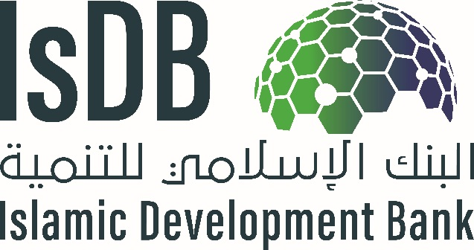

# Project Preparation Report Template

**PROJECT TITLE”**

**Project Number:** “Insert the Project Code”

**Country:** “Insert the Name of the Country”

**Department:** “Insert Department in charge of project”

**Acronyms and Abbreviations**

**Glossary**

**Currency and Measurement Conversions**

**Key Stakeholders and Focal Points**

|  |  |  |  |
| --- | --- | --- | --- |
| **Name** | **Designation** | **Contact No** | **Email** |
|  |  |  |  |
|  |  |  |  |
|  |  |  |  |
|  |  |  |  |
|  |  |  |  |
|  |  |  |  |
|  |  |  |  |
|  |  |  |  |
|  |  |  |  |
|  |  |  |  |

[4]

Date of Study:

Dates of Field Visits and Stakeholder Consultations:

**Name of the Project, Country**

1. **Strategic Context**

The annotation for this document is for guidance only, please remove it in the final document.

This section will include a narrative in the following sub-sections that will describe in summary the context and rationale for developing the project and seeking financing from IsDB:

**Brief Project History:**

1. Provide information relevant to the origins of the project, including the following:
   * Timeline towards conceptualization, development, preparation and appraisal of the project
   * Approval and endorsement of the project by different government authorities
   * Internal processes undertaken to clear/ endorse the project concept and feasibility study
   * Additional steps to be undertaken for clearance of the feasibility study by relevant country authorities and its inclusion in countries investment program for the year
   * Participatory approach used in preparing the project (consultations/ interactions with stakeholders and its outcomes)
   * Documents, studies, consultations and information on the basis of which the feasibility is prepared.

**Other Similar Projects Planned or Already Undertaken in the Country and their Performance:**

1. Provide a brief description of other similar projects undertaken in the country with specific reference to their current status, financing, and performance.

Suggested table as follows:

Country Sector

|  |  |  |  |  |
| --- | --- | --- | --- | --- |
| **Source of Funds** | **Project Name** | **Key Dates**   1. **Approval** 2. **Completion** | **Amount (US$ m eq.)** | **Status**  **Ongoing or Completed and other details** |
|  |  | a.  b. | a.  b. |  |
|  | a.  b. | a.  b. |  |
|  | a.  b. | a.  b. |  |
|  | a.  b. | a.  b. |  |
|  | a.  b. | a.  b. |  |
|  | a.  b. | a.  b. |  |

*Provide additional information in* ***Annex if needed.***

**Project Context:**

***Sector Context:***

1. Provide a brief description of sector context relevant to the project, including the following:
   * Description of the salient features of the sector in the country, and its potential/opportunities
   * Details of the sector situation and performance in the country, supported by recent statistics
   * Relevant sector policies of the country
   * Explanation of key sector issues/challenges/major constraints hindering the growth of the sector in the country that will be addressed as part of the proposed project
   * Possible solutions for addressing these constraints
   * Government strategy/ policies for development of the sector
   * Interventions by other Development Partners (DPs) helping to improve this sector in the country / address sector challenges.

*Provide additional information in* ***Annex if needed***.

***Thematic Context:***

1. Provide a brief description of the thematic context, including the following thematic considerations: include relevant information on women and youth empowerment strategies in the country in general, and the sector of the project in specific.

**Alignment with Government Strategy:**

1. Provide a brief description of the alignment of the project with the Government country and sector Strategy, covering the and how it will help achieve the SDGs. Provide specific linkages with SDG indicators and government policy pillars which the project will directly address.
2. **Project Development Objective and Rationale**

This section states the development objectives of the proposed project, including the key project results indicators and information related to target beneficiaries. The project objective should be outlined as:

1. Impact: Higher level contribution to government national strategy or sector strategy
2. Outcome: Specific objective the project will achieve directly after its completion and key indicators to measure that. The indicators should be “SMART” (see log-frame on relevant information required for each indicator)
3. Outputs: Key direct deliverables that will result through completion of project activities with SMART KPIs

Outline the direct beneficiaries in specific location and their socio-economic characteristics as well as indirect beneficiaries.

**Project Objectives:**

1. Include the project development objective (PDO) directly relevant to the issues being identified. While defining the PDO, the following are considered:
   * Problem Statement and problem tree: “What is the problem(s) the project is going to address?” This should be a critical constraint or a priority earlier mentioned in sector context. Presenting a problem tree is essential to show how the project (see project description) will address the sector constraint through project activities.
   * Linkage of Project Development Objective to Problem Statement and Country’s Development Goals / MCPS

NOTE: Project Development Objective is a clear, succinct and measurable objective statement.

Provide the project log-frame as below:

SMART and CREAM indicators are the following:

* *Specific* – stated clearly and relate to the results the project seeks to achieve.
* *Measurable* – can be monitored and provide verifiable data (quantitative)
* *Achievable* – are neither too ambitious nor too modest. The latter will call into question the planned investment.
* *Relevant* – useful for management information purposes.
* *Time-Bound*– stated with target dates.
* *Clear* – precise and unambiguous.
* *Relevant* – appropriate and timely.
* *Economic* – the data is available at reasonable cost.
* *Adequate* – sufficient to assess performance (in order to reduce the number of indicators for a given result).
* *Monitorable* – can be independently verified.

|  |  |  |  |  |  |
| --- | --- | --- | --- | --- | --- |
| Country and Project Title:  Project Purpose: | | | | | |
| Narrative Summary | Performance Indicators | | | Means of Verification | Assumptions |
| Indicator | Baseline | Target |
| Impact(s) |  |  |  |  | Sustainability assumptions |
| Outcome(s) |  |  |  |  | Country effectiveness assumptions |
| Outputs |  |  |  |  | Project effectiveness assumptions |
| **Key Activities**  Component 1:  Component 2:  Etc. | Inputs  Component 1:  Component 2: (etc.) | | |  | Project implementation assumptions |

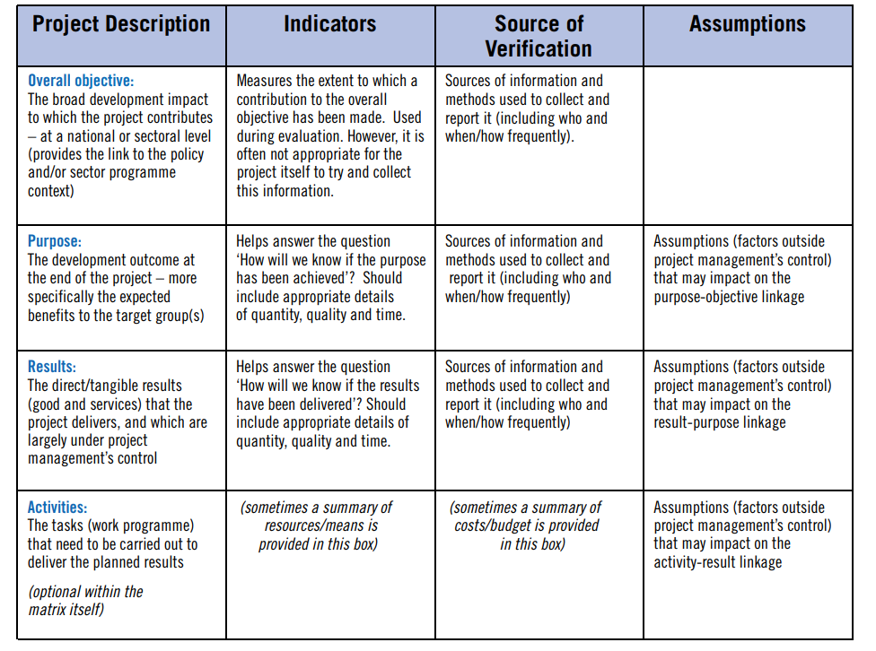

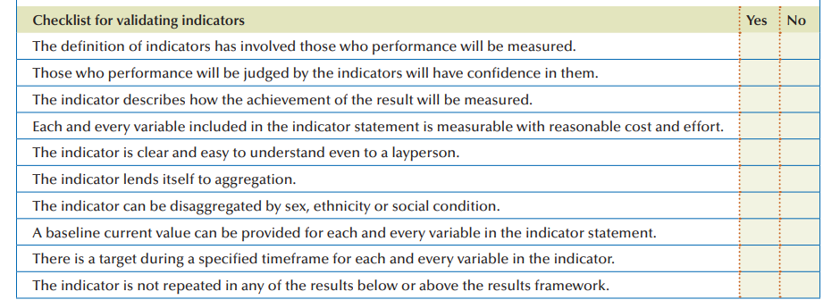

**Project Location:**

1. State the location of the project site (s), region/ provinces, highlighting the access to the project site, the overall commination mechanisms, i.e., access to road, rail, etc. and distances from the main cities/ airports. Any other socio-economic and logistical indicators relevant to project implementation. Also indicate if the land is available or steps to be undertaken to ensure project location is available to start the project with timelines.
2. Provide the **Project Location Map(s)**

*Provide additional information in* ***Annex if needed****.*

**Project Beneficiaries and Stakeholder Consultations:**

1. State the target beneficiaries (age and gender disaggregated), direct and indirect, of the project. Moreover, provide information about ownership by national stakeholders (govt ministries and other stakeholders) and beneficiary groups evidenced through consultations with key project stakeholders and participatory processes that were held during the design and preparation stages of the project. The consultation modalities should be briefly outlined for the various types of stakeholders involved. Key findings of the consultations, and concerns raised by beneficiary groups, especially women, youth and vulnerable groups of the population, should be presented. Further concerns of any stakeholders which may not support the project should also be noted. Lastly, the priorities or consultations with direct beneficiaries of the project, including private sector that will utilize project facilities should be outlined clearly. Provide stakeholder analysis table summary below:
2. Stakeholders Chart

|  |  |  |  |  |  |  |
| --- | --- | --- | --- | --- | --- | --- |
| Diagnostic Phase | | | | | Design Phase | |
| (1)  Stakeholder  Group | (2)  Interests | (3)  Problems Perceived | (4)  Resources/ | (5)  Mandates | (6)  Interest in the Project (proposed or underway) | (7)  Force-field Analysis |
|  |  |  |  |  |  |  |
|  |  |  |  |  |  |  |
|  |  |  |  |  |  |  |
|  |  |  |  |  |  |  |
|  |  |  |  |  |  |  |

**Rationale for Seeking IsDB Financing for Investing in the Project:**

1. State the rationale for proposed IsDB financing, including the following:
   * Rationale for Country and Sector Support: Key development country / sector issues addressed by the project. This should be linked to sector/ country context.
   * Alignment with country’s development strategy / priorities and sector-specific strategy and the basis for the project being a high priority for the country,
   * Alignment with policies/activities of the government and other DPs who are also working in the sector.
   * Alignment with SDGs
2. **Project Description**

This section includes a description of the core of the project, including the project’s scope, components, financing plan and reflects lessons learned within project design. This is the MOST important section of the feasibility study,

**Project Design and Scope/Components:**

1. Provide a brief description of what the project entails, including the proposed project design, different project components covering all categories of expenditures, i.e., Works, Goods and Services. It should include:
   * civil works
   * equipment
   * consultancies
   * training and capacity building
   * project management arrangements
   * audit arrangements
   * any other activities which are part of the project scope

It should cover detailed information on technical aspects of the project clearly indicating all activities which will be undertaken within the project scope to achieve the project results.

1. Provide the results tree linking project components with project objective. It will be directly linked with project problem tree presented earlier, to show how the project components will address some of the problems to achieve the project objective. A sample of project problem and results tree are presented below.

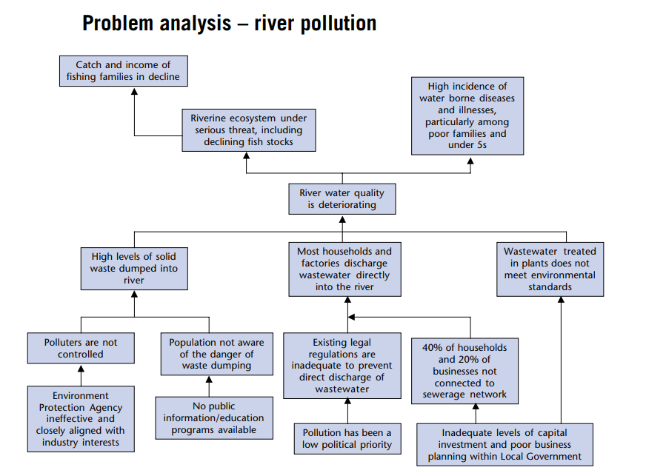

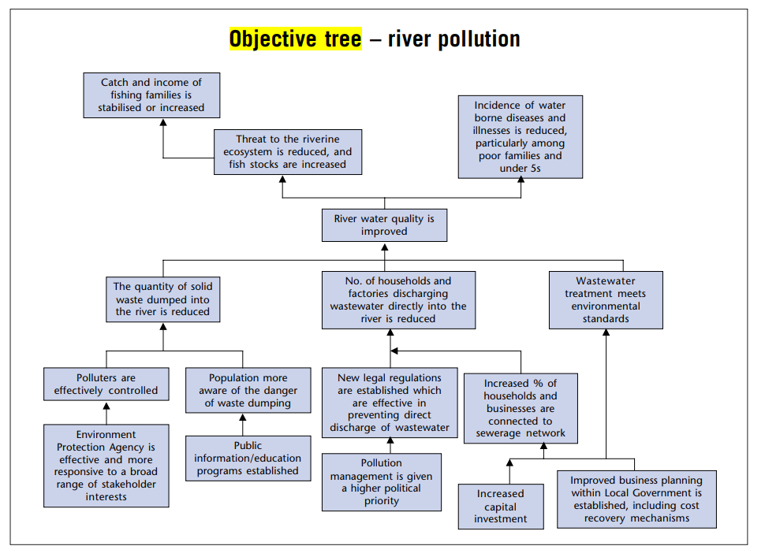

*Provide additional information in* ***Annex if needed***

**Past Lessons Learned and Reflected in Project Design:**

1. Provide a brief description of how the project design reflect on the lessons learned from on-going/completed projects by the country, and known best practices, including the following:

* Lessons learned from executing agency past projects, especially with other MDBs.
* implementation issues and current experience of Executing Agency in implementing such projects.
* Experience of implementing similar projects in other countries and lessons from those.
* Various remedial/mitigation measures proposed in the project to overcome issues faced during design and implementation of previous projects.
* Indicate in tabular form how each of the project lessons have been addressed in the project design.

1. **Project Thematic Orientation**

This section will include a discussion of the project’s orientation towards the Bank’s thematic areas.

**Climate Change:**

1. Provide a brief on integration of climate considerations in the project, including the following:

* Project Potential Contribution to Climate Adaptation, Mitigation, and Resilience
* Project Climate co-benefits
* Project Climate Finance share
* Project linkage to NDCs, NAPs, NAMAs or other climate relevant SDG goals
* Indicate clearly how the project design takes adverse climate implications into account and how the project contributes to climate adaptation, mitigation or building resilience as well as to countries climate and environment strategy. Also indicate how the negative climate impacts will be addressed during implementation.

**Women and Youth Empowerment:**

1. Provide a brief on the analysis on women and youth empowerment, fragility and employment generation (where applicable) and how that is integrated in the project design. Demonstrate how concerns raised by beneficiary groups, especially women and youth, are reflected in the design of the proposed project. This section should specifically indicate how the women and youth will be engaged in project implementation and benefit from its results. What is the project doing to ensure that these outcomes are achieved.
2. **Project Cost and Financing Plan**

This section includes the project cost and financing plan information.

**Project Costs:**

1. Provide an item-wise project cost estimate in detail in the table in local and foreign currency (US$ equivalent). Local currency items are those which are expenses that will be made in local currency, while foreign currency items are those which are imported to implement the project. This should not include any operational expenses and only expenses to be incurred to complete the project investment. Provide breakdown where necessary through additional tables for specific activities. BOQ and TOR based tables where applicable for specific activities should be separately provided in addition to overall project table.
2. Outline all key assumptions and sources used in calculation of costs

|  |  |  |  |  |  |
| --- | --- | --- | --- | --- | --- |
| **Sr. No.** | **Project Component** | **Category of Expenditure** | **Local Cost** | **Foreign Cost** | **Total Cost** |
|  |  |  |  |  |  |
|  |  |  |  |  |  |
|  |  |  |  |  |  |
|  |  |  |  |  |  |
|  | Base Cost |  |  |  |  |
|  | Contingency (Physical) |  |  |  |  |
|  | Contingency (Financial) |  |  |  |  |
|  | Total Cost |  |  |  |  |

Provide detailed cost and resource schedule. Template is below:

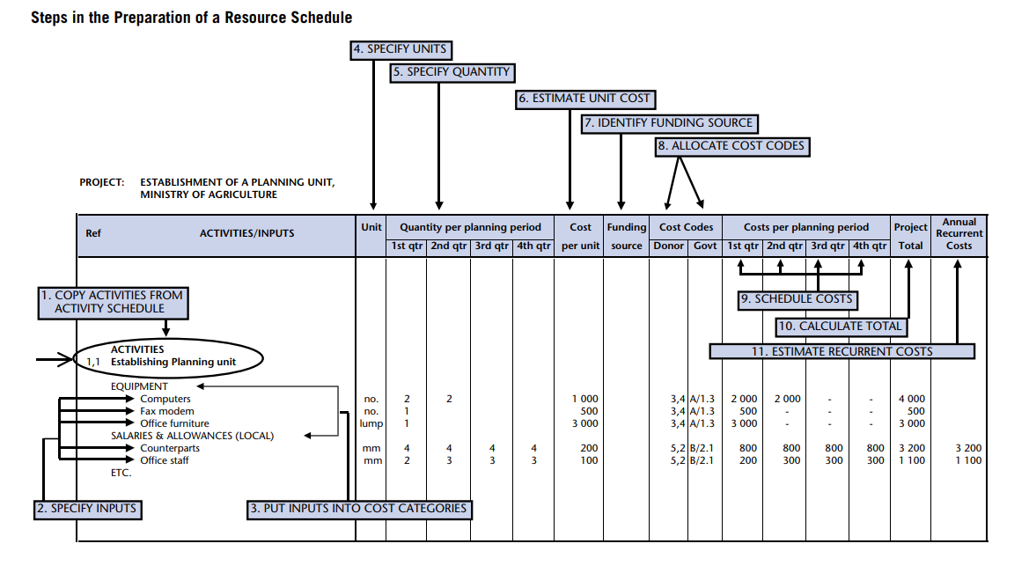

**Proposed Financing Plan:**

1. Provide the proposed project financing plan which shows the suitable mode of financing and the various sources of funds for each project component in project currency

*Provide additional information in* ***Annex if necessary****.*

|  |  |  |  |  |  |
| --- | --- | --- | --- | --- | --- |
| **Sr. No.** | **Project Component** | **IsDB** | **Co-Financiers** | **Government** | **Total Cost** |
|  |  |  |  |  |  |
|  |  |  |  |  |  |
|  |  |  |  |  |  |
|  |  |  |  |  |  |
|  | Base Cost |  |  |  |  |
|  | Contingency (Physical) |  |  |  |  |
|  | Contingency (Financial) |  |  |  |  |
|  | Total Cost |  |  |  |  |

1. **Implementation Arrangements**

This section includes a description of the project’s implementation arrangements. It should be clearly developed with sufficient detail.

**Executing Agency / Agencies (EAs):**

1. Provide a brief description of the suitability of the Executing Agency (main agency that will oversee the project implementation) / Agencies, including the following:

* Identification of the suitable EA and Implementing agency (if different from executing agency or if more agencies are involved or specific departments within the implementation agency)
* Listing the main Responsibilities / Functions of EA and IA, including the effect/ collaboration of other institutions/ ministries on these roles
* Project implementation capacity of EAs: Staffing of EA, prior experience of EA(s) of working on similar projects, same location/area, IsDB in particular and other MDBs and DFIs in general, and the brief on the status of those projects / programs;
* Assessment of agencies capacity, experience and skills to manage project implementation from a technical, financial and procurement standpoint, and adequate capacity-building measures (if needed) that are built in the design of the operation. The specific capacity building needed should be included in project components.
* Assessment of adequacy of operational rules, regulations, procedures and staff incentives that will enable the agency/ies to successfully implement and later operationalize the project.
* Assessment of financial management systems and capacity of the EA/ IA and their systems in the area of planning and budgeting, management and financial accounting, reporting, auditing, and internal controls for efficient project implementation and sustainability.

*Provide additional information in* ***Annex if needed****.*

**Institutional Arrangements:**

1. Provide a brief on the institutional arrangements (exact description of who will manage the project implementation and decision making roles on day to day basis) for project implementation and the required reporting structure, including the following:

* Overall governance and project management structure/ organizational chart for Project Implementation with all relevant stakeholders / institutions clearly identified and their roles/ responsibilities listed clearly. Organogram for project implementation setup
* Project Management Unit (PMU): Mention where the PMU is housed, including its main responsibilities, experience, reasons for selecting particular type of PMU structure, financing of PMU and Budget / capacity building needs of the PMU
* Structure of PMU: Staff composition of PMU and their roles, reporting structure, and coordination requirements
* Project Implementation Unit (if required): Mention location (s), staffing budget, and the TOR, etc.
* Project Implementation Consultant(s) if needed: provide the reasons and corresponding ToR
* Staffing of the Project Management / Implementation Unit and Implementation Consultants (if any) along with their intended TORs

*Provide additional information in* ***Annex if needed****.*

**Implementation Plan and Project Readiness:**

1. Provide a brief on the status of project readiness, including the following:

* Project implementation plan / chart by key project components: This indicates the estimated time / schedule / timeline for project implementation, kind of works that have already been completed or commenced, and key implementation milestones (key implementation dates). This should accompany a Gantt chant with clear activities in detail. Example of part of the gantt chart is below:

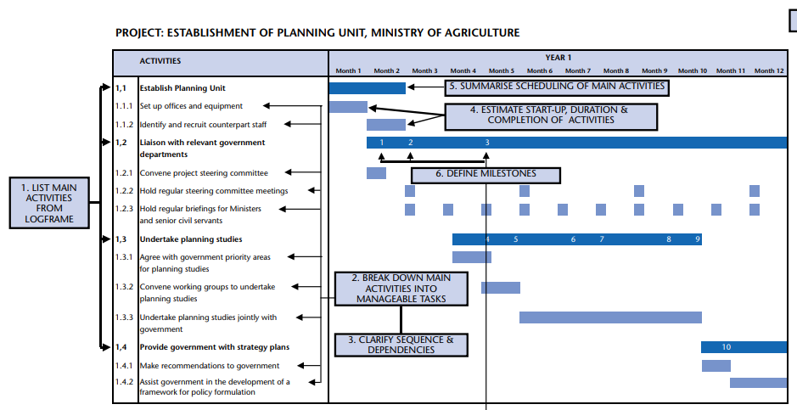

* Presentation of modalities for the participation of national stakeholders and beneficiary groups during implementation, including CSOs and beneficiary groups, who will be involved in the implementation of the proposed intervention and analyzing its results.
* Project Readiness: This can be indicated by answering the following questions:
  + What is the status of project design/bidding documents for the first-year implementation program?
  + What is the status of readiness of specifications or the timeline to do that and who will do it
  + What is the status of PMU, i.e. is it in-place and staffed? and timeline for that (should also be reflected in Gantt chart above
  + Are the required physical facilities – land, utilities etc. available?
  + Is Counterpart funding available?
  + is government approval obtained on FS or timeline to obtain that
* Measures, if any, to fast-track implementation (as part of implementation strategy)

*Provide additional information in* ***Annex if needed***

1. **Project Results and Monitoring**

This section includes a description of the project results and monitoring and evaluation (M&E) framework.

**Key Development Results Indicators:**

1. Include a summary of development results that the project will deliver in line with its objectives, with clearly defined cause-and-effect relationship all along the result chain, i.e., inputs, activities, outputs, outcomes and impact. The development results will include outputs, outcome(s) and impact with the associated SMART results indicators.

Provide *additional information in* ***Annex if needed****.*

**Monitoring and Evaluation of Outcomes/Results:**

1. Provide a brief description of project’s M&E framework, including the following:

* Monitoring and evaluation framework to track inputs, outputs and outcomes and evaluate the project results. The framework must be accompanied by SMART results indicators, with appropriate baseline and target values, and the corresponding sources of information for verifying them.
* Roles and responsibilities for monitoring results indicators during implementation
* Mechanisms used for Project Monitoring and Evaluation: it will include a summary of the mechanism agreed with the PMU/PIU to submit to IsDB the status of implementation, achievement on outputs and outcomes indicators and actions taken to ensure satisfactory project implementation.

**Project Monitoring and Implementation Supervision Plan:**

1. Provide a brief overview of the mechanisms for project’s progress monitoring and progress reporting, including the following:

* Provide a project results monitoring plan covering key objective, KPIs, source of information, frequency of information collection, responsible party to collect the information, cost of information collection, storage and compiling of information, MIS to be used etc.
* Arrangements for coordination and exchange of information amongst the key stakeholders (government, implementing entities, consultants, contractors, IsDB and the co-financiers, if any), with responsibilities clearly assigned
* Assessment of the capacities of the execution and implementing agencies to fulfill IsDB’s information needs and reporting requirements, related to reporting on project implementation, KPIs, procurement, financial management and risks
* Information on the agreed Project achievements (including key milestone dates, PIASR frequency, trigger for the Mid Term Review)
* M&E reporting requirements.
* Type of activities, tools and mechanisms used for supervising, monitoring and reporting progress:
  + Reports submitted by EA / PMU to IsDB: Frequency / schedule of submission, contents of the report outlining project progress achievements, financial progress, procurement plan progress, problems encountered, and mitigation actions
  + Project Start-Up Workshop: Purpose and scope, location
  + Project Supervision Missions by Senior EA staff
  + Mid-term review: agreement on the milestone to launch the review to assess the overall performance of the Project and gap analysis to identify if any improvements are needed

*Provide additional information in* ***Annex if needed****.*

1. **Project Risks and Sustainability**

This section includes description of the project risks and project sustainability.

**Project Risks:**

1. Provide a brief description of the potential risks associated with the project, the impact of the risk proportional to its severity, likelihood of the identified potential risks, and the proposed / existing mitigation measures including responsible party to manage it during implementation and upon completion, including the following:

* The Project Risk Matrix: Identify all the potential risks associated with the project (with specific emphasis on project sustainability), assess and assign a risk rating to each risk, and provide an explanation for the risk rating considering the severity/ impact of risk, likelihood of the risk. This will identify the overall risk rating of the project. **The risks should be assessed both from the lens of these factors impact on project as well as how the project itself increases these risks.**  The risks can either be things that can “go wrong” in the project compared to plan during implementation and operations or “any outcome worse then what was targeted in the results matrix”. Ideally, the impact of most severe risks should be quantified, while others can be qualitatively assessed. The risks are identified related to the following categories
  + Stakeholder Risks: This includes risks related to Counterpart, Co-financiers, Beneficiary, Contractors/Suppliers
  + Country Risks: This includes risks related to Political/Security, Economy and Legal Risks.
    - *Economic risks: how will macroeconomic situation impact the project during implementation and operations. What macroeconomic assumptions are made and why? How can the impact of economic growth, inflation, tax or subsidies, government policies be made favorable to increase project success? Can the impact of these risks be reduced?*
    - *Economic Resilience: Vulnerability of project to world events; impact of project on increasing economic vulnerability.*
    - *Site availability and permits from various agencies*
    - *Political Risks: This includes continued support from beneficiary/ government for project; change in government or key ministries or its structure; change in operating laws or regulations; war/ unrest; nationalization risk for potential beneficiaries which may invest after project completion; FOREX and capital flows laws; currency controls and exchange rate controls.*
    - *Legal and Policy Risks: Change in statute- taxes, environmental laws, employment laws, investment laws, H&S standards, change in strategy or sector policy etc that impact project during implementation and operations.*
    - *Pandemics that could impact pace of work.*
  + Economic and Financial Risks: This includes assessment of the following:
    - *Demand risk: how much demand is present for project goods/ services. Is the market growing or shrinking; what are local, regional and global trends? What are the alternative markets available. What alternate products can be produced if market for one product shrinks? What is the possibility or available off-taker agreements? What marketing strategies and consumer segmentation strategies can be used (different regional markets or different product categorization for example?)? What subsidies will be provided and what cost they will entail to government?*
    - *Price Risk: Are prices for products or services offered by project reasonable? How much can market price vary for inputs and outputs? How volatile are the prices? can the prices be locked or long-term agreements to secure prices available in any market? how much market power would project have in determining prices? Is there a govt set price? Are there subsidies available or required and how do they distort the market? Are prices determined locally or internationally? What is the ability to pass through inflation through high prices?*
    - *Product Differentiation/ Competition: Is the service or product different from what is available in the market. Is the market competitive. Who gets the margins and how can they be maximized for targeted beneficiaries. Is the product solely provided by the project or government or other entity. What risks or benefits that entails? How will the product market change, competitors react or impact on behaviour of other providers of same products and services? Does the project “crowd-out” private suppliers market? Are their markets for “special” products such as organic production? Is country member of such agreements which offer access to these markets?*
    - *Counter party or consumer risks: Can consumers pay for the product/ service. Do they have capacity or credit worthiness? Are their guarantees (such as govt guarantees) available that minimize the risk? What mechanisms are available if counter party defaults?*
    - *Exchange rate risk: Is exchange rate risk significant. Is foreign currency available for operations? Will the counterparty be able to secure finance from market to buy the offered product and service?*
    - *Resourcing Risks: Can the required materials, labor and other inputs to project during investment and operation be obtained at reasonable cost and time.*
    - *Financing Risk: is there a gap in project financing. What are the risks to obtaining the financing at reasonable rate and what alternates are available for cheaper financing? How will co-financiers engagement increase or change project risks and returns?*
    - *Volatility: how volatile the project cash flows are and what mitigation are available?*
  + Social Risks: This includes assessment of the following risks:
    - *Environmental risks: the risks related to environmental hazards, environmental degradation, etc*
    - *Health risks: related to possible negative health impacts to project direct and in direct stakeholders.*
    - *Social unrest: such as widening social divides or possibility of creating conflict among different stakeholders.*
  + **Project Risks:** This includes risks related to Design, Operations, Accessibility, Sustainability/Results, and Project Procurement Risk
    - Operational risks, including:
      * *Capex Risk:* *capital expenditure risk (or cost overrun)- what if it costs more then estimated and what has been done to mitigate this. What will be done if there is cost overrun?*
      * *Design risk: will the project deliver the intended results/ will it produce the required outputs? Will it work as per expected standards of operations (capacity and quality)? Will the outputs lead to desired outcomes? Will the desired design be delivered?*
      * *Processing Risk: will the technology or any production process in the project be able to process inputs/ raw materials as envisaged? Is it robust? Can raw material/ input be varied and still lead to same results? How much do we need to control the inputs quality to achieve intended production results? Are their by-product markets or can services be provided for other purposes then intended?*
      * *Construction risk, related to risks of contractors to deliver the assets on time. Availability of service providers and their capacity.*
      * *Technological risk: Will the technology used work in the project context as intended? Do we have guarantees? Are their test runs or defect liability period? Who holds this risk.*
      * *Obsolescence risk: will the technology become obsolete before the intended project life? How can we leave possibilities for upgrades? How much investment is worth putting. How would new technology impact the project?*
      * *Volume risk: will the project solution(s) be able to deliver if scale changes? What would be the costs of such scale changes? How can we improve sustainability at low volumes? Can volume be scaled up or down quickly?*
      * *Input risks: Are relevant inputs available for delivery and operations of project. What happens if their price changes. Do we have supply guarantees?*
      * *Timing Risk: Delay in achievement of various milestones and overall completion and operational timelines.*
      * *Operations and maintenance risks including: (i) available capacity locally, (ii) available markets; (iii) costs and funding source; (iv) any subsidies available? (v) management structures?*
      * *Site risks: such as suitability of site for intended project activities. Initial assumptions about site don’t hold true.*
      * *Labor risk, such as non-availability of skills or labor strikes and wage disputes during implementation or operation.*
  + Executing/ Implementing Agency Risks: This includes risks related to Capacity, and Fiduciary Risks
    - *Adherence to IsDB procedures*
    - *Capacity of EA to implement the project on time.*
    - *Financial mis management.*
* Defining Risk Mitigation Measures with clear Responsibility for each risks in the Risk Matrix: Determine appropriate response strategies and actions for each individual risk
* Risk Management Plan: Highlight the plan and mechanism to monitor the identified high impact risks during implementation of the project for overall project risk mitigation

*Provide Risk Matrix as below:*

|  |  |  |  |  |  |  |  |
| --- | --- | --- | --- | --- | --- | --- | --- |
| Risk Category | Risk | Risk Impact Level | Likelihood | Mitigation Measure | Risk Impact after Mitigation | Responbile to manage | Risk management strategy |
|  |  |  |  |  |  |  |  |
|  |  |  |  |  |  |  |  |
|  |  |  |  |  |  |  |  |
|  |  |  |  |  |  |  |  |
|  |  |  |  |  |  |  |  |
|  |  |  |  |  |  |  |  |

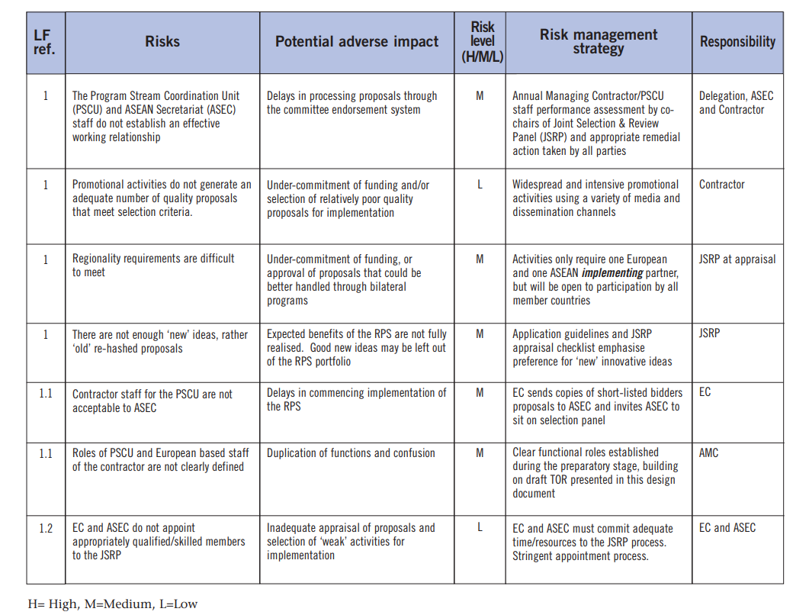*.*

**Project Sustainability:**

1. Taking into account the various risks and mitigation measures identified in the Project Risk Matrix, provide a general summary of the effectiveness of the measures to ensure sustainability of the proposed intervention with respect to the following dimensions:

* **Economic Sustainability:** It addresses the economic effectiveness and expected economic impacts of this project over its life cycle. It should assess the impact of the project on economy and sector as well as associated costs to economy. Economic sustainability also entails potential wider economic benefits that may not be captured through the EIRR and how they will lead to sustainability of project results.
  + **Social Sustainability:** It describes how the project would impact the poor, vulnerable groups and some target groups such as youth, women, and how the project would strengthen social cohesion and enhance social inclusiveness. It also entails any impacts that the project may have on the safety and security of the people in addition to any other socio-economic impacts it may have (such as new employment opportunities). It should demonstrate the positive and negative impacts of the project on social structure and whether that would lea to continuation of project benefits or risk its sustainability. Conduct distribution analysis covering: (i) Which group benefits and loses. ; (ii) Is it in line with the targeting. (iii) What kind of incentives and disincentives are created as a result of this and is it assessed in the risk and assumption analysis.
* **Environmental Sustainability:** It describes the entire life cycle of the project (construction, maintenance, and operation) and its impact in each of these stages on the surrounding environment as reflected by the Environmental and Social Impact Assessment (ESIA). It also takes implementation of the Environmental and Social Management Plan (ESMP) into account. In addition, resilience of the project to the long-term risks from climate change (climate change resilience) may also be highlighted in this section.
* **Operational Sustainability:** It is a cross-cutting criterion that addresses some of the main weaknesses usually found in projects, namely: i) Operation and Maintenance (including setup and budget availability); ii) Institutional Capacity, and Regulatory Framework and government support; iii) Resilience of the project results and Implementation to exogenous factors (i.e., resilience to risks).

1. Particular importance is to be made on the mechanisms agreed that allow local stakeholders to provide feedback and to monitor implementation of such mechanisms.
2. **Project Feasibility**

This section assesses the feasibility of the various aspects of project

**Technical and Operational Feasibility:**

1. Provide an assessment of the technical and operational feasibility of the project, outlining how the project achieves to answer the following questions. **This not a YES or NO answer but should be detailed assessment substantiated by relevant evidence and information. This needs to be very detailed to allow IsDB to assess the project feasibility independently:**

* Will the technical solution/ design of overall project proposed address the key problem being addressed and development objective being achieved?
* How does project address the sector binding constraints (regulatory, infra or policy related).
* What is the performance of the Public entity providing services, its management and government finances for the sector and entity.
* How does the project contribute to demand, affect cost, promote technology.
* What are the new investments expected in sector and how will they impact project.
* Is project the best way to address the issue.
* What are the government interventions (taxes, subisidies, price controls etc) that support or hinder the project results.
* Demand – supply analysis of the sector and other sources of supply.
* What is the Government sector development plan and how will it impact the project deliverables.
* How well proven the proposed design solution is in other projects/ countries.
* What technology is proposed and what pros and cons it has. Has it been tested elsewhere?
* What are the assumptions within which the proposed solution will operate? How well can it operate if assumptions don’t realize?
* How well can the technology operate in different circumstances.
* What is the capacity available locally or internationally to implement the proposed solution.
* What kind of operational expenses, equipment, other resources will be needed in implementation and during operations? Are they available? Who are the suppliers for these items/ resources/ technologies.
* What potential operational and managerial problems can be experienced in managing the provided assets as well as any key technology and equipment?
* How robust is the proposed solution to meet the demand of beneficiaries.
* How long and what key items would need to be replaced?
* Can the project be done within the planned cost and time and other resources?
* Is the technology adequate?
* ▪Upon completion, is the project capable of operating as planned?
* Does the country poses capacity (management, manpower etc) to implement and operate the project?
* Can the project sustain for its planned lifetime?
* Are implementation arrangements adequate to implement the project?
* Are post-project implementation mechanisms for operation adequate?
* How will the supervision consultants be engaged?
* What capacity building aspects have been included for successful implementation?
* Are operational risks, such as capital expenditure risk, design risks, processing risks, technology risks, obsolescence risks, volume risks, and input supply risks and their mitigation adequate? Assess the overall operational and technical risk.
* What other alternate design and technology alternates are available and why were they not considered?

**Economic and Financial Analysis and Feasibility:**

***Alternative Solutions:***  This section should outline key alternative solutions which have been rejected in favor of project design. The alternative solutions could entail different options in following areas:

* With or without project
* scale of project
* beneficiaries
* type of outputs/ services
* technology
* location
* starting date
* sequencing of components
* Implementation arrangement

***Financial Analysis and Feasibility:***

1. This section should provide the detailed description of the project’s financial analysis undertaken to determine its financial viability when compared to alternative project options. Provide the financial analysis of the project that answers the question, ‘Is the financial rate of return acceptable?’ Additionally, mention the key assumptions underlying the financial analysis, including the key risk factors based on the results of sensitivity analysis.
2. The financial analysis should take into account the various financial costs and benefits (at market prices), as follows:

* Revenues
* Operating Costs
* Capital Costs
* Working Capital

1. The financial analysis and feasibility should look at factors such as:
   * total production or marketable output/ services generated by the project, the amount/ volume of that output/ services
   * size and nature of the market where these outputs/ services will be sold. Who are the target consumers/ off-takers and what determines their demand; what is their socio-economic situation.
   * Demand for project services and price curve
   * Total demand and share taken by project
   * Impact of project on prices and tariffs.
   * Future growth trends of the market and what can terminate the demand. What are the competitive, social or political advantages that project produced services/ output has over alternates?
   * Impact of local and global macroeconomic situation on project finances and cash flows (both inputs and outputs), including economic growth, inflation, exchange rate, taxes and subsidies, trade regimes, labor laws etc.
   * Factors impacting the demand for the product in short term and over the project period
   * Price at which the products can be sold
   * Recent and long-term trends in pricing and what can impact that, both locally and globally depending on the projects products/ services.
   * Costs at which inputs are available and what are their cost determinants.
   * What are the prevailing price distortions and sources of distortions: Taxes/ price controls/ imperfect market.
   * Exchange rate movements and trends that could impact the project costs and prices
   * Possibility and nature of any “off-taker” agreements
   * Ability of consumers (or those paying on their behalf) to pay
   * cost for production/ investment over the project lifetime
   * Factors that impact the inputs availability and cost
   * CAPEX and OPEX costs determinants
   * Assessment of all financial and economic risks as stated in the risk section.
   * What guarantees, warranties and other securities are available that impact risks to cash flow.
   * Project reliance on FOREX and mechanism of its availability during investment and operations stages
   * If other co-financiers are involved, can the project be financed at reasonable rates. What alternate financing channels are available? Is the chosen financing best and most practical among various options available?
   * Is the FIRR of project comparable to other such projects locally or internationally?
2. Additionally, all the assumptions underlying the financial analysis must be clearly stated with appropriate reasoning.
3. The following financial indicators of the project should be used to determine the financial viability of the project:
4. Net Present Value (NPV)
5. Financial Internal Rate of Return (FIRR)
6. **Describe the results of project sensitivity analysis and identify the key risk factors that will have the maximum impact on the financial returns of the project. Key severe risks identified in the project risk matrix should be analyzed using sensitivity analysis to determine their impact on project FIRR as well as benefits.**

***Economic and Social Analysis and Feasibility (Separate Social Feasibility should be done when project is of “Social Nature”):***

1. This section should provide the detailed description of the project’s economic analysis undertaken to determine its economic viability when compared to alternative project options.
2. Provide the economic analysis of the project that answers the question, ‘Is the benefit/cost ratio for the country acceptable? and what Economic and developmental benefits are generated from the project, which may not be measurable. It covers the impact of the project on wider society and economy. It should incorporate benefits that associate to wider shareholders beyond the direct stakeholders such as project lenders, operators, and employees/ labor engaged. The economic feasibility should assess the project impact on:
   * Broad employment outcomes and multiplier effect of the project
   * Health outcomes
   * Educational and improved capacity outcomes
   * Growth of economy
   * Poverty reduction
   * Women empowerment
   * Improved governmental services.
   * environmental benefits
   * Additional tax revenue
   * Economic resilience and diversification
   * Increased forex or exports

It should also evaluate and analyze any negative impacts of the project and how they have been mitigated in project design, including:

* + Environmental degradation, hazards, habitat destruction
  + negative health outcomes such as accidents, health hazards during construction or operations for labor or community
  + impact of traditional lifestyle, culture or local population
  + Economic vulnerability such as making the economy more vulnerable to world economy downturn or global pandemics
  + Negative impact on balance of payments
  + Increased inequality
  + Increased vulnerability to any disasters or natural risks
  + Increasing social tensions among various groups

To the extent possible, the feasibility should quantitatively measure the project economic impacts quantitatively using best assumptions and expected impacts on these indicators. The details of environmental, social, gender and resilience should be thoroughly captured in relevant sections of the Feasibility Report. The summary of that assessment can be presented here.

1. This should yield cost-benefit ratio for the project by incorporating all costs and benefits of the project. **The cost-benefit analysis should be done for with and without project scenarios:**
2. Economic analysis also reflects the efficiency in which a project’s economic resources are used to deliver its outcomes, which is primarily measured by the economic internal rate of return (EIRR) of the project. This entails assessing alternate ways of resolving the problem. Additionally, mention the key assumptions and parameters used in the economic analysis.
3. The alternative analysis should be provided covering:
   * Is the project most efficient way of addressing the issue.
   * What other alternates are available and at what unit cost of output?
   * Is there a quality difference between outputs of different alternatives.
4. The economic analysis should take into account the various economic costs and benefits (valued in terms of shadow prices), as follows:

* Revenues
* Operating Costs
* Capital Costs
* Working Capital

1. Additionally, all the assumptions underlying the economic analysis must be clearly stated with appropriate reasoning.
2. The following financial indicators of the project should be used to determine the economic viability of the project in comparison to alternates (EIRR of other alternate should also be ideally calculated):
3. Economic Net Present Value (NPV)
4. Economic Internal Rate of Return (EIRR)

**Annex-2**



# Project Appraisal Document (PAD)

**“PROJECT TITLE”**

**Project Number:** “Insert the Project Code”

**Country:** “Insert the Name of the Country”

**Department:** “Insert Department in charge of project”

**Regional Hub:** “Insert Regional Hub in charge of project”

**Date of Submission:** “Insert the date of Submission”

**Acronyms and Abbreviations**

**Glossary**

**Currency and Measurement Conversions**

**Project Team Members**

|  |  |  |  |
| --- | --- | --- | --- |
| **Name** | **Designation** | **Signature** | **Date** |
|  |  |  |  |
|  |  |  |  |
|  |  |  |  |
|  |  |  |  |
|  |  |  |  |
|  |  |  |  |
|  |  |  |  |
|  |  |  |  |
|  |  |  |  |
|  |  |  |  |

**[5]**

Date of Preparation Mission (if applicable):

Date of Appraisal Mission:

Date and Venue of Negotiations:

1. **Table of Contents**

**A.**

**Strategic Context**

1. Brief project history

2. IsDB Operations in the Country and Portfolio Preface

3. Project Context

4. Alignment with IsDB Strategy

**B.**

**Project Development Objective and Rationale**

1. Project Objectives

2. Project Location

3. Project Beneficiaries and Stakeholder Consultations

4. Rationale for IsDB involvement

**C. Project Description**

1. Project Design and Scope/Components

2. Past Lessons Learned and Reflected in Project Design

**D. Project Thematic Orientation**

1. Climate Change

2. Women and Youth Empowerment

3. Fragility and Conflict Sensitivity Analysis:

4. Disaster Risks Management Analysis:

**E. Project Cost and Financing Plan**

1. Project Costs

2. Proposed Financing Plan

**F. Implementation Arrangements**

1. Executing Agency / Agencies (EAs)

2. Institutional Arrangements

3. Implementation Plan and Project Readiness

4. IsDB Project Monitoring and Implementation Support Plan

**G. Fiduciary Due Diligence**

1. Procurement Arrangements

2. Project Financial Management and Audit Arrangements

3. Project Disbursement Arrangements

**H. Project Results and Monitoring**

1. Key Development Results Indicators

2. Monitoring and Evaluation of Outcomes/Results

**I. Project Risks and Sustainability**

1. Project Risks

2. Project Sustainability

**J. Project Justification**

1. Technical Feasibility

2. Economic and Financial Analysis

**K. Conditions of Financing**

1. **List of Technical Annexes**
2. **Results Framework and Monitoring (Results Based Logical Framework)**
3. **Project Location Map(s)**
4. **List of related projects financed by IsDB and/or other agencies**
5. **Country and Sector Context / Background**
6. **Detailed Project Description**
7. **Climate Change Mainstreaming and Risk Rating**
8. **Project Costs / Detailed Financing Plan**
9. **Implementation Arrangements / Progress Reporting**
10. **Procurement Arrangements**
11. **Project Financial Management**
12. **Project Disbursement Arrangements**
13. **Project Risk Matrix**
14. **Economic and Financial Analysis**
15. **Terms and Conditions of Financing**
16. **System Generated Basic Project Data Sheet**

**Name of the Project, Country**

1. **Strategic Context**

The annotation for this document is for guidance only, please remove it in the final document.

This section will include a narrative in the following sub-sections that will describe the context and rationale for IsDB to provide its financing to the Beneficiary Country for the proposed project:

**Brief Project History:**

1. Provide information relevant to the origins of the project, including the following:
   * Timeline towards development, preparation and appraisal of the project
   * Participatory approach used in preparing the project (consultations/ interactions with stakeholders and its outcomes)
   * Documents on the basis of which the PPR/PAD is prepared, such as the date of receipt of official request from the beneficiary country, inclusion of project in work program, feasibility study, field mission(s) etc.

**IsDB Operations in the Country and Portfolio Preface:**

1. Provide a brief description of IsDB country and sector portfolios analysis and performance in the country with specific reference to pre-effective and post-effective portfolio, disbursements and CUC.

*Provide additional information in* ***Annex-3****.*

**Project Context:**

***Country Context:***

1. Provide a brief description of the country’s context (limited to last five years), including the following:
   * Country Economic Situation and Recent Economic Performance: include information related to GNP/GDP, growth rate trends, drivers of growth or deceleration, highlights of fiscal and monetary policy
   * Poverty Profile of the Country: include information about poverty rate and changes over time reflected by indicators such as Human Development Index etc.
   * Country Development Strategy and Challenges: include relevant information on the development plan adopted by government, pillars, objectives, and commitment towards achieving SDG targets
   * Other major Development Partners in the country: include the donor density information in the sector of focus, including their portfolio size and performance.

*Provide additional information in* ***Annex-4***.

***Thematic Context:***

1. Provide a brief description of the thematic context, including the following thematic considerations: include relevant information on women and youth empowerment strategies in the country in general, and the sector in specific.

*Provide additional information in* ***Annex-4***.

***Sector Context:***

1. Provide a brief description of sector context relevant to the project, including the following:
   * Description of the salient features of the sector in the country, and its potential/opportunities
   * Key sector issues/challenges/major constraints hindering the growth of the sector in the country
   * Possible solutions for addressing these constraints
   * Interventions by other Development Partners (DPs) helping to improve this sector in the country / address sector challenges.

*Provide additional information in* ***Annex-4***.

**Alignment with IsDB Strategy:**

1. Provide a brief description of the alignment of the project with the IsDB Strategy, covering the P5P, 10YS and the focus of the Bank towards SDG.
2. **Project Development Objective and Rationale**

This section states the development objectives of the proposed project, including the key project results indicators and information related to target beneficiaries.

**Project Objectives:**

1. Include the project development objective (PDO) directly relevant to the issues being identified. While defining the PDO, the following are considered:
   * Problem Statement: “What is the problem(s) the project is going to address?”
   * Linkage of Project Development Objective to Problem Statement and Country’s Development Goals / MCPS

NOTE: Project Development Objective is a clear, succinct and measurable objective statement

**Project Location:**

1. State the location of the project site (s), region/ provinces, highlighting the access to the project site, the overall commination mechanisms, i.e., access to road, rail, etc. and distances from the main cities/ airports.

*Provide additional information in* ***Annex-2****.*

**Project Beneficiaries and Stakeholder Consultations:**

1. State the target beneficiaries (age and gender disaggregated), direct and indirect, of the project. Moreover, provide information about ownership by national stakeholders and beneficiary groups evidenced through consultations with key project stakeholders and participatory processes that were held during the design and preparation stages of the project. The consultation modalities should be briefly outlined for the various types of stakeholders involved. Key findings of the consultations, and concerns raised by beneficiary groups, especially women, youth and vulnerable groups of the population, should be presented.

**Rationale for IsDB Involvement:**

1. State the rationale for proposed IsDB financing, including the following:
   * Rationale for Country and Sector Support: Key development country / sector issues addressed by the project
   * Alignment with country’s development strategy / priorities and sector-specific strategy and the basis for the project being a high priority for the country,
   * Alignment of IsDB involvement with policies/activities of the government and other DPs.
   * Alignment with IsDB Strategy: State the project linkages with IsDB’s strategic priorities, IsDB’s sector / thematic policy/ strategy, country’s MCPS and the SDGs.
2. **Project Description**

This section includes a description of the core of the project, including the project’s scope, components, financing plan and reflects lessons learned within project design.

**Project Design and Scope/Components:**

1. Provide a brief description of what the project entails, including the proposed project design, different project components covering all categories of expenditures, i.e., Works, Goods and Services.

*Provide additional information in* ***Annex-5****.*

**Past Lessons Learned and Reflected in Project Design:**

1. Provide a brief description of how the project design reflect on the lessons learned from on-going/completed projects, country analytical work and known best practices, including the following:

* Lessons learned from IsDB portfolio in the country (based on the evaluated projects, and most recent CPPR and project supervision reports), country and sector-related project design and implementation issues encountered in the past, experience of Executing Agency etc.
* Various remedial/mitigation measures proposed in the project to overcome issues faced during design and implementation of previous projects.

1. **Project Thematic Orientation**

This section will include a discussion of the project’s orientation towards the Bank’s thematic areas.

**Climate Change:**

1. Provide a brief on the results from application of the Climate Risk Screening tool on the project and integration of climate considerations in the project, including the following:

* Project Potential Contribution to Climate Adaptation, Mitigation, and Resilience
* Project Climate co-benefits
* Project Climate Finance share
* Project linkage to NDCs, NAPs, NAMAs or other climate relevant SDG goals

*Provide additional information in* ***Annex-6****.*

**Women and Youth Empowerment:**

1. Provide a brief on the analysis on women and youth empowerment, fragility and employment generation (where applicable) and how that is integrated in the project design. Demonstrate how concerns raised by beneficiary groups, especially women and youth, are reflected in the design of the proposed project.

**Fragility and Conflict Sensitivity Analysis:**

1. Provide context and situation analysis to drivers and causes of the risks and pressures conducted to address underlying causes of fragility and conflict and prevent future conflict by working on complex deep-rooted issues that drive fragility, such as patterns of exclusion, uneven distribution of project resources, results and impacts. Means to capitalize opportunities to prevent conflict and promote resilience are identified.

**Disaster Risks Management Analysis:**

1. Provide project’s potential impact on mitigating disaster risks and response in member countries that are prone to natural disasters needs to be carried out, to ensure that “development gains” from the Bank’s projects are sustainable to tackle potential disasters. This step needs to be included in relevant components of projects considering that vulnerability to natural hazards is complex one that have unique challenges, which require specific solutions.
2. **Project Cost and Financing Plan**

This section includes the project cost and financing plan information.

**Project Costs:**

1. Provide an item-wise project cost estimate in the table in local and foreign currency (US$ equivalent).

*Provide additional information in* ***Annex-7****.*

|  |  |  |  |  |  |
| --- | --- | --- | --- | --- | --- |
| **Sr. No.** | **Project Component** | **Category of Expenditure** | **Local Cost** | **Foreign Cost** | **Total Cost** |
|  |  |  |  |  |  |
|  |  |  |  |  |  |
|  |  |  |  |  |  |
|  |  |  |  |  |  |
|  | Base Cost |  |  |  |  |
|  | Contingency (Physical) |  |  |  |  |
|  | Contingency (Financial) |  |  |  |  |
|  | Total Cost |  |  |  |  |

**Proposed Financing Plan:**

1. Provide the project financing plan which shows the suitable mode of financing and the various sources of funds for each project component in project currency

*Provide additional information in* ***Annex-7****.*

|  |  |  |  |  |  |
| --- | --- | --- | --- | --- | --- |
| **Sr. No.** | **Project Component** | **IsDB** | **Co-Financiers** | **Government** | **Total Cost** |
|  |  |  |  |  |  |
|  |  |  |  |  |  |
|  |  |  |  |  |  |
|  |  |  |  |  |  |
|  | Base Cost |  |  |  |  |
|  | Contingency (Physical) |  |  |  |  |
|  | Contingency (Financial) |  |  |  |  |
|  | Total Cost |  |  |  |  |

1. **Implementation Arrangements**

This section includes a description of the project’s implementation arrangements.

**Executing Agency / Agencies (EAs):**

1. Provide a brief description of the suitability of the Executing Agency / Agencies, including the following:

* Identification of the suitable EA and IA
* Listing the main Responsibilities / Functions of EA and IA, including the effect of other institutions on these roles
* Project implementation capacity of EAs: Staffing of EA, prior experience of EA(s) of working on similar projects, same location/area, IsDB in particular and other MDBs and DFIs in general, and the brief on the status of those projects / programs;
* Assessment of agencies capacity, experience and skills to manage project implementation from a technical, financial and procurement standpoint, and adequate capacity-building measures (if needed) that are built in the design of the operation
* Assessment of adequacy of operational rules, regulations, procedures and staff incentives.
* Assessment of financial management systems and capacity of the EA/ IA and their systems in the area of planning and budgeting, management and financial accounting, reporting, auditing, and internal controls for efficient project implementation and sustainability.

*Provide additional information in* ***Annex-8****.*

**Institutional Arrangements:**

1. Provide a brief on the institutional arrangements for project implementation and the required reporting structure, including the following:

* Overall governance and project management structure / organizational chart for Project Implementation with all relevant stakeholders / institutions clearly identified
* Project Management Unit (PMU): Mention where the PMU is housed, including its main responsibilities, experience, reasons for selecting particular type of PMU structure, financing of PMU and Budget / capacity building needs of the PMU
* Structure of PMU: Staff composition of PMU and their roles, reporting structure, and coordination requirements
* Project Implementation Unit (if required): Mention location (s), staffing budget, and the TOR, etc.
* Project Implementation Consultant(s): provide the reasons and corresponding ToR

*Provide additional information in* ***Annex-8****.*

**Implementation Plan and Project Readiness:**

1. Provide a brief on the status of project readiness, including the following:

* Project implementation plan / chart by key project components: This indicates the estimated time / schedule / timeline for project implementation, kind of works that have already been completed or commenced, and key implementation milestones (key implementation dates)
* Presentation of modalities for the participation of national stakeholders and beneficiary groups during implementation, including CSOs and beneficiary groups, who will be involved in the implementation of the proposed intervention
* Project Readiness: This can be indicated by answering the following questions:
  + What is the status of project design/bidding documents for the first-year implementation program?
  + What is the status of PMU, i.e. is it in-place and staffed?
  + Are the required physical facilities – land, utilities etc. available?
  + Is Counterpart funding available?
* Measures, if any, to fast-track implementation (as part of implementation strategy)
* Project Effectiveness: Conditions of Financing for project effectiveness and agreement signing, and what happens if there is a delay in compliance?

*Provide additional information in* ***Annex-8****.*

**IsDB Project Monitoring and Implementation Support Plan:**

1. Provide a brief overview of the mechanisms for project’s progress reporting, including the following:

* Overall purpose of IsDB’s project monitoring activities and implementation support plan
* Arrangements for coordination and exchange of information amongst the key stakeholders (government, IsDB and the co-financiers, if any), with responsibilities clearly assigned
* Assessment of the capacities of the execution and implementing agencies to fulfill IsDB’s information needs and reporting requirements
* Type of activities, tools and mechanisms used for supervising, monitoring and reporting progress:
  + Reports submitted by EA / PMU to IsDB: Frequency / schedule of submission, contents of the report outlining project progress achievements, problems encountered, and mitigation actions
  + Project Start-Up Workshop: Purpose and scope, location
  + Project Supervision Missions by IsDB staff: Frequency of Project Implementation Assessment and Supervision Report (PIASR), scope and contents
  + Mid-term review: agreement on the milestone to launch the review to assess the overall performance of the Project and gap analysis to identify if any improvements are needed

*Provide additional information in* ***Annex-8****.*

1. **Fiduciary Due Diligence**

This section will include a brief on the project’s fiduciary requirements.

**Procurement Arrangements:**

1. This provides a brief analysis of the project’s procurement arrangements, including the following:

* Procurement Strategy: Highlight the strategy to ensure that capable key staff is in place to satisfactorily implement project procurement tasks. This entails taking into consideration the assessment of Procurement Capacity of Country and Executing Agency, while reflecting on IsDB’s previous experience on similar projects with the country and EA. Also assess procurement risks and mitigation measures, corresponding responsibility, and timeframes.
* Procurement Plan: Show the contracts required to be procured to implement the Project throughout its duration as a list of Indicative Procurement Packages for all IsDB financed items. This will also provide information about the procurement method, timelines, type (s) of contract(s) to be used, how vendors will be managed, and who will be involved at each stage of the process.
* Detailed justification for choice of Mode of Procurement & Method of Selection for all IsDB financed items.
* Procurement status of the project including the need for advance procurement (where applicable).

*Provide additional information in* ***Annex-9****.*

**Project Financial Management and Audit Arrangements:**

1. This provides a brief description of the project’s financial management arrangements, including the following:

* Assessment of EA’s Financial Management System: Verify the integrity of the financial management (FM) system of the EA, considering the areas of: (i) planning and budgeting, (ii) accounting; (iii) internal control; (iv) financial reporting; and, (v) external audit provisions.
  + Accounting: key accounting policies and procedures, financial information system, and staffing arrangements funds flow, accounting and auditing arrangements.
  + Internal control: the internal control system, including internal audit function.
  + Financial reporting: responsibility, reporting period / frequency, the type and format / contents of the audit reports to be submitted.
  + External oversight: external auditing arrangements, including the type of auditor, frequency of submission of reports. The arrangements should also present a financial management action plan that specifies the actions to be taken by the borrower to complete the arrangements based on the level of risk and weaknesses identified.
* Relevance of country public financial management system: if applicable, provide rationale for not using the country FM systems should also be provided.
* Describe Financial/Accounting Management Arrangements based on applicable accounting policies, procedures, and standards, for the project. Consider the following aspects:
  + Staffing arrangements
  + including the type of auditor (private firm, national audit institution or both)
  + IT Financial information system
  + Responsibility for financial reporting

*Provide additional information in* ***Annex-10.***

**Project Disbursement Arrangements:**

1. This provides a brief description of the project’s disbursement arrangements, including the following:

* Assessment of EAs capacity to manage funds flow and disbursements
* Disbursement process highlighting flow and processing of funds, including the responsibilities regarding initiating, review, clearance and approval of disbursement requests
* Tentative Project Disbursement Schedule
* Disbursement Methods: Modes of payments to various stakeholders for all activities; justification for the need for any Special Account (SA)

*Provide additional information in* ***Annex-11****.*

1. **Project Results and Monitoring**

This section includes a description of the project results and monitoring and evaluation (M&E) framework.

**Key Development Results Indicators:**

1. Include a summary of development results that the project will deliver in line with its objectives, with clearly defined cause-and-effect relationship all along the result chain, i.e., inputs, activities, outputs, outcomes and impact. The development results will include outputs, outcome(s) and impact with the associated SMART results indicators.

Provide *additional information in* ***Annex-1****.*

**Monitoring and Evaluation of Outcomes/Results:**

1. Provide a brief description of project’s M&E framework, including the following:

* Monitoring and evaluation framework to track inputs, outputs and outcomes and evaluate the project results. The framework must be accompanied by SMART results indicators, with appropriate baseline and target values, and the corresponding sources of information for verifying them.
* Roles and responsibilities for monitoring results indicators during implementation
* Mechanisms used for Project Monitoring and Evaluation: it will include a summary of the mechanism agreed with the PMU/PIU to submit to IsDB the status of implementation, achievement on outputs and outcomes indicators and actions taken to ensure satisfactory project implementation.

1. **Project Risks and Sustainability**

This section includes description of the project risks and project sustainability.

**Project Risks:**

1. Provide a brief description of the potential risks associated with the project, the impact of the risk proportional to its severity, likelihood of the identified potential risks, and the proposed / existing mitigation measures, including the following:

* The Project Risk Matrix: Identify all the potential risks associated with the project (with specific emphasis on project sustainability), assess and assign a risk rating to each risk, and provide an explanation for the risk rating considering the severity/ impact of risk, likelihood of the risk. This will identify the overall risk rating of the project. The risks are identified related to the following categories
  + Stakeholder Risks: This includes risks related to Counterpart, Co-financiers, Beneficiary, Contractors/Suppliers
  + Country Risks This includes risks related to Political/Security, Economic/Market, and Legal Risks
  + Project Risks: This includes risks related to Design, Accessibility, Sustainability/Results, and Project Procurement Risk
  + Executing/ Implementing Agency Risks: This includes risks related to Capacity, and Fiduciary Risks
* Defining Risk Mitigation Measures with clear Responsibility for each risks in the Risk Matrix: Determine appropriate response strategies and actions for each individual risk
* Risk Management Plan: Highlight the agreement reached with the Beneficiary Country to monitor the identified high impact risks during implementation of the project for overall project risk mitigation

*Provide Risk Matrix in* ***Annex-12****.*

**Project Sustainability:**

1. Taking into account the various risks and mitigation measures identified in the Project Risk Matrix, provide a general summary of the effectiveness of the measures by the stakeholders to ensure sustainability of the proposed intervention with respect to the following dimensions:

* **Economic Sustainability:** It addresses the economic effectiveness and expected economic impacts of this project over its life cycle. Economic sustainability also reflects the efficiency in which a project’s economic resources are used to deliver its outcomes, which is primarily measured by the economic internal rate of return (EIRR) of the project. Economic sustainability also entails potential wider economic benefits that may not be captured through the EIRR.
* **Social Sustainability:** It describes how the project would impact the poor, vulnerable groups and some target groups such as youth, women, and how the project would strengthen social cohesion and enhance social inclusiveness. It also entails any impacts that the project may have on the safety and security of the people in addition to any other socio-economic impacts it may have (such as new employment opportunities).
* **Environmental Sustainability:** It describes the entire life cycle of the project (construction, maintenance, and operation) and its impact in each of these stages on the surrounding environment as reflected by the Environmental and Social Impact Assessment (ESIA). It also takes implementation of the Environmental and Social Management Plan (ESMP) into account. In addition, resilience of the project to the long-term risks from climate change (climate change resilience) may also be highlighted in this section.
* **Operational Sustainability:** It is a cross-cutting criterion that addresses some of the main weaknesses usually found in IsDB projects, namely: i) Operation and Maintenance (including setup and budget availability); ii) Institutional Capacity, and Regulatory Framework and government support; iii) Resilience of the project results and Implementation to exogenous factors (i.e., resilience to risks).

1. Particular importance is to be made on the mechanisms agreed that allow local stakeholders to provide feedback and to monitor implementation of such mechanisms.
2. **Project Justification**

This section justifies the need for IsDB to finance the project, supported by detailed annexes.

**Technical Feasibility:**

1. Provide a summary of the technical feasibility of the project, outlining how the project achieves to answer the following questions:

* Can the project be done within the planned cost and time?
* Is the technology adequate?
* ▪Upon completion, is the project capable of operating as planned?

**Economic and Financial Analysis:**

***Economic Analysis:***

1. Provide a summary of the economic analysis of the project that answers the question, ‘Is the benefit/cost ratio for the country acceptable?’ Additionally, mention briefly the key assumptions and parameters used in the economic analysis.

*Provide additional information in* ***Annex-13****.*

***Financial Analysis:***

1. Provide a summary of the financial analysis of the project that answers the question, ‘Is the financial rate of return acceptable?’ Additionally, mention briefly the key assumptions underlying the financial analysis, including the key risk factors based on the results of sensitivity analysis.

*Provide additional information in* ***Annex-13****.*

1. **Conditions of Financing**

This section will be prepared by the Legal Department and will include two sub-sections.

1. Suitability of the Selected Mode of Financing: This will contain explanation for selecting the recommended mode(s) of financing, its relevance and advantage.
2. Terms and Conditions of the Selected Mode of Financing: This will highlight the key financing terms and conditions of the specified Mode of Financing that include project pricing, conditions for Loan Effectiveness, Special Loan Conditions for the Project, Financing Terms Sheet etc.

*Provide additional information in* ***Annex-14****.*

ANNEX-1

**Results Framework and Monitoring (Results Based Logical Framework)**

This Annex is prepared by the Project Team members and validated by OQR/Results unit.

The Annex should include the Results Based Logical Framework (RBLF) or result framework for the project.

ANNEX-2

**Project Location Map(s)**

This Annex is prepared by the Country Manager.

ANNEX-3

**List of Related Projects Financed By IsDB and/or Other Agencies**

This Annex is prepared by the concerned Country Manager. and validated by the Project Team members

This Annex should provide a list of all IsDB projects in that country and sector. Major projects by other Development Agencies of the last five years should also be covered. Suggested table as follows:

Country Sector

|  |  |  |  |  |
| --- | --- | --- | --- | --- |
| **Source** | **Project Name** | **Key Dates**   1. **Approval** 2. **Completion** | **Amount (US$ m eq.)**   1. **IsDB** 2. **Other** | **Status**  **Ongoing or Completed**  **O/C** |
| **IsDB** |  | a.  b. | a.  b. |  |
|  | a.  b. | a.  b. |  |
|  | a.  b. | a.  b. |  |
| **OTHERS** |  | a.  b. | a.  b. |  |
|  | a.  b. | a.  b. |  |
|  | a.  b. | a.  b. |  |

ANNEX-4

**Country and Sector Context / Background**

This Annex is prepared by the concerned Country Manager and validated by the Project Team members

This Annex provides the details of the economic development situation of the country (limited to last five years) and the relevance of the sector under consideration. The following information should be provided:

* Principal features of the beneficiary country: Geographical location and its strategic importance, land area, population demography
* Summary of country’s main socio-economic indicators
* Country’s growth rate, output / productivity trends supported by recent statistics, drivers of growth or deceleration, global ranking (Global competitiveness index), sovereign credit risk rating
* Country’s poverty reduction strategy, policies, instruments, etc.
* Details of the sector situation and performance in the country, supported by recent statistics
* Relevant sector policies of the country
* Explanation of key sector issues/challenges/major constraints hindering the growth of the sector in the country that will be addressed as part of the proposed project

Recommended length of the Annex is 3-4 pages.

ANNEX-5

**Detailed Project Description**

This Annex is prepared by Project Team members and validated by Global Practices (GP) department.

The Annex covers a detailed description of the project by components along with total cost for each component.

The salient technical features of the project components should be highlighted.

[Suggested length 2-4 pages]

ANNEX-6

**Climate Change Mainstreaming and Risk Rating**

This Annex is to be prepared by the Climate Change division.

ANNEX-7

**Project Costs / Detailed Financing Plan**

This Annex is prepared by Project Team members.

The Annex provides detailed cost information by component and contingencies.

1. **Tentative Project Costs:**

Provide a detailed item-wise cost estimates in the table in local and foreign currency (US$ equivalent).

1. **Proposed Financing Plan:**

Provide the detailed project financing plan which shows the suitable mode of financing and the various sources of funds for each project component in project currency

.

ANNEX-8

**Implementation Arrangements/Progress Reporting**

This Annex is prepared by Project Team members and validated by OQR / Policy unit.

This Annex provides detailed information on implementation arrangements, including the following:

* Staffing of the Project Management / Implementation Unit and Implementation Consultants (if any) along with their intended TORs
* Organogram for project implementation setup
* Agreed protocol on the project information reporting
* Tentative project implementation plan (bar chart type).
* Information related to the agreement reached between the bank and the Executing Agency on the format, contents, frequency of the project progress reporting.
* Information on the agreed Project achievements (including key milestone dates, PIASR frequency, trigger for the Mid Term Review)
* M&E reporting requirements.

ANNEX-9

**Procurement Arrangements**

This Annex is prepared by Project Team members and validated by Project Procurement (PPR) unit.

This Annex would cover in detail the following:

* Assessment of Agency’s Capacity to implement procurement – remedial measures
* General description as to how the procurement would be cared out – using IsDB procurement manual dated _______. Similar reference to governing documents are to be given for procurement of civil works, goods, equipment, services, etc.
* Procurement Plan – project specific procurement plan

ANNEX-10

**Project Financial Management**

This Annex is prepared by Project Team members and validated by Project Financial Management (PFM) unit.

This annex should cover in detail the following aspects:

* Assessment of financial management capacity in the country and the project entity.
* Measures to bring this capacity to acceptable level (if needed)
* Agreed financial management arrangements for the project
* Audit arrangements/ frequency of the audit reports of the project

ANNEX-11

**Project Disbursement Arrangements**

This Annex is prepared by Project Team members and validated by Financial Control Department.

This annex should cover in detail the following aspects:

* Assessment of capacity of the project entity/ the project management unit to process and keep record of the project proceeds.
* Measures to bring this capacity to acceptable level (if needed)
* Agreed Project Disbursement arrangements for each component/ contract/ category of expenditures
* Detailed Projected disbursement Plan (linked with the project procurement plan)
* Audit arrangements for any specific disbursement modality

ANNEX-12

**Project Risk Matrix**

This Annex is to be prepared by the Project Team members.

|  |  |  |  |  |  |
| --- | --- | --- | --- | --- | --- |
| Risk Category | Risk | Risk Impact Level | Likelihood | Mitigation Measure | Risk Impact after Mitigation |
|  |  |  |  |  |  |
|  |  |  |  |  |  |
|  |  |  |  |  |  |
|  |  |  |  |  |  |
|  |  |  |  |  |  |
|  |  |  |  |  |  |

ANNEX-13

**Economic and Financial Analysis**

This Annex is prepared by Project Team members and validated by Global Practices (GP) department.

**Economic Analysis:**

This section should provide the detailed description of the project’s economic analysis undertaken to determine its economic viability when compared to alternative project options.

The economic analysis should take into account the various economic costs and benefits (valued in terms of shadow prices), as follows:

* Revenues
* Operating Costs
* Capital Costs
* Working Capital

Additionally, all the assumptions underlying the economic analysis must be clearly stated with appropriate reasoning.

The following financial indicators of the project should be used to determine the economic viability of the project:

1. Economic Net Present Value (NPV)
2. Economic Internal Rate of Return (EIRR)

**Financial Analysis:**

This Annex should provide the detailed description of the project’s financial analysis undertaken to determine its financial viability when compared to alternative project options.

The financial analysis should take into account the various financial costs and benefits (at market prices), as follows:

* Revenues
* Operating Costs
* Capital Costs
* Working Capital

Additionally, all the assumptions underlying the financial analysis must be clearly stated with appropriate reasoning.

The following financial indicators of the project should be used to determine the financial viability of the project:

1. Net Present Value (NPV)
2. Financial Internal Rate of Return (FIRR)

Describe the results of project sensitivity analysis and identify the key risk factors that will have the maximum impact on the financial returns of the project

ANNEX-14

**Terms and Conditions of Financing**

This Annex is prepared by the Legal Department Representative of the Project Team members and is validated by the Director/ Global Lead of the Legal Department.

ANNEX-15

**System Generated Basic Project Data Sheet**

This Annex is a OMS system generated Basic Project Data Sheet of the proposed project

1. <https://www.globalpartnership.org/>
2. <https://www.isdb.org/>
3. <https://theacg.org/>
4.
5.