Invitation for Expression of Interest (IEOI) – Individual Consultant

Invitation for Expression of Interest (IEOI)

Date: March 2024

**Preparation of Project Completion Report (PCR) of Sarymsak Irrigation Scheme Development Project (KGZ 0053), Kyrgyz Republic**

1. The Islamic Development Bank (IsDB) has approved an administrative budget for financing consulting services ***(the Services)*** for the above project.
2. The Terms of Reference (TOR) for the Services are in **Appendix-A.** The Services will be provided by an **individual international** consultant ***(the Consultant)*** who may be a self-employed professional or an employee of a consulting firm.
3. IsDB will select and engage the Consultant in accordance with the IsDB Corporate Procurement Policy (Policy). The consultant for the assignment will be engaged based on a Fixed Budget Selection method.
4. IsDB now invites Expressions of Interest (EOI) from potential applicants for consideration by IsDB in selecting qualified candidates.
5. The Consultant should complete the EOI Form in **Appendix-B** and submit it along with his/her CV.
6. The full set of documents should be submitted through email to the following authorized IsDB representative not later than 15/04/2024 (08:00 PM GMT):

Mr. Bakhodir Mirzaev/ Consultant Selection Panel

Senior Global Water & Sanitation Specialist

E-mail: [6e517466.isdb.org@emea.teams.ms](mailto:6e517466.isdb.org@emea.teams.ms)

**Appendix-A:** Terms of Reference of the Assignment

**Appendix-B:** EOI Form

**Appendix-C:** IsDB Table of Contents of Project Completion Report (PCR)

Appendix A

TERMS OF REFERENCE

**Short Term Evaluation Consultancy Services for the Preparation of a Project Completion Report (PCR) of the Islamic Development Bank (IsDB) funded project**

**Project Background:**

1. In 2015, IsDB approved the Sarymsak Irrigation Scheme Development Project, which was an immediate response to help the Government of Kyrgyz Republic to support the objectives of the National Sustainable Development Strategy and also addresses the irrigation sub-sector challenges by improving farmers’ access to irrigation water and improvement of water resource management. The resulting beneficial effect of this project on agriculture production will contribute to improvement of the welfare of the rural communities, reduce poverty and contribute to national food security.
2. The project objective was to improve living conditions of the rural communities, alleviate poverty, contribute to the national food security, and enable regional economic development. The project was designed to improve water supply on 1,685 ha irrigated land and develop new 1,918 ha irrigated lands through reconstruction and upgrading Sarymsak irrigation system in Kara-Bura district of Talas region of Kyrgyz Republic.
3. The project scope comprises of the following components and sub-components:

**Component-A:** Improvement of Sarymsak irrigation system, which includes the following two major sub-components:

A.1. Improvement of Sarymsak Main Irrigation Canal.

A.2. Improvement of Irrigation & Drainage Networks.

**Componenrt B.** Supply of O&M Machinery and Equipment.

**Componenrt C.** Capacity Building on Water Resources Management:

C.1. Demonstration Plot.

C.2. Measurement Equipment.

C.3. Training.

C.4. Scale-up the experience.

1. The IsDB financing of US$ 16.37 million was earmarked to finance components A, B, and C as detailed above. The project was designed based on 2-step financing by IsDB, including Step-1 for undertaking activities mainly related to the preparation of the project, and Step-2 for implementation of civil work activities under Component-A.
2. The project Executing Agency[1] (EA) was the Department for Water Resources and Amelioration (DWRA) under the Ministry of Agriculture & Amelioration, which implemented the project through its existing division - the Directorate for Construction of Water Resources Facilities (DCWRF) that acted as Project Implementation Agency.
3. The project was completed at the end of 2023. Hence, the IsDB is required to conduct the Project Completion Report (PCR) to capture overall achievements compared to its intended outputs and outcomes. In addition, the PCR should identify the lessons learned from the project implementation.

**Objectives of the assignment**

* 1. **Objectives**

1. The Agriculture, Water, and Rural Development Division (AWRD) of the Economic and Social Infrastructure Department (ESID) within IsDB is seeking a consultant to assist in preparing a Project Completion Report (PCR) for the Sarymsak Irrigation Scheme Development Project (KGZ0053), Kyrgyz Republic. The services shall be performed within a period of **3 months** starting from **the second week of May 2024** or any other period as may be subsequently agreed by both parties in writing.
   1. **Expected Outputs of the Consultant**
2. The Consultant will prepare the PCR according to IsDB standards, guidelines, and procedures. The consultant's report on the assignment should be based on the IsDB standard template of PCR, which is attached in **Appendix C.**
3. A knowledge product will be prepared **(maximum of 5 pages)** based on specific lessons learned, and a PowerPoint presentation.

**Scope of the assignment**

1. The scope of the assignment is as follows:

* Evaluate the processing and design of the project, both by IsDB and the Beneficiary Country (and, as applicable, co-financiers and other project partners).
* Assess the performance of the relevant Executing Agency (EA) and Beneficiary Country in managing and implementing the project, in complying with IsDB’s guidelines, policies, practices, procedures, and loan covenants, and evaluate project costs, disbursements, and institutional improvements.
* Assess the performance of consultants, contractors, and suppliers with respect to services, construction, supply, delivery, and installation.
* Review problems encountered during implementation and the effectiveness of measures to resolve them, by the EA, the Beneficiary Country (as applicable) and IsDB.
* Assess whether the EA, the Beneficiary country and IsDB monitored progress effectively in comparison with quantifiable and monitoring targets.
* Re-evaluate the financial and economic performance of the project at its initial stage of operation and compare with the qualified indicators in the project log-frame and in project progress reports and, as applicable, the PIASR.
* Assess the project’s transition to operations, and identify any remedial measures needed.
* Assess future operation and maintenance schedules to ensure sustainability of the project.
* Recommend any other steps that the Beneficiary country and EA need to take to ensure the project’s sustainable operation.
* Assess the performance of the monitoring and evaluation system established for the project and re-examine the indicators selected for monitoring operations and assessing development impact.
* Assess whether the procurement and disbursement plans have been carried out as originally framed and the reasons for any difference between planned and actual project achievements:

1. Assess, if applicable, the extent and effectiveness of implementation of project safeguard measures (e.g., environmental, social); and
2. Assess whether the immediate development objective has been met and the likelihood of attaining long-term development impacts in terms of the planned and final project log-frame targets.
3. The project assessment should take into account the following five dimensions of **Relevance, Efficiency, Effectiveness and Sustainability,** by answering the following questions:

**1)** **Relevance – Assess the relevance of project to the GOE and IsDB**

* Was the project relevant to the identified needs and country’s strategy?
* Was the project relevant to the IsDB strategic priorities?
* Were the inputs and strategies identified, and were they realistic, appropriate, and adequate to achieve results?

**2)** **Effectiveness – Describe the management processes and their appropriateness in supporting delivery.**

* Was the project effective in delivering expected results (time and budget)?
* Was the project implemented according to the schedule?
* How does the actual project implementation schedule compare with the initial schedule?
* What are the reasons for any deviations from the original schedule?
* What are the financial results of the project, the total cost, financing plan, and disbursements against the estimates made during the appraisal?
* How effective were the strategies and tools used in the implementation of the project?
* How effectively did the project respond to the need of the beneficiaries?

**3) Efficiency – of Project Implementation**

* Do the deliveries of the project justify the costs incurred?
* Were the resources made available efficiently utilized?
* Did project activities overlap with and duplicate other similar interventions?
* Are there more efficient ways and means of delivering more and better results (output and outcomes) with the available resources?
* Could a different approach have produced better results?

**4) Sustainability- assess economic, environmental, and social sustainability.**

* Does the project cause natural resources depletion in the long run?
* Were the local communities and stakeholders consulted during the project implementation?
* To what extent will the project revenues cover its O&M costs?
* Does the EA possess the technical capacity for the project operation?
* Did the project address the training needs for operation and maintenance?
* What is the likelihood of continuation and sustainability of the project outcomes and benefits after their completion?
* What are the key factors that will require attention in order to improve prospects of sustainability of project outcomes and the potential for replication of the approach?

**5) Lessons learned- what are the lessons learned:** The recommendations should provide comprehensive proposals for future interventions by answering inter alia the following questions:

* What are the main lessons that have emerged?
* What are the recommendations for similar future interventions?
* What are the problems and obstacles encountered during the implementation of the project?
* How did the project financial management processes and procedures affect implementation?
* What are the strengths, weaknesses, opportunities, and threats of the project implementation process?
* What are the future intervention strategies and issues?

**Detailed tasks of the assignment**

1. The tasks of the Consultant are as follows:

* Coordinate the communication to and interface with EA, relevant ministries, and other key stakeholders.
* Prepare a questionnaire for the stakeholders’ interviews of the project.
* Initiate the required meetings, interviews, and visits to the project area for close communication with key stakeholders.
* Undertake a field visit: following the clearance of EA and IsDB, the Consultant proceeds with the field visit: (i) visit the site as per the scope of the project and expected outputs; (ii) hold thorough on-the-ground discussions with the stakeholders including the EA, Project Management Consultant, and end beneficiaries; (iii) collect all necessary information concerning project implementation, outputs and outcomes; and (iv) collect photographs & videos of the project outputs and beneficiaries upon consent of the concerned parties.
* If necessary, the IsDB team may join the field visits and the consultant should provide/contribute all the required support to facilitate the discussions with all the stakeholders.
* The draft PCR is prepared after the field visit of the Consultant and should point out and explain the eventual variations in terms of cost, implementation schedule, financing plan and stakeholders’ performance. It should include among other things: (i) evaluation of the performance of the executing agency, the Bank, the contractors, and the consultants based on available information; and (ii) lessons learnt along with the Consultant’s recommendation to the Bank and the Country concerning project implementation and sector interventions.
* The draft PCR should draw attention to the variations from the position envisaged at the time of the appraisal and assess the results delivered by the project against the project outputs and outcomes detailed in the *Results-Based Logical Framework* (Annex 1).
* The final draft PCR should be submitted to IsDB, and revised based on the field visits, feedback from IsDB.
* Prepare a knowledge product of **5 pages** on specific lessons learned and relevant annexes, such as graphs, photos, videos and maps.
* Prepare a short presentation highlighting key issues and lessons learned from the site visit (i.e. slide highlighting key issues and lessons learnt from the project summarizing the main findings of the exercise).

**Deliverables and Reporting**

1. The Assignment will be completed by the presentation of detailed reports, to be provided to the IsDB with required annexes as follows:
2. The PCR inception report detailing the methodology and work plan shall be submitted to IsDB within 7 days of receiving the Project Document from IsDB.
3. Supporting documents, including:
   * Semi-structured interview questionnaires;
   * List of interviewees;
   * Brief note summarizing the interviews;
4. The PCR Draft-1, as per the IsDB PCR standard format, shall be submitted to IsDB within 2 weeks after IsDB receives the Inception report.
5. The PCR Draft-2 shall be submitted to the IsDB within 7 days after the field mission for comments.
6. The Final Draft of the PCR, based on the IsDB feedback, shall be submitted within 7 days of receiving the comments.
7. The Knowledge Product should be received by IsDB after the approval of the final draft with high-resolution photos and video materials.
8. PowerPoint Presentation of PCR as a part of the knowledge product.

**Time Frame of the Assignments**

1. The assignment shall be over **3 months (15 May to 15 August 2024),** with a total duration of 22 working days, including7 days for field visits (including travel dates).

* The Bank’s Agriculture, Water Resources and Rural Development Division (AWRD) Team from ESID will supervise the Consultant. The AWRD Team will provide overarching supervision of the process and feedback and guidance to achieve the goal and specific objectives of the consultancy.
* All deliverables are expected to be finalized through rigorous consultative meetings and in-depth discussions with the Executing Agency (EA), the Project Implementation Unit (PIU) and other key stakeholders at the national and provincial levels.

**Qualification and Requirements**

1. The Consultant should have the following minimum qualifications and skills:

* MSc degree in Civil Engineering, or relevant field in the Agriculture Economist, Water Resources Management, Irrigation Development or another related field in Economics, Environmental Engineering, Water Resources Development etc.;
* Work experience in handling similar consultancy assignments in preparing at least 2 PCRs, in the context of developmental projects financed by Multilateral Development Banks;
* Language skills: fluency in written and spoken English and Russian will an asset;
* Knowledge of analytical and statistical tools.

**Evaluation Criteria**

1. The consultant will be selected according to the Fixed Budget Method of selection. As such, the contract will be awarded to the highest-ranked technical proposal within the available budget. Financial proposals exceeding the budgetary limit shall not be considered. The following criteria will be used for evaluation of technical proposals **(detailed criteria in Annex-2):**

* General Qualifications 20 points.
* Adequacy for the Assignment 60 points.
* Experience in the Sector 20 points.
* Total 100 points.

**Budget and Payment Schedule**

1. For indication, the Payment amount of US$13,000 (US Dollars Thirteen Thousand only) will be paid for the preparation of the PCR as a lump sum, which includes all the expenses, travel (airfare), accommodation and meals during the mission. Payments are linked to deliverables as defined below:

* **First payment** **in the amount of 20%** of the Contract Price upon receipt by the Bank of the Inception Report detailing the methodology and work plan;
* **Second progress payment in the amount of 30%** of the Contract Price upon receipt and written acceptance of the first draft PCR by the Bank;
* **Third progress payment in the amount of 30%** of the Contract Price upon receipt and written acceptance of the final PCR by the Bank and
* **Final payment in the amount of 20%** of the Contract Price upon receipt and written acceptance by the Bank of the knowledge product, PowerPoint Presentation on the report, and high-resolution photos for the project.

1. The remuneration perceived by the Consultant includes all his/her costs and profits as well as any tax obligations that may be imposed on the Consultant.

**Contract Administration**

1. **Client's Input:** The Bank’s AWRD team will provide access to all required documents (i.e., the Bank's standard template for Project Completion Report (PCR), Project Appraisal Document (PAD/RRP/RRM), Detailed Technical Documents, Project Progress Reports, Relevant Official Communications on the project, etc.). IsDB will also facilitate the assignment remotely by introducing the consultant to the EA and providing any official support which may be required.
2. **Logistics:** The Consultant will coordinate with the EA to make necessary arrangements for the logistics of the field visit. The visit’s related expenses shall be borne by the Consultant.
3. **Confidentiality:** The Consultant shall not, during the term of this Contract and within 3 years after its expiration, disclose any proprietary or confidential information relating to the Services, this Contract or the IsDB's business or operations without the prior written consent of the IsDB.
4. **Ownership of Material:** Any studies, reports or other material, graphic, software or otherwise, prepared by the Consultant for the IsDB under this Contract shall belong to and remain the property of the IsDB.

**EOI Submission:**

ESID invites eligible consultants to indicate their interest in providing the above-mentioned services. Interested consultants must provide the following:

* 1. Information on availability for the expected services;
  2. Curriculum Vitae, including relevant publications and assignments;
  3. Sample of similar works

Interested candidates are requested to submit their Expression of Interest through email to the following addresses: EOI Submission - BCC2024-017 Project Completion Report _PCR_ of Sarymsak Irrigation Scheme Development Project _KGZ 0053__ Kyrgyz Republic [db61aa2f.isdb.org@emea.teams.ms](mailto:db61aa2f.isdb.org@emea.teams.ms)

stating the subject as: “**Preparation of a Project Completion Report (PCR) of the Islamic Development Bank (IsDB) funded project**” and surname of the candidate. The Expression of Interest should be submitted not later **than 15th April 2024**. Please note that this Expression of Interest entails a non-binding commitment.

**For clarification email:** General - BCC2024-017 Project Completion Report _PCR_ of Sarymsak Irrigation Scheme Development Project _KGZ 0053__ Kyrgyz Republic [6e517466.isdb.org@emea.teams.ms](mailto:6e517466.isdb.org@emea.teams.ms)

All Consultant requested to complete their registration within IsDB Supplier a

management system, SAP ARIBA for current and future opportunities : <http://isdb.supplier.mn2.ariba.com/ad/selfRegistration/>

**\*\*\*\*\*\*\*\*\*\*\*\***

Annex 1. Results-Based Logical Framework

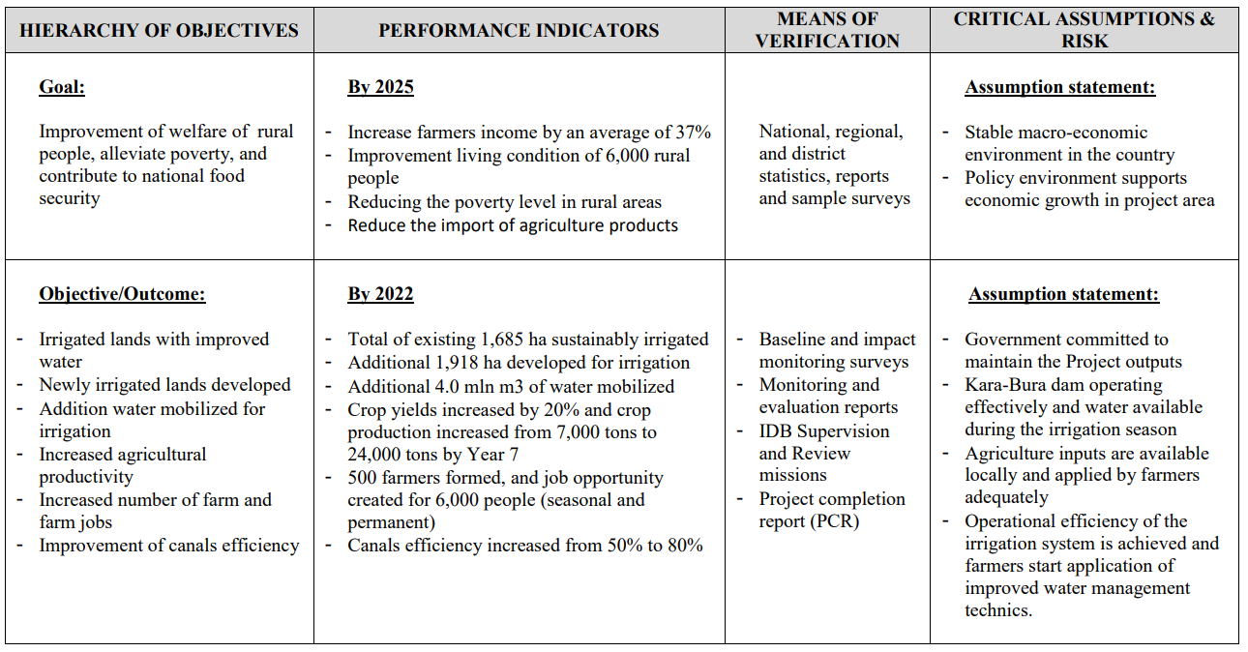

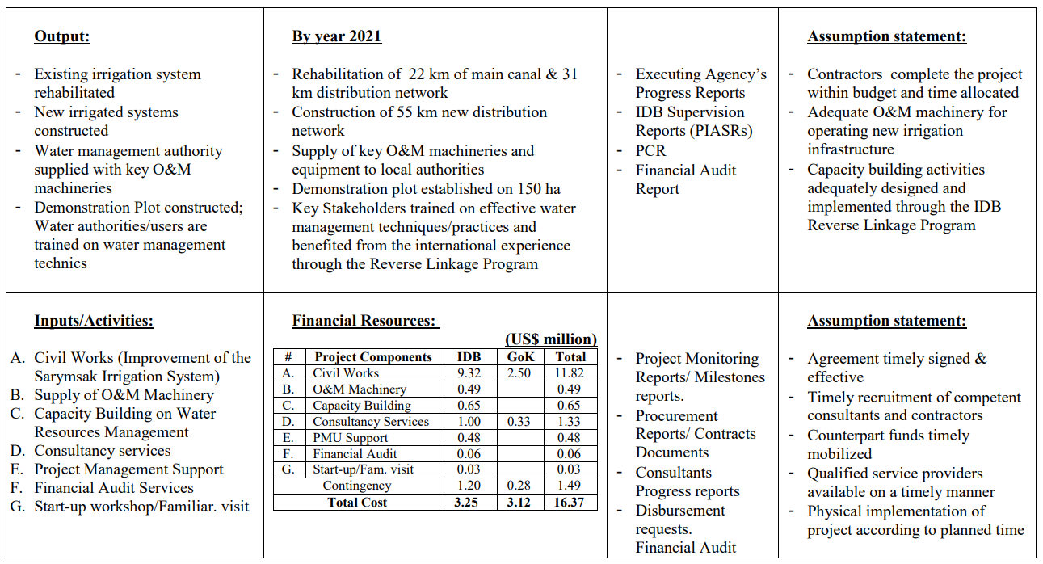

Annex 2. Detailed Evaluation Criteria

|  |  |  |
| --- | --- | --- |
| **#** | **Criteria** | **Maximum score** |
|
| **1.0** | **General Qualifications** | **20** |
| 1.1 | *Academic Background* | *10* |
| 1.2 | *Language skills* | *10* |
|  |  |  |
| **2.0** | **Adequacy for the Assignment** | **60** |
| *2.1* | *General Experience* | *20* |
| *2.2* | *Experience with similar assignments* | *40* |
|  |  |  |
| **3.0** | **Experience in the Sector** | **20** |
| *3.1* | *Sector and relevant sub-sectors* | *10* |
| *3.2* | *Multilateral /International Organizations* | *10* |
|  | **Total Score:** | **100** |

Appendix-B

Expression of Interest (EOI) by Applicant

Preparation of Project Completion Report (PCR) for support to the Sarymsak Irrigation Scheme Development Project (KGZ-0053) Kyrgyz Republic

Date: ________________

Dear Consultant Selection Panel , Islamic Development Bank (IsDB).

I have read your Invitation carefully for Expression of Interest (IEOI) for the captioned assignment/project and find the Terms of References (TOR) and Scope of Work match my skill mix and experiences for providing the services required in the TOR. I would like to express my interest in being considered for the assignment. I understand that IsDB does not have an obligation that I must be selected.

I have attached to this EOI my Curriculum Vitae (CV) for your consideration. Some of the key information is highlighted below:

**I. Personal Profile**

|  |
| --- |
| Nationality:  Date of Birth:  Permanent Address:  Phone No.:  Email: |

**II. Past Consultancy Assignment References**

*[****Notes to consultant:*** *Please select most relevant consultancy assignments you have recently completed to demonstrate your technical qualifications and experience.]*

|  |  |  |  |  |  |
| --- | --- | --- | --- | --- | --- |
| **Period** | **Client** | **Project** | **Country** | **Your role (As lead consultant or as member of a team?)** | **Value of the**  **Contract** |
|  |  |  |  |  |  |
|  |  |  |  |  |  |
|  |  |  |  |  |  |
|  |  |  |  |  |  |
|  |  |  |  |  |  |
|  |  |  |  |  |  |
|  |  |  |  |  |  |
|  |  |  |  |  |  |

**III. Availability**

I shall be available for the services from *____________* to*____________.*

**IV. Eligibility Declaration**

I, the undersigned, certify to the best of my knowledge and belief:

I have read terms of reference (TOR) and Scope of Work (Appendix A), for this assignment.

I confirm that the project references submitted as part of this EOI accurately reflect the experience of myself.

I confirm that I have ever been convicted of an integrity-related offense or crime related to theft, corruption and fraud.

I understand that any misrepresentations that knowingly or recklessly mislead or attempt to mislead may lead to the automatic rejection of the proposal or cancellation of the contract, if awarded, and may result in further remedial action, in accordance with IsDB’s Integrity and Anti-corruption Policy.

{day/month/year}

Name of the Applicant Signature Date

Financial Proposal Format

|  |  |  |  |  |  |
| --- | --- | --- | --- | --- | --- |
| **No.** | **Item** | **Unit** | **Qty** | **Unit Cost**  **(USD)** | **Total**  **(USD)** |
| 1 | Professional Fees (unit rate) per day[2] | Man. days |  |  |  |
| 2 | Expenses during the field visits | Man. days |  |  |  |
| 3 | Expenses for International travel | Lump-sum |  |  |  |
|  | **Total:** |  |  |  |  |

{day/month/year}

Name of the Applicant Signature Date

Curriculum Vitae (CV)

**Position Title and No.:** *{Individual Consultant for Preparation PCR}*

**Name of Expert:** *{Insert full name}*

**Date of Birth:** *{day/month/year}*

**Country of Citizenship/Residence:**

**Contact information:**

___

**Education:**

*{List college/university or other specialized education, giving names of educational institutions, dates attended, degree(s)/diploma(s) obtained}*

**Employment record:**

*{Starting with present position, list in reverse order. Please provide dates, name of employing organization, titles of positions held, types of activities performed and location of the assignment, and contact information of previous clients and employing organization(s) who can be contacted for references. Please mark if the assignment is considered relevant to the assignment.}*

|  |  |  |  |
| --- | --- | --- | --- |
| **Period** | **Employing organization and title/position. Contact information for references** | **Country** | **Summary of activities**  **(Comment if relevant to the Assignment)** |
|  |  |  |  |
|  |  |  |  |
|  |  |  |  |
|  |  |  |  |
|  |  |  |  |
|  |  |  |  |

Membership in Professional Associations and Publications: ___

Skills (language, technical, computer, others): ___

**Certification:**

I, the undersigned, certify that to the best of my knowledge and belief, this CV correctly describes myself, my qualifications, and my experience, and I am available to undertake the assignment in case of an award. I understand that any misstatement or misrepresentation described herein may lead to my disqualification and/or sanctions by the Bank.

{day/month/year}

Name of Expert Signature Date

|  |  |
| --- | --- |
|  | Yes / No |
| 1. *I am employed by the concerned Agency / (ies) related to this consultancy assignment* |  |
| 1. *I was involved with the preparation of the terms of reference for this consultancy assignment* |  |
| 1. *I am not currently debarred by a multilateral development bank or other similar institutions (If yes, identify who)* |  |

Appendix-C

IsDB Table of Contents of Project Completion Report (PCR)

Table of Contents

**Contents**

Abbreviations **Error! Bookmark not defined.**

Project Map **Error! Bookmark not defined.**

Executive Summary **Error! Bookmark not defined.**

A. Project Information **Error! Bookmark not defined.**

1. Responsible Bank Staff **Error! Bookmark not defined.**

2. Project Data **Error! Bookmark not defined.**

3. Key Dates **Error! Bookmark not defined.**

4. Project Financing by Mode (All Financiers) **Error! Bookmark not defined.**

5. Project Cost by Component (only for IsDB financing) **Error! Bookmark not defined.**

6. Procurement Plan (only for IsDB Financing) **Error! Bookmark not defined.**

7. Disbursement Plan (only for IsDB Financing) **Error! Bookmark not defined.**

8. PIASR Ratings **Error! Bookmark not defined.**

9. Project Audits **Error! Bookmark not defined.**

B. Project Performance Assessment **Error! Bookmark not defined.**

1. Relevance **Error! Bookmark not defined.**

2. Effectiveness **Error! Bookmark not defined.**

3. Efficiency **Error! Bookmark not defined.**

4. Sustainability **Error! Bookmark not defined.**

C. Project Stakeholders Performance **Error! Bookmark not defined.**

1. Bank’s Performance **Error! Bookmark not defined.**

2. Beneficiary’s Performance **Error! Bookmark not defined.**

3. Other Stakeholders’ Performance **Error! Bookmark not defined.**

D. Overall Score and Rating **Error! Bookmark not defined.**

E. Risks, Lessons and Recommendations **Error! Bookmark not defined.**

1. Risks to Development Outcome(s) **Error! Bookmark not defined.**

2. Recommendations **Error! Bookmark not defined.**

3. Lessons Learned **Error! Bookmark not defined.**

Appendix 1: Results Framework Targets Vs. Achievements **Error! Bookmark not defined.**

Appendix 2: Project Implementation Structure **Error! Bookmark not defined.**

Appendix 3: EIRR/FIRR Scores and Assumptions **Error! Bookmark not defined.**

Appendix 4: Reference Documents **Error! Bookmark not defined.**

Appendix 5: PCR Mission Dates and Persons Met **Error! Bookmark not defined.**

Appendix 6: Project Events, Missions and Milestones **Error! Bookmark not defined.**

Appendix 7: Project Photographs and Beneficiary Testimonials **Error! Bookmark not defined.**

Appendix 8: Performance Rating Scale and Methodology **Error! Bookmark not defined.**

***(Note: Full version of IsDB Standard Template of Project Completion Report (PCR) will be provided to the Consultant upon the signing of the Contract)***

1. *Currently the EA is State Water Resources Agency under Ministry of Agriculture, Forestry and Water Resources of the Kyrgyz Republic*
2. *Includes any overhead costs while working at place of residence.*