THE REPUBLIC OF UZBEKISTAN
ISLAMIC DEVELOPMENT BANK
STRENGTHENING OF ECONOMIC RESILIENCE OF VULNERABLE ENTERPRISES (SERVE)
(UZB-1037)
COMPONENT B. BUSINESS ENGINEERING AND CAPACITY BUILDING
TERMS OF REFERENCE
for the
CONSULTING COMPANY TO DEVELOP BUSINESS ENGINEERING MODELS AND CAPACITY BUILDING (B.E.T.)
Contract №SERVE/QCBS/BET-01

Project Overview
The Islamic Development Bank (IsDB) acting on its own behalf and as the administrator of Islamic Solidarity Fund for Development (ISFD) has allocated financing for the Project “Strengthening of Economic Resilience of Vulnerable Enterprises” (SERVE). The Republic of Uzbekistan has received financing from IsDB and ISFD toward the cost of the SERVE Project.
The Project is designed to provide priority support to Micro, Small and Medium-sized Enterprises (MSMEs) by extending Sharia compliant access to finance to the targeted MSMEs and related capacity building in Islamic finance and economic empowerment. The primary focus will be on supporting affected MSMEs, smallholder producers, women and youth engaged in economic activities in the targeted regions.
The Project is a joint effort of the Islamic Development Bank and Islamic Solidarity Fund for Development, to provide development support to the Government of Uzbekistan in supporting vulnerable enterprises.

Scope and objective of the Project
The Project will support enterprises in targeted regions by providing an integrated economic empowerment package that will enable access to economic opportunities, allow them to recover from vulnerability and sustain inclusive growth of the individual entrepreneurs and MSMEs. The Project will be primarily implemented in the following target regions: Karakalpakstan AR, Khorezm, Bukhara, Navoiy, Samarkand, Kashkadarya and Surkhandarya regions.
The main focus of the Project is to enhance access to finance for Micro, Small, and Medium Enterprises (MSMEs). This will be achieved by providing a line of financing (LOF) through a selected Partner Financial Institution (PFI). Currently, the Business Development Bank (BDB) has been chosen to facilitate this process. The operations will comply with Islamic Sharia law under an agency agreement using instalment financing. Additionally, the Entrepreneurship Development Company (EDC) will offer a separate financial instrument in the form of a guarantee facility, specifically aimed at supporting micro and small enterprises to improve their access to finance.
The Project will also include consulting services that focus on the following key areas: (a) assisting MSMEs in business planning for value chain development; (b) providing capacity building to the Business Development Bank (BDB) and Entrepreneurship Development Company (EDC) by helping them develop effective working tools and services targeted at women and youth, including appropriate financing solutions and targeted capacity building; and (c) supporting the design and implementation of non-financial support to MSMEs through Business Development Services (BDS) under the Project. The key project results (a) 4,500 entrepreneurs benefited from sharia compliant financing, with at least 30%women and 30% youths; (b) 18,000 people employed and/or maintain their jobs; (c) At least 2,000 entrepreneurs directly trained on various business skills, including at least 30% women and 30% youths; (d) 100 staff of partner financial institutions (PFI) and Ministry of Economy and Finance (MEF or Executing Agency- EA) trained on sharia compliant products and financing.

Objective of the Consultancy Assignment
The objective of appointing the Consulting Company is to support the Executing Agency in promoting the Economic Empowerment approach (as outlined in Annex 1) and Islamic finance by developing practical recovery solutions for 10 selected vulnerable business activities and at least 30 profitable business models for women, including women who intend to start a new business, designing targeted training programs, providing relevant tools and recommendations for partner financial institutions, and supporting the initial implementation of Business Development Services (BDS).

Scope of the Consultancy Assignment
The project will recruit a qualified consulting team with appropriate expertise in MSME business development. The Consulting Company may mobilize international and national experts, as appropriate, based on its proposed methodology, work plan and understanding of the assignment . The Consulting Company, acting as the Business Engineering Team (B.E.T.), will mobilize specialized business consultants with experience in MSMEs, business planning, value chain development, and Islamic finance. The B.E.T. will work closely with the PMU and SME development department of the Executing Agency and develop solutions that will link such services to meet the needs of vulnerable MSMEs and women wishing to start income-generating businesses.
The consultancy scope consists of the following:
- Developing recommendation package for Vulnerable MSMEs
Identify vulnerable micro and small enterprises (as outlined in Annex 3) and develop tailored business development recommendations for 10 selected business activity types with strong recovery and growth potential.
- Development of Profitable Business Models
Conduct analytical research to identify and design at least 30 profitable, innovative, and non-redundant business models for women wishing to start new income-generating businesses. Each model should be supported by a clear value chain framework, in line with the criteria provided in Annex 2.
- Design Targeted Training Programs
Develop comprehensive training programs for both target groups:
- For the 10 selected vulnerable business activities: Develop train programs and practical guidance for entrepreneurs on recovery and scale-up strategies.
- For the 30 profitable business models: Develop, organize and find train programs for women to gain practical skills to start and run these businesses.
- Institutional Capacity Building for Partner Financial Institutions (PFIs)
Provide targeted technical assistance to the Business Development Bank (BDB) and the Entrepreneurship Development Company (EDC) to:
- Develop practical financing tools and recommendations to support 10 selected vulnerable business activities and 30 profitable business models for women.
- Design and pilot Islamic financial instruments tailored to the business models identified in the project.
- Implementation of Business Development Services (BDS)
Support the Executing Agency in designing a sustainable BDS framework based on findings and tools developed under the previous components, including the use of suitable local training and BDS providers where appropriate.
- Mentorship and Supervision During BDS Delivery
Act as instructors during the initial BDS implementation by:
- Coordinating and overseeing the correct delivery of BDS;
- Providing practical guidance and supervision during service delivery;
- Monitoring the effectiveness and quality of services in real-time.

Working Plan
The Consulting company will elaborate a detailed work plan and secure approval from PMU/EA within 3 weeks of contracting.

Schedules of implementation
The implementation period is expected to be 12 months, related to the project life-cycle, starting as soon as the consulting contract has been signed between the PMU/EA. Funding of the assignment is secured by the ISFD financing. The service will be divided into 2 phases with breakdown – Phase-I with up to 6 months duration of Implementation activities (focused on analysis, drafting, development, planning, examination, research, and formulation of a package of recommendations) and Phase-II with 6 months duration of Monitoring and Supervision activities (focused on monitoring and guidance, including coordination and oversight of the initial implementation of the proposed solutions under the BDS).
The actual delivery of BDS will be carried out by local service providers to be selected by the PMU/EA through a separate procurement process during Phase I. The Consulting Company will support the PMU/EA, as required, in defining the technical requirements for such services and in facilitating the initial rollout of the BDS.

Expected Deliverables
The Consulting Company shall be responsible for delivering the following key outputs in accordance with the assignment objectives and timeline. Each deliverable must be submitted in English and Uzbek language, both in print and electronic format, and must meet the content and quality standards defined by the PMU/EA. Each deliverable shall be subject to review and written acceptance by the PMU/EA.
7.1 Inception Report (by Month 1): A detailed plan for the assignment, including timelines, team setup, stakeholder engagement, and how MSMEs and business models will be identified. Approval from PMU/EA is required before continuing.
7.2 Selection Approval Report (by Month 2): Presentation of the 30 selected/proposed profitable business models for women wishing to start income-generating businesses and 10 selected/proposed vulnerable business sectors/activity types for official validation and approval by PMU/EA.
7.3 BDS Service Provider Technical Requirements (by Month 3): Preparation of the technical requirements and scope of services for the local BDS service providers to be procured separately by the PMU/EA, including the proposed service delivery approach, target groups, geographic coverage, expected activities, minimum qualification requirements, key outputs and monitoring arrangements.
7.4 Business Model Portfolio (by Month 5): At least 30 profitable business models developed with supporting studies, value chain analysis, and income projections. Models must meet criteria from Annex 2 and provide clear guidance for entrepreneurs and financiers.
7.5 Sector Assessment Report (by Month 5): Study of 10 vulnerable business sectors and 50 example enterprises. Includes analysis, recommended actions (recovery and scale-up solutions), and visual summaries (such as maps) where needed.
7.6 Training Programs (by Month 5): Two training packages: One for MSMEs on how to recover and grow. One for women on how to start and manage the proposed businesses. Each package includes materials, guides, and monitoring tools. The Consultant may also provide initial Training of Trainers and pilot support, while wider training delivery will be carried out through local service providers.
7.7 Institutional Tools & Support for PFIs (by Month 5): Development of practical financing tools and recommendations for BDB and EDC to support the 10 selected vulnerable business activities and 30 profitable business models, including appropriate Sharia-compliant financing options. Targeted orientation or Training of Trainers may be provided to relevant PFI and EA staff, as required.
7.8 BDS Framework (by Month 6): Plan for a sustainable Business Development Services (BDS) system that supports MSMEs and links with training and finance tools.
7.9 BDS Mentorship and Initial Implementation Support (Ongoing: Months 7–12)
The Consulting Company shall provide hands-on assistance to the EA/PMU in implementing Business Development Services (BDS), including:
(i) On-Site Support and Coordination: Assist EA/PMU in planning and managing the rollout of BDS across selected regions. This includes helping to organize service delivery schedules, coordinating the technical aspects of service delivery with BDS providers selected separately by the PMU/EA.
(ii) Instructor-Level Mentorship: Actively guide EA/PMU staff and BDS providers during service implementation by:
Offering real-time coaching and technical support;
Demonstrating best practices in business diagnostics, advisory, and coaching;
Ensuring consistency and quality of services delivered to MSMEs.
(iii) Monitoring and Feedback: Collaborate with EA/PMU to:
Develop and apply monitoring tools;
Track service effectiveness, client feedback, and performance indicators;
Identify gaps or weaknesses in service delivery.
(iv) Corrective Action and Continuous Improvement: Prepare periodic mentoring and monitoring reports that include:
Recommendations for immediate corrective actions;
Adjustments to tools, training, or processes based on field realities;
Documentation of lessons learned and good practices to inform future scale-up.
7.10 Final Reports (Draft by Month 11; Final by Month 12): Completion Report: Summary of activities, achievements, and lessons.

Responsibilities of the PMU/EA
The PMU/EA is responsible for:
- providing reasonable administrative and coordination support necessary for the performance of the assignment (if applicable);
- coordination and supporting of the B.E.T. when interacting with government agencies and other relevant stakeholders;
- timely review and written acceptance of deliverables submitted by the Consulting Company;
- organizing and managing the separate procurement of local BDS service providers, based on the technical requirements developed under the assignment;
- facilitating access to relevant project information, institutions and stakeholders necessary for the assignment;
- timely payment for services in accordance with the Contract.

Responsibilities of the Consulting company
The Consulting company is responsible for:
- observing the timeframe of consultancy services and agreed deliverable schedule;
- ensuring the high quality of the services and deliverables;
- observing the budget for the assignment;
- timely informing the PMU/EA in cases when there are significant changes in the work schedule or circumstances that may affect timely delivery of the assignment.
The Consulting company shall perform services and carry out their obligations with all due diligence, efficiency, and economy, in accordance with generally accepted professional techniques and practices, and shall observe sound management practices, and employ appropriate advanced technology and safe methods. The Consulting company shall always act, in respect of any matter relating to the services, as faithful advisers to the PMU/EA, and shall at all times support and safeguard the PMU/EA’s legitimate interests in any dealings with Subconsultants or third parties.

Information on the PMU/EA’s counterpart staff to be associated with the service and the facilities to be provided to the Consulting company
The Recipient of the consultancy service is the PMU/EA. The PMU will coordinate the work of the Consulting company. The responsible contact from PMU side are as follows:
  - Project Manager
  - MSME Financing Specialist
  - M&E Specialist
The PMU/EA will provide the Consulting company with all project-related relevant documents and information available.

Description of main terms and conditions of the appointment
The PMU/EA during selection of Consulting Company or JV of Consulting Companies (B.E.T.) will apply Quality and Cost Based Selection through an international shortlist (QCBS-International), open to eligible consulting firms from any country, subject to the applicable IsDB eligibility requirements. The PMU/EA will follow procedures in accordance with the provisions contained in the Guidelines for the Procurement of Consultancy Services under Islamic Development Bank Project Financing, April 2019, revised February 2023.

Requirements set for the staff
The Consulting Company will carry out the assignment in office and field as required for the effective delivery of the assignment. The Consulting Company shall propose an appropriately qualified and adequately resourced team to deliver the assignment.
The Consulting Company shall determine the number, mix, nationality, and level of input of experts required, based on its proposed methodology, work plan and understanding of the assignment.
The proposed team shall collectively demonstrate adequate qualifications and practical experience in areas relevant to the assignment, including MSME and private sector development; business model and business plan development; market and value chain analysis; recovery and growth support for vulnerable enterprises; entrepreneurship training and Business Development Services (BDS); women’s economic empowerment; MSME financing, including appropriate Sharia-compliant financing solutions; and monitoring and implementation support.
The Team Leader shall have appropriate academic qualifications and at least 10 years of relevant professional experience, including demonstrated experience in managing similar complex consultancy assignments. Experience with projects financed by international development organizations or MDBs will be an advantage. The Team Leader shall be fluent in written and spoken English and have strong analytical, coordination and report-writing skills.
In forming its team, the Consulting Company shall ensure that the proposed experts collectively possess sufficient knowledge, skills and practical experience across all technical areas required for the assignment. The team composition shall adequately cover, among others, MSME and private sector development, business engineering and business model development, market and value chain analysis, entrepreneurship and BDS, training and capacity building, women’s economic empowerment, MSME finance and Sharia-compliant financing, monitoring and evaluation, and implementation support. The Consultant shall assign appropriately qualified team members to each relevant area and ensure that the overall team has sufficient capacity to perform all tasks and deliver all outputs specified in the TOR.
In consultation with the PMU/EA, the Consulting company shall have flexibility to adapt timing, sequencing, and the short-term experts’ field/home office time allocations to ensure optimal delivery of the assignment and achievement of its objectives.

Reporting and other matters
The Consultant is expected to prepare and deliver to PMU/EA an inception report within 1 month after commencement of its services and thereafter monthly progress reports describing the progress of the assignment, activities completed, key issues, and any challenges encountered in the reporting period.
By Month 11, the Consultant shall prepare and deliver a draft report covering the activities undertaken and assessment of the Assignment in terms of meeting its objectives, as well as conclusions and recommendations for future steps and further implementation of the developed solutions. The draft report shall also summarize the initial implementation experience, results observed during BDS rollout, lessons learned, and any recommended adjustments for further scale-up. The PMU/EA’s comments must be submitted not later than three weeks after receipt of draft reports. The final report must be delivered not later than one week after the end of the assignment and shall incorporate, as appropriate the PMU/EA’s comments.
In addition, the Consultant shall promptly inform the PMU/EA of any circumstances that may materially affect the timely or effective achievement of the assignment objectives and propose appropriate corrective measures.
All reports shall be submitted in English and Uzbek in electronic form and, where requested by the PMU/EA, in printed form. Generally, the reports will summarize all information and explanations, so that the PMU/EA will be in a position to understand the conclusions.

General Eligibility and Compliance Requirements:
Eligibility Compliance
- The Consultant must comply with IsDB eligibility rules (Part 1, Chapter 1, Section 1.11).
- The Consultant must not be subject to any restrictions, sanctions, or debarment by IsDB or any other major international financing institution.
- The Consultant must be free from any conflict of interest that could give rise to a competitive advantage.
Relevant Experience and Performance
- The Consultant must demonstrate at least 5 years of experience in providing consulting services in MSME development, financial services, Islamic finance, and capacity building.
- The Consultant must have successfully implemented at least two (2) similar projects in the last five (5) years, preferably in Central Asia or similar emerging markets.
- Experience with economic empowerment programs is required, particularly in the development and implementation of Sharia-compliant financial products and services.
- The Consultant must have experience working with MDB’s, or similar organizations.

Annex 1
IsDB Economic Empowerment Approach (“EEA”)

From Financial Inclusion to Economic Inclusion
- The EEA considers the multi-facet needs of the poor, which goes beyond financial services to cover the most important non-financial services. The latter services have the strong potential to make the financial services/support efficient and with sustainable impact on the poor’s conditions, as they facilitate its inclusion as an active actor in the real economy.
- The EEA also recognize the importance of providing the poor with access to not-for-profit financial and non-financial services for the potentially active poor through Islamic Social Finance to help them satisfy their primary needs and consequently enable them to “graduate” and focus on most rewarding economic endeavors enabling them to reach full economic inclusion.
- The EEA starts by endeavoring to design innovative interventions that take into account (a) Engineering of Profitable Business/Investment Opportunities (b) Providing Capacity Building/Development (c) Providing Supporting Basic Infrastructure (d) Building Smart Partnerships with the Public, Private & Third Sectors Actors (e) Access to Appropriate Financing and (f) Access to Relevant Markets. Thus, a solid and sustainable ecosystem is built in collaboration with strategic partners around the end-beneficiary.

Targeted Paradigm Shift from Financial to Economic Inclusion
- 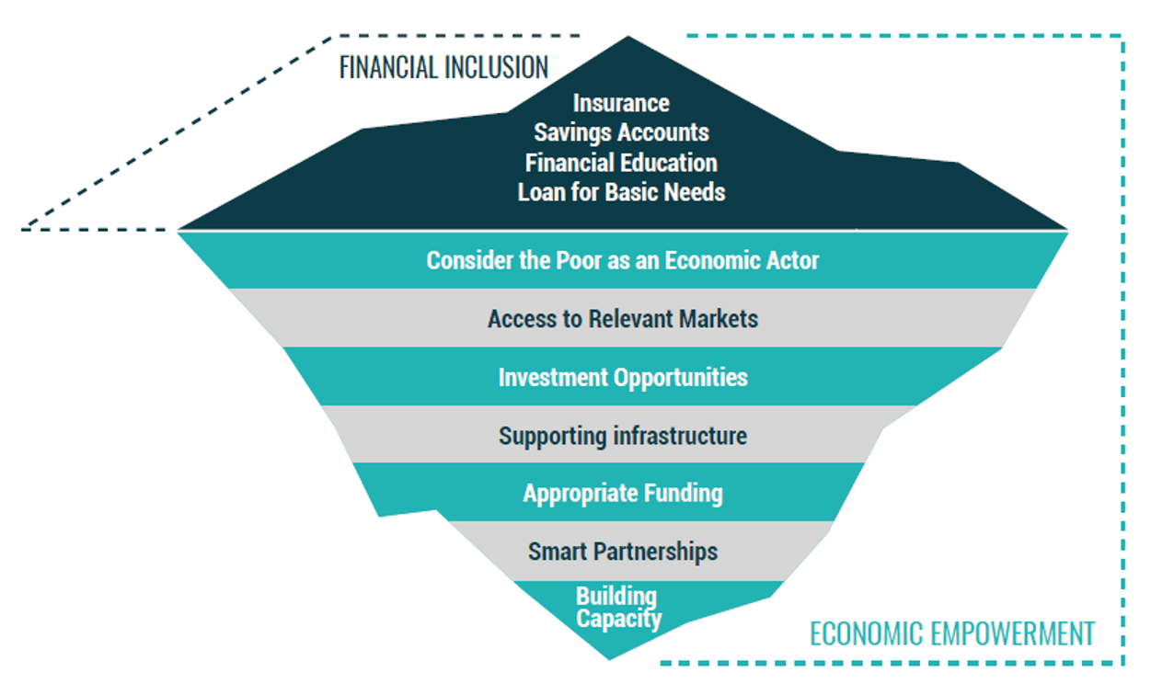

- Economic Empowerment Business Model in the Field

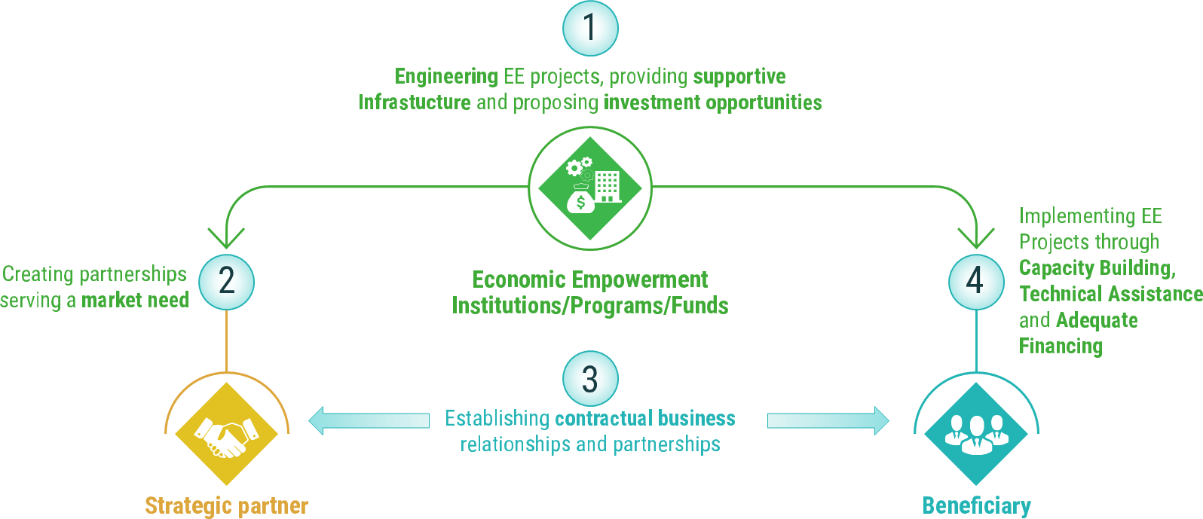

Annex 2

Terms for business models
This section outlines the detailed criteria for selecting and developing business activity types, with a strong focus on women’s economic empowerment, feasibility, scalability, and impact. The selected business models must be practical, commercially viable, and responsive to identified market opportunities in the target regions. Models should avoid activities that are already highly saturated and, where existing business concepts are proposed, demonstrate clear adaptation or differentiation to the local market context.
Criteria for Business Activity Types:
1. Target Group: Business activities should be suitable for economically disadvantaged women with limited education, specialized knowledge, or prior experience.
2. Training Feasibility: Women in the target group should be able to develop the basic technical and entrepreneurial skills required to start the proposed activity within a maximum of 2 months, through up to 40 hours of training.
3. Location: Participating women should be able to operate their businesses from their current place of residence without relocation.
4. Ownership and Control: The business activity must be capable of being independently owned and managed by the participating women.
5. Investment Ranges: The capital required for each business activity should fall within at least one of the following ranges (USD equivalent):
(i) Up to $5,000
(ii) $5,000 to $20,000
(iii) $20,000 to $50,000
6. Variety: Provide at least 10 distinct business activity types for each investment range listed above, resulting in at least 30 business model concepts in total.
7. Economic Impact: A business activity requiring an investment of up to $5,000 should be capable of providing a sustainable source of income for a family of at least 3 people, taking into account applicable minimum household consumption levels..
8. Innovation and Originality: Each business model must present a new concept, approach, or product offering in the target region. Models must not replicate existing, widespread business types. Preference will be given to ideas with unique market value, untapped customer demand, or emerging technologies/applications. Adaptations of global ideas must be locally contextualized and demonstrate clear differentiation.
9. Growth Potential: Entrepreneurial activity should demonstrate realistic potential for growth and expansion through reinvestment, increased sales, productivity improvements or access to wider markets. The business plan should provide reasonable three-year financial projections and explain the key assumptions underlying expected growth.
10. Market Saturation: Each basic business plan should clearly outline the potential for market saturation, considering distribution channels, demand sufficiency, and resource availability within a Mahalla, district, and region. The maximum number (or cost) of similar business activities that can be supported should be indicated.
11. Prioritization and Assessment: Prioritize business activities up to $5,000 (basic business plans) with a separate assessment of prospects. Economic activities with higher investment requirements should be assessed using a distinct system.
12. Compliance: Basic business plans must adhere to current legislation and the environmental and social requirements.
13. Business Plan Design Standards:
Each business activity plan should include:

- A brief description of the business model,
- Key products/services to be offered,
- Target market and customer segment,
- Cost breakdown of initial investment and estimated working capital requirements,
- Expected monthly and annual income and expenses,
- Indicative break-even/payback period,
- Training modules required and resources available,
- Outline of growth strategy over 3 years,
- Assessment of local competition and market saturation,
- Appropriate financing options, including Sharia-compliant financing where applicable;
- Relevant risks and mitigation measures.

Annex 3
Criteria for Identifying Vulnerable Enterprises
The Consultant will focus on identifying and analyzing micro and small enterprises (MSEs) In accordance with the priority financing list that are unable to operate at full capacity or have suspended operations due to limited market access or other external constraints. These enterprises will be grouped by sector and assessed to determine the marketability of their products or services, as well as the potential for developing practical recovery solutions, improving market linkages and value chains, supporting business recovery, and identifying pathways to long-term viability.
1. Sector-Level Criteria. To qualify as a vulnerable sector, the following conditions must be met:
- The consulting firm must identify and select at least 10 vulnerable business sectors or activities.
- For each identified sector, there must be a sufficient concentration of micro or small enterprises, either operational or temporarily inactive, with at least 30 such enterprises present in each target region, as an indication that the business activity is sufficiently widespread and that the identified vulnerability is sector-wide rather than isolated. This threshold is a sector-identification criterion and does not represent the number of enterprises to be selected for detailed diagnostic analysis..
- Selected sectors must include already established businesses with core production assets (such as equipment, tools, buildings, or infrastructure) already procured, installed, or in use.
- A significant portion of businesses in the sector must be functionally limited or temporarily non-operational due to constraints such as lack of buyers, limited access to markets, or other forms of vulnerability,financing constraints, input limitations, or other relevant factors affecting business performance.
- The sector must demonstrate potential for recovery, meaning that businesses could resume or scale up operations if appropriate support is provided—such as marketing assistance, consultancy services, or financing or other relevant business development support.
2. Enterprise-Level Criteria. Enterprises selected for deeper analysis and support must meet the following eligibility conditions:
- The enterprise must be classified as micro or small, with no more than 20 employees.
- The business must be home-based or located on personal land or premises (e.g., private buildings or informal facilities), even if the property is not formally owned by the entrepreneur.
- The enterprise must not be declared bankrupt, and key assets such as equipment must not be subject to liquidation or sale due to outstanding debts.
- The entrepreneur must express a willingness to continue operations and not intend to sell the business equipment, particularly where doing so would result in significant financial loss compared to the original investment.
- The business must currently be underperforming or inactive primarily due to external constraints, such as limited customer access or market demand, rather than internal mismanagement or unresolved legal issues.
3. Case Study Sample Selection and Analysis. For each of the 10 identified vulnerable sectors, the consulting firm shall:
- Select a minimum of 5 representative enterprises per sector, from different regions or areas, resulting in a total sample of 50 enterprises across 10 sectors.
- Conduct a comprehensive diagnostic analysis of each selected enterprise and its respective sector, covering the following dimensions:
- Review of any market research conducted by the entrepreneur prior to launching operations;
- Assessment of the quality and completeness of the original business plan;
- Identification of operational challenges, misjudgments, and capacity limitations experienced by the enterprise;
- Evaluation of external factors affecting business performance, including regulatory changes, the presence of new (especially imported) competitors, input shortages, or loss of skills and know-how;
- Analysis of cost structure and pricing strategy, with recommendations for improving cost-efficiency and identifying alternative inputs or methods;
- Identification of gaps in existing marketing strategies and the need for updated or more effective market research;
- Examination of the feasibility of building sales chains or aggregators, based on the scale and similarities among enterprises within the sector;
- Documentation of any additional findings that may influence enterprise sustainability, market relevance, or potential for growth.

Source: Financing Agreements signed on 18 April 2024 between the Republic of Uzbekistan and the Islamic Development Bank (IsDB) for the Strengthening the Economic Resilience of Vulnerable Enterprises (SERVE) Project (UZB-1037). These indicators represent overall Project-level results and targets.

