

Government of The People’s Republic of Bangladesh

Ministry of Road Transport and Bridges
Road Transport and Highways Division
Roads and Highways Department

TERMS OF REFERENCE
FOR
SENIOR PROCUREMENT SPECIALIST-INTERNATIONAL
(INDIVIDUAL CONSULTANT)

FOR

Construction of Five Climate Resilient Bridges in Mymensingh Division, Bangladesh

October 2026

Terms of Reference (TOR)
for
Senior Procurement Specialist-International
(Individual Consultant)

- Background
The Roads and Highways Department (RHD), under the Ministry of Road Transport and Bridges (MoRTB) is going to implement a project titled “Construction of Five Climate Resilient Bridges in Mymensingh Division, Bangladesh”. RHD is responsible for sustainable highway network and safe road transport system. In this context RHD has the responsibility of the Development of sustainable, safe and quality highway infrastructure and integrated modern public transport system for socio-economic development of the people through repair, renovation, maintenance, development and expansion of highways and bridges. Government of the People’s Republic of Bangladesh (GoB) has received financial assistance from the Islamic Development Bank (IsDB) for the project. As per provision of the project scope an individual consultant (Procurement Specialist) will be hired to support the project implementation unit (PIU).

- Project Objectives
The Government of the People’s Republic of Bangladesh has signed Financing Agreements in favour of Construction of Five Climate Resilient Bridges in Mymensingh Division, Bangladesh (BGD- 1096) Project with Islamic Development Bank (IsDB). The main objectives of the project are: - 1. To enhance regional connectivity by bridging gaps on border roads. 2. To promote economic development of remote areas in Mymensingh Division. 3. To Promote tourism by providing access to places of scenic beauty. 4. To facilitate connectivity with land ports.
The project scope covers the following components: i) Component (A) Civil Works, ii) Component (B) Design Review and Supervision Services, iii) Component (C) Land Acquisition, Resettlement and Compensation, iv) Component (D) Project Implementation Support & Start up workshop (PMU), v) Financial Audit (E), vi) Component (F) Contingency Emergency Response Component (CERC).

- Project Location
The project is located in Mymensingh Division along the roads Z-2834 and Z-3704 in Netrokona and Mymensingh Districts. (Map attached)

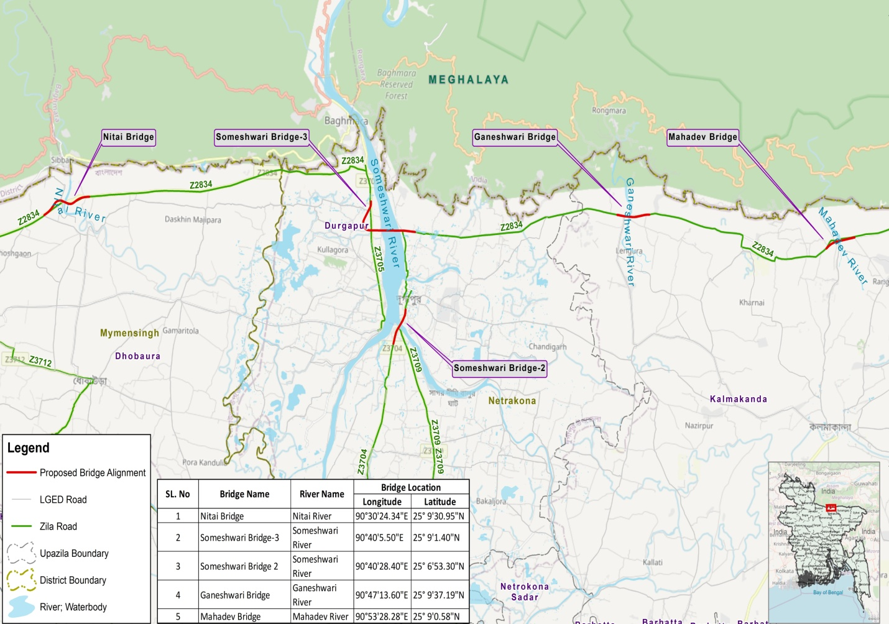

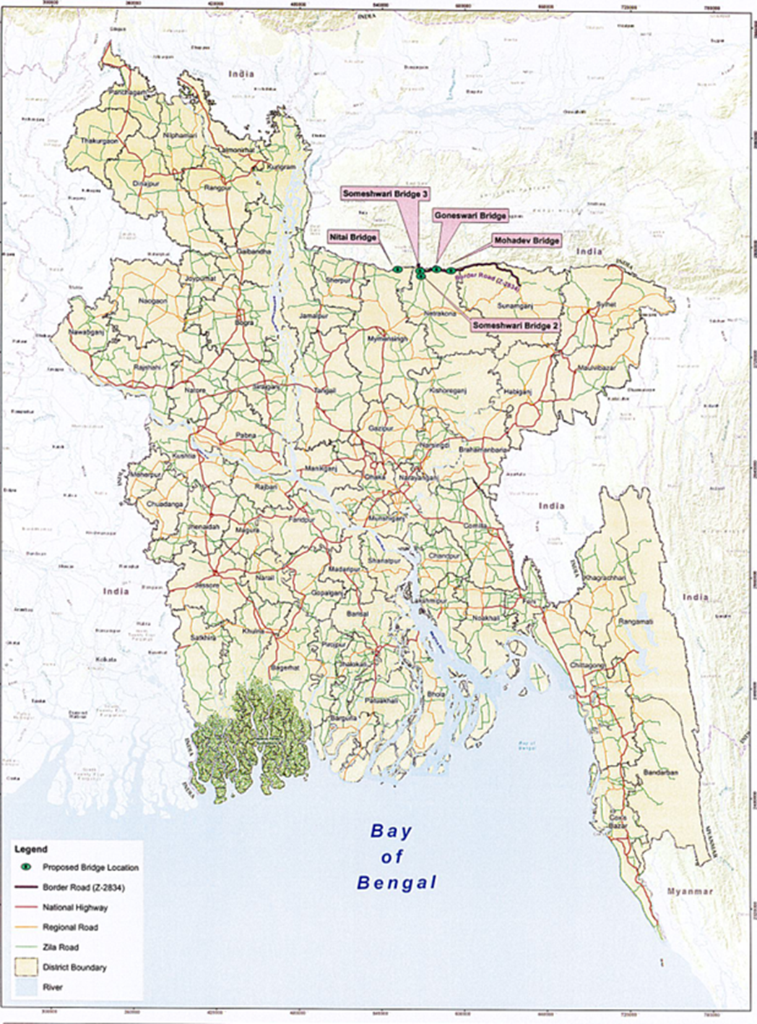

- Objective of the Assignment:
The Roads and Highways Department is now seeking to hire a procurement specialist to assist in procuring works, goods, consultancy services and non-consultancy services for the effective and efficient implementation of the Project and delivering best value for money. The consultant will be selected following the procurement guidelines and procedures of the Bank or using the National Procurement system as per the approved project and financing agreement.

The Senior Procurement Specialist will function under the direct supervision and report to the Project Director.

E. Scope of Work
The Procurement Specialist will be responsible for discharging all functions pertaining to the procurement of works goods and consultancy and non-consultancy services under the Project. The Consultant’s scope of services shall include, but not limited;

- Preparation, implementation and updating of the Procurement Implementation Manual (PPIM) as per the Prescribed Template of IsDB or other MDBs.
- For the project covering all goods, work, consultancy and non-consultancy services to be procured for the project based on approved mode of procurement.
- Prepare and regularly update procurement plan for all goods, works, consultancy and non-consultancy services to be procured for the project, detailing contract packages, the estimated cost, the procurement or selection methods, market approach and timelines for each package. The procurement plan is to be used for monitoring progress on procurement activities and submitted to the Bank using the e-Procurement Portal (ePP).
- Advise and guide Project Management Unit (PMU)/Project Implementation Unit (PIU) management, related staff and stakeholders on IsDB procurement policies and guidelines.
- Prepare and review standard procurement documents (General Public Notice (GPN), Specific Public Notice (SPN), Request for Quotation (RFQ), Request for Proposal (RFPs), Standard Bidding Documents (SBDs) and draft contracts to be submitted to IsDB for no-objection or cleared using country systems and maintained for post-review of the Bank.
- Arrange and coordinate pre-bid meetings, prepare meeting minutes, provide written response and clarification to the queries from the bidders/consultants.
- Coordinate and attend bid openings and prepare bid opening minutes.
- Carry out bid/proposal evaluation and prepare, Bids Evaluation Reports (BER), Technical Evaluation Reports (TER), Combined Evaluation Reports (CER).
- Identify and report any suspicious activity which is red flag that might pose potential risks or lead to practices of fraud and corruption.
- Ensure compliance with the procurement principles and requirements as per agreed the procurement process for the project.
- Ensure transparency and integrity in the procurement processes as per the Bank’s procedure and the procurement laws of Bangladesh. S/he should not have any conflict of interest while working and should keep all the project information confidential.
- Build and enhance procurement capacity within the executing agency/PMU/PIU. This includes on-the-job training at least five (05) RHD officials, seminars on procurement and contract management related aspects.
- Maintain close coordination and collaboration within the executing agency/PMU/PIU, relevant stakeholders and IsDB.
- Handle complaints during various stages of the Procurement process. Ensure timely and objective resolution of the complaints. Provide comprehensive timely response to the Complainant on procurement related complaints.
- Ensure the procurement activities are carried out in accordance with agreed procurement procedures and guidelines set out in the project financing agreement.
- Supervise the implementation of contracts including transportation, delivery, acceptance and storage of goods.
- Prepare and submit timely procurement activities report as per agreed format.
- Establish and manage a central procurement record system and ensure all procurement related documents are properly recorded both in hard copy and electronic form.
- Participate and coordinate with the various staff missions and provide required information and documents for the mission.
- Liaise with the relevant line ministries, stakeholders and departments for effective and efficient project implementation.
- Contribute to the development/update of procurement policies and procedures considering the Member Countries’ needs, IsDB Group priorities and the best practices in other MDBs.
- Support in the elaboration of project concept notes, preparation and appraisal of projects in order to provide the required advice on procurement matters.
- Contribute to development of procurement strategies for project including assessment of procurement capacity, regulations and procedures, market and risk assessments etc. which can guide procurement arrangements for project delivering best value for money.
- Organize start-up project workshops, conduct staff briefings and provide necessary support for the procurement-related aspects for projects covering various sectors.
- Oversee the implementation of contracts to ensure that all parties adhere to the agreed terms and conditions including price escalation and contract amendments.
- Monitor contract performance and compliance, including delivery schedules, quality of goods/services, and adherence to specifications.
- Follow up and monitor procurement related activities and ensure timely procurement activities.
- Conduct regular reviews and assessments of contract performance and address any issues or discrepancies.
- Perform other work-related duties and responsibilities as may be assigned by the Project Director/Project Management.

- Qualifications
- Bachelor’s degree or equivalent in Engineering, Law, Project Procurement Management, Project Management, Business Administration, Public Administration, Supply Chain Management and related field;
- Master's degree in a relevant field or CIPS/equivalent professional qualification will be given preference.
- Completion of IsDB’s Project Procurement e-Learning​ modules will be preferred.

- Experience
- At least 12 years of relevant professional experience for bachelor’s degree holders and 10 years of relevant professional experience for master’s degree holders;
- At least 3 similar assignments completed in the past 10 years;
- Similar experience in Transportation sector will be an advantage;
- Experience in FIDIC contract administration/forms, preferably in the transport sector;
- Working experience with IsDB and other MDB-financed projects will be an advantage.

- Core Competencies
- Shall have effective project procurement, planning and management skills;
- Ability to handle and prioritize workload;
- Shall have effective team management skills;
- Shall have high standards for integrity and ethics.

- Language Skills
- Shall have English Language proficiency (speaking, reading, and writing).

- Duration of the assignment:
The duration of the assignment will be 24 months. The duration may be extended as per requirement of the project, subject to availability of funds and satisfactory performance of the individual consultant. For payment purpose, maximum 22 business days of service will be considered a month and eight working hours a day. It could be extended on mutually agreed terms if required by Project Director/Project Management as per rules and regulation of IsDB and GoB.

- Institutional Arrangement:
The Senior Procurement Specialist (International) will work under the direct supervision of the Project Director (PD), RHD. S/he will report directly to the Project Director or a senior official designated by the PD and will work in close collaboration with other officials/ subject matter experts deployed at the Project Implementation Unit (PIU).

- Location of Service
The consultant’s office will be in Dhaka/Mymensingh Division, Bangladesh. The service will necessitate frequent site visits. The duty station of the individual consultant will be assigned by the Project Director.

