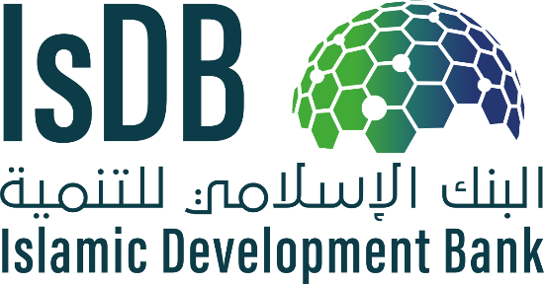

REQUEST FOR EXPRESSION OF INTEREST

(CONSULTANT SERVICES)

Islamic Development Bank

Islamic Financial Sector Development Department

The Preparation of Islamic Microfinance Toolkit (IMT) and Capacity Building

Consultancy Services for a New Product Development

The Islamic Development Bank (IsDB) started a program to develop the Islamic microfinance sector, including building its internal capacity in the operations, appraisal, monitoring, and implementation of microfinance projects and enhance the capacity of IsDB Group partners and beneficiaries in conducting Islamic microfinance.

The objective of this assignment is to develop an Islamic Microfinance Toolkit (IMT), building upon the existing work done so far by the IsDB internal team. The IMT will serve as benchmark guidance for conventional microfinance institutions to take the necessary steps to introduce Shari’ah-compliant microfinancing products and/or completely transform their operations into Shari’ah-compliant ones. The toolkits will also provide guidance to the existing Shari’ah-compliant microfinance institutions in order to enhance their current product ranges while improving efficiency as well as compliance with ethical and Shari’ah standards. The IMT should also provide a focus on consumer empowerment with a view to achieving financial inclusion objectives i.e., women empowerment, youth empowerment, etc.

IsDB now invites eligible consultants to indicate their interest in providing the aforementioned services. Interested consultants must provide specific information which demonstrate that they are fully qualified to perform these services (brochures, description of similar assignments, experience in similar conditions, availability of appropriate skills among staff, etc.). Experience in the following area or tasks shall be the minimum requirement for the assignment:

* Development of the following books:
* The deliverable under this component is the IMT which is expected to comprise five books as follows:
  + Book 1 – Islamic Microfinance
  + Book 2 – Setting up a new Islamic Microfinance Company
  + Book 3 – Value Chain for Islamic Microfinance
  + Book 4 – Monitoring and Evaluation of Islamic Microfinance Institutions
  + Book 5 - Islamic Microfinance Model Regulations and Supervisory Guidelines
* Capacity Building and Training Materials on the IMT which will be used to conduct training workshops.
* The shortlisting criteria are: The Consulting Firm will be procured through the Quality- and Cost-based Selection (QCBS) method. Key Experts will not be evaluated at the shortlisting stage.

The attention of interested Consultants is drawn to Paragraphs, 1.23, and 1.24 of the Guidelines for Procurement of Consultant Services under Islamic Development Bank Project Financing (the “Procurement Guidelines”), setting forth IsDB’s policy on conflict of interest.

Consultants may associate with other firms to enhance their qualifications but should indicate clearly whether the association is in the form of a joint venture and/or a sub-consultancy. In the case of a joint venture, all the partners in the joint venture shall be jointly and severally liable for the entire contract, if selected.

Consultants will be selected in accordance with the QCBS method set out in the Procurement Guidelines

Consultants may express interests in the forms of association, validated by an agreement among members of the association which clearly specifies the type of association, i.e. a joint-venture, intermediate forms of association, or sub consultancy.

A consultant will be selected in accordance with the procedures set out in the Guidelines for the Use of Consultants under Islamic Development Bank Financing (attached, current edition).

Interested consultants may obtain further information at the emails below until the due date.

Expressions of interest must be delivered to the address (or email addresses) below by 15:00 hours Jeddah Standard Time on June 30, 2020.

|  |  |  |
| --- | --- | --- |
| Name |  | cid:image002.jpg@01D6182C.2520C2E0 |
| Mehmet Fehmi Eken | MEken@isdb.org | +966 (12) 646 7118 |
| Syed Faiq Najeeb | SNajeeb@isdb.org | +966 (12) 646 7119 |

Islamic Development Bank Group

Head Quarter, 8111 King Khalid St. AI Nuzlah AI Yamania Dist. Unit No. 1

Jeddah, 22332-2444, Kingdom of Saudi Arabia

Website: [https://www.isdb.org](https://www.isdb.org/)